Data Lake Training With Starburst
BofA Lab Guide (November, 2026)
Table of Contents

Student setup
Lab 1: Access student account
Starburst features
Lab 1: Execute queries in Starburst Enterprise
Lab 2: Exploring federated queries
Data lake tables
Lab 1: Create a schema and tables
Lab 2: Investigate Hive’s special columns
Apache Iceberg
Lab 1: Create and populate Iceberg tables
Lab 2: Explore partitions with Iceberg
Lab 3: Data modifications and snapshots with Iceberg
Advanced Iceberg
Lab 1: Utilize Iceberg’s MERGE statement
Lab 2: Exercise advanced features of Iceberg
Data lake performance
Lab 1: Create tables with multiple file formats
Lab 2: Using columnar file formats & eliminating small files
Lab 3: Exploring table partitioning and bucketing
Starburst cache service
Lab 1: Table scan redirection in action
Lab 2: Using materialized views for performance gains
Data Products for Analysts
Lab 4: Compare Results from Raw Tables vs. a Curated Data Product
Cost-based optimizer
Lab 1: The EXPLAIN command
Lab 2: The EXPLAIN ANALYZE command
Lab 3: Explore the impact of statistics on query plans

Student setup

Lab 1: Access student account

Estimated completion time
- 5 minutes

Learning objectives
This lab will walk you through the process of accessing your training lab account and switching to the student role.

Prerequisites
- Before completing this lab, your instructor will send you an invitation email. If you have not received an email, please contact your instructor.

Activities
- Log in to account using provided credentials
- Confirm correct role

Step 1 - Log in to account using provided credentials
Your instructor should have provided you with the link to the Starburst Enterprise lab environment along with your username and password.

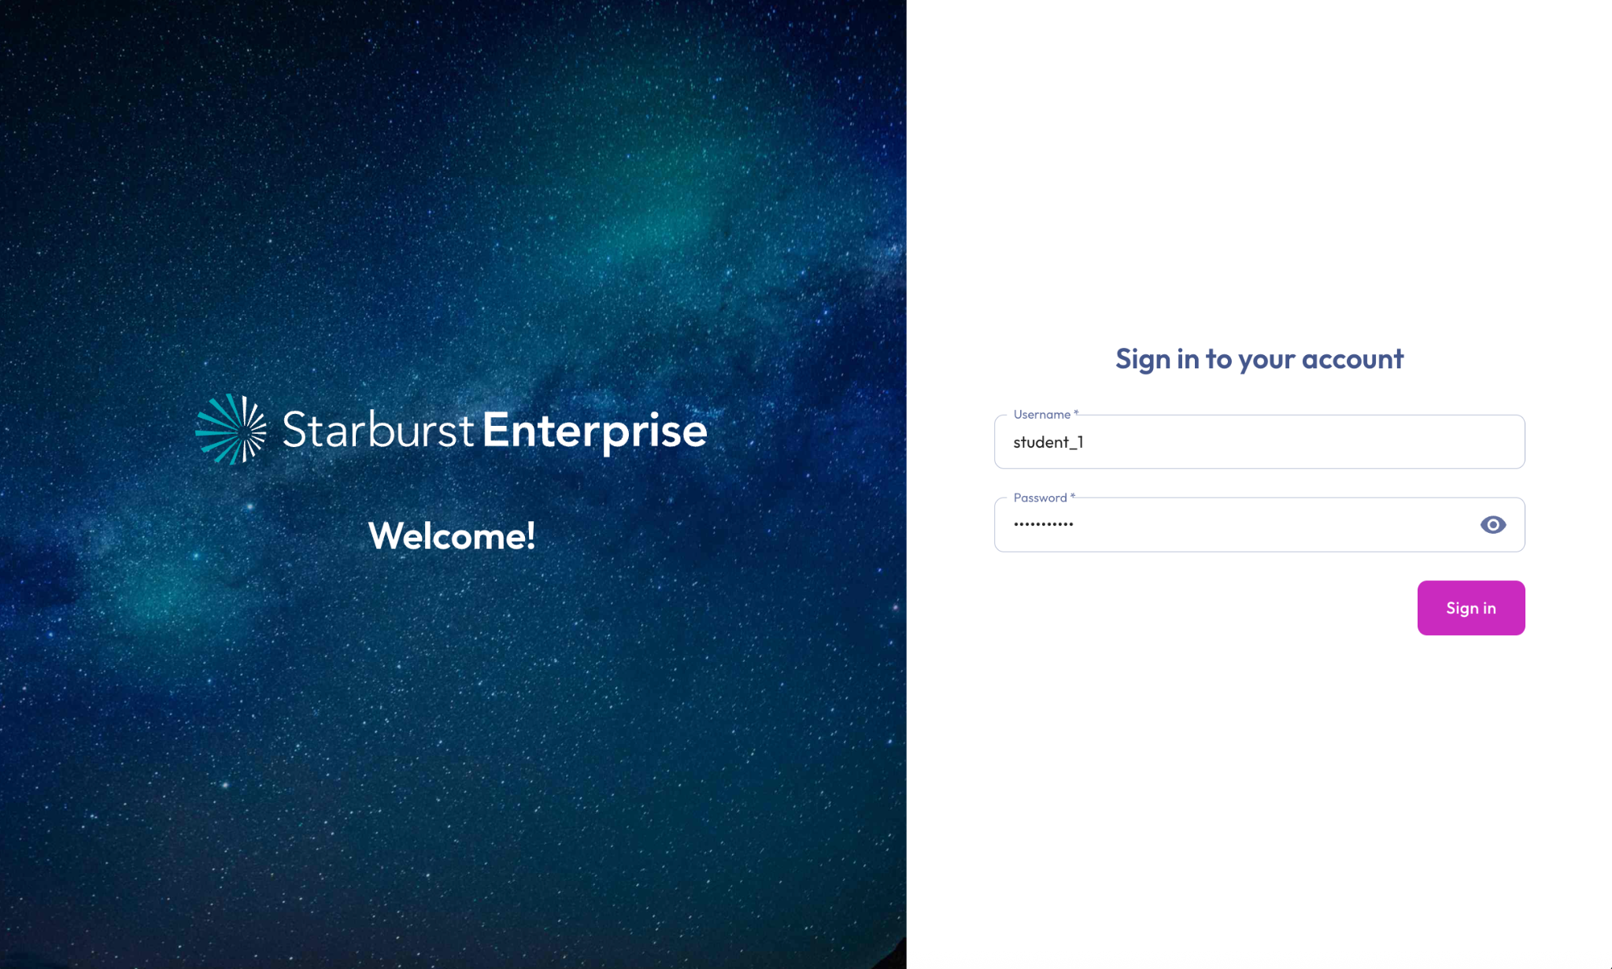

Step 2 - Confirm role
Starburst Enterprise users have an assigned role. For this training, your role should be set as students.

You can view your active role at the top-right of the screen. The first time you log in, this will likely be set to the default public role.



- Changing your role is a simple process. First, click the current role to bring up the dropdown menu.

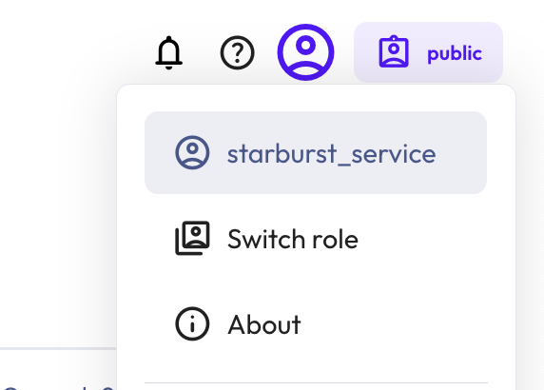

- Click Switch role, and choose students from the options list. Toggle Remember select role to ensure you are using the students role for the remainder of the labs.

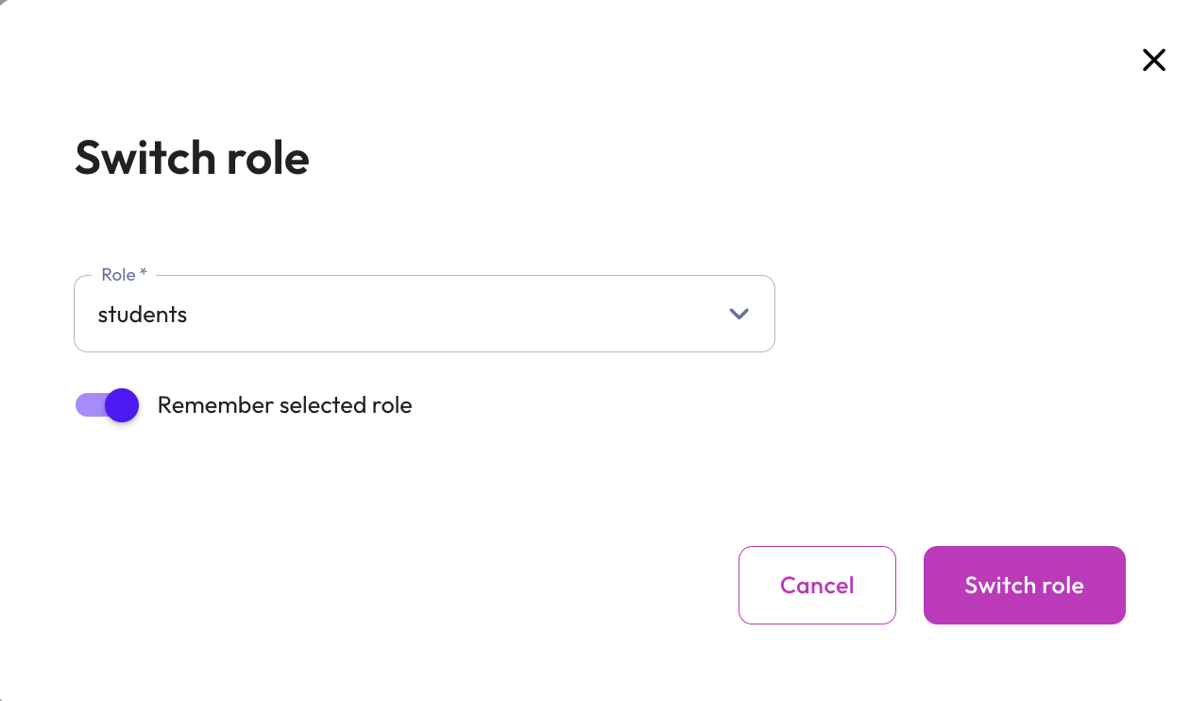

END OF LAB EXERCISE

Starburst features

Lab 1: Execute queries in Starburst Enterprise
Estimated completion time
- 40 minutes

Learning objectives
- This lab is designed to outline the basic query operations used in Starburst Enterprise. By the end of it, you will be able to navigate the UI and perform basic query operations like selecting, filtering, ordering, and grouping. Additional UI features are also introduced.

Activities
- Sign in and verify role
- Review the cluster explorer hierarchy
- Review Entity Relationship Diagram (ERD)
- Execute SELECT query
- Execute DESCRIBE query
- Run SELECT COUNT (*) and SELECT * queries
- Downloading results
- Selecting specific columns
- Filtering results by country or region
- Ordering your query
- Using the AS keyword
- Grouping
- Additional UI features

Step 1 - Sign in and verify role
- Sign in and verify that the students role is selected in the upper-right corner of the screen.

Step 2 - Review the cluster explorer hierarchy
Because Starburst uses federated querying, you identify objects by specifying the catalog, schema, and table (or view) in your SQL statements. This fully-qualified naming convention tells Starburst which data source to query. You can explore the catalogs, schemas, tables, and views available to you using the Cluster Explorer in the Starburst web UI.
- Use the left-hand menu to navigate to Query > Query editor and then expand tpch from the list of catalogs in the Cluster explorer.
- Now, expand the sf1 schema to see the tables contained within:

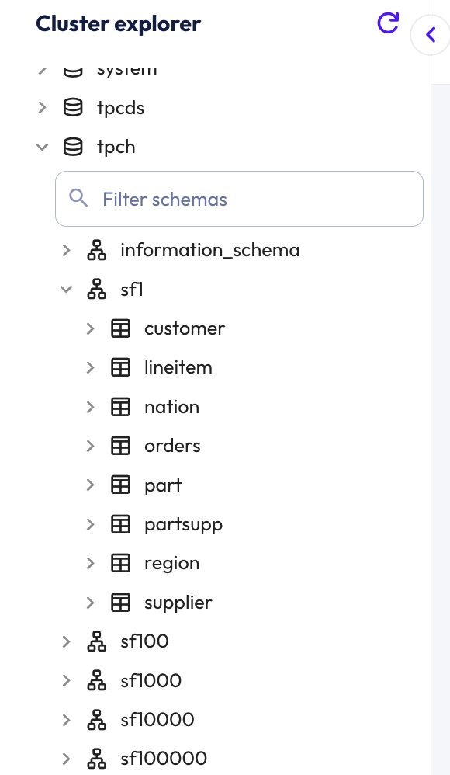

Step 3 - Review Entity Relationship Diagram (ERD)
The tpch catalog is an instance of the TCPH connector. As the documentation identifies, this is a deterministic data generator that has no actual backing datastore. The tables and their relationships are documented in the TPC-H Benchmark specification.

The Entity Relationship Diagram (ERD) presented below is from the benchmark specification. It describes the logical relationships between the tables. Review it and consider the relationships expressed.

Note: Starburst web UI does NOT have a mechanism to generate an ERD like the following and it is only being presented to aid in understanding of this schema.
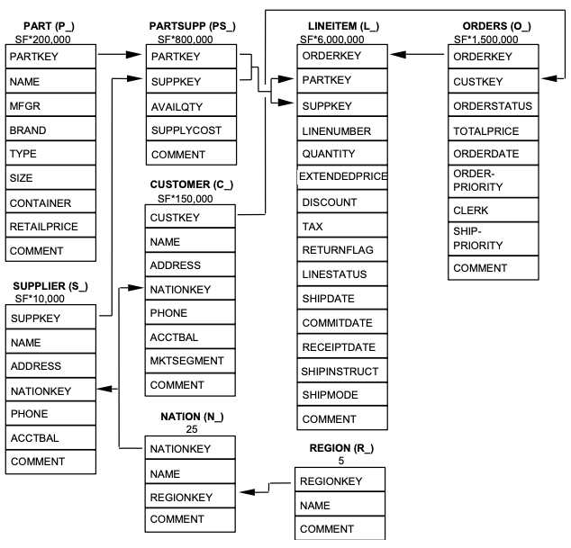

Step 4 - Execute SELECT query
For the remainder of this lab, you’ll execute queries on the astronauts and missions tables, which are located in the hive.demo schema.

Use the Cluster explorer to perform the following actions:
- Expand the hive catalog.
- Expand the demo schema.
- Hover over the missions table.
- Click the pop-up vertical ellipsis menu when it appears.
- Click the option showing the SELECT statement pictured below.

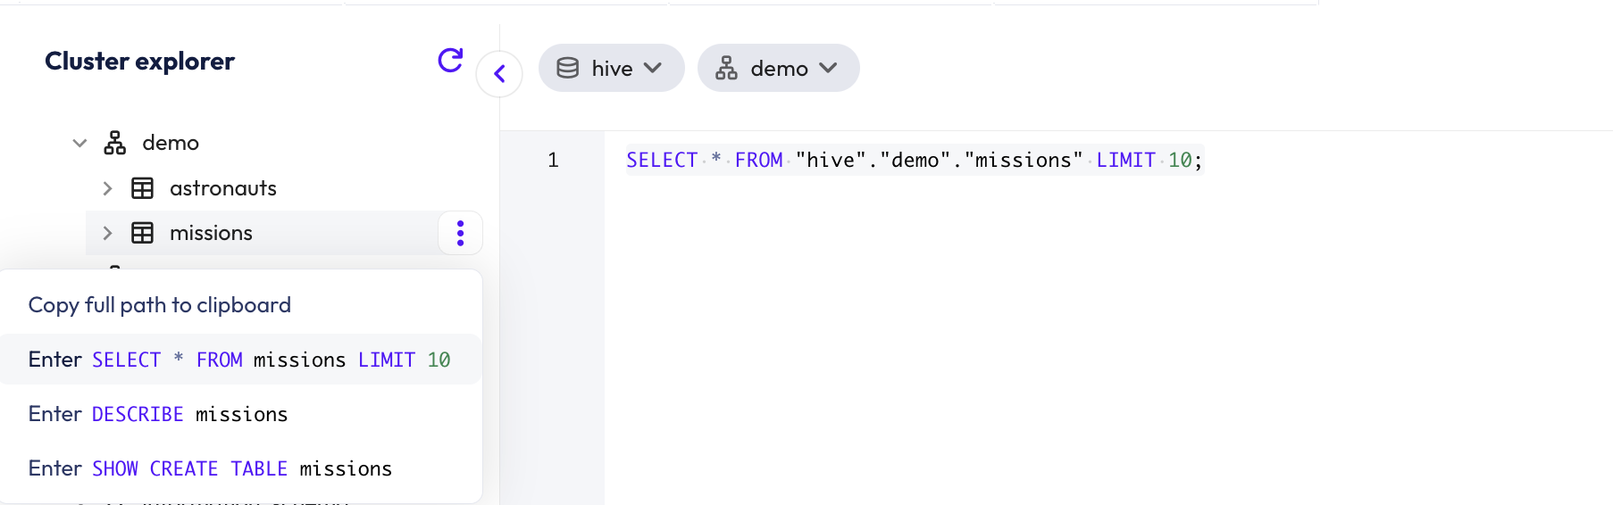

The query should now be copied into the query editor.
You are now ready to execute the query by selecting the Run selected button. The results will be displayed below the editor as pictured below.

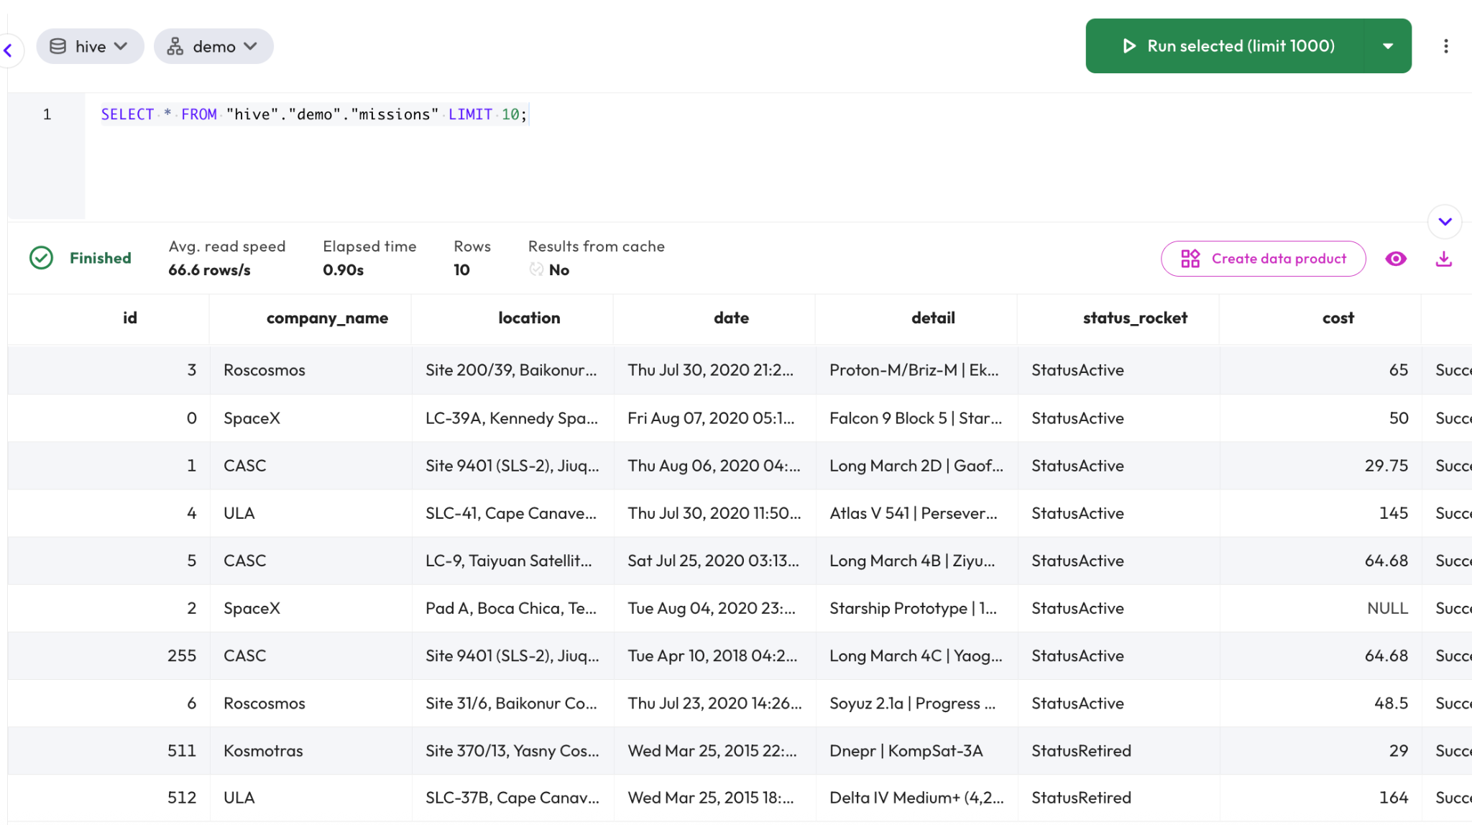

Step 5 - Execute DESCRIBE query
Next, execute the DESCRIBE query using the same pop-up vertical ellipsis menu used in the last query. Compare the results with what you see when expanding the missions table in the catalog/schema/table list.

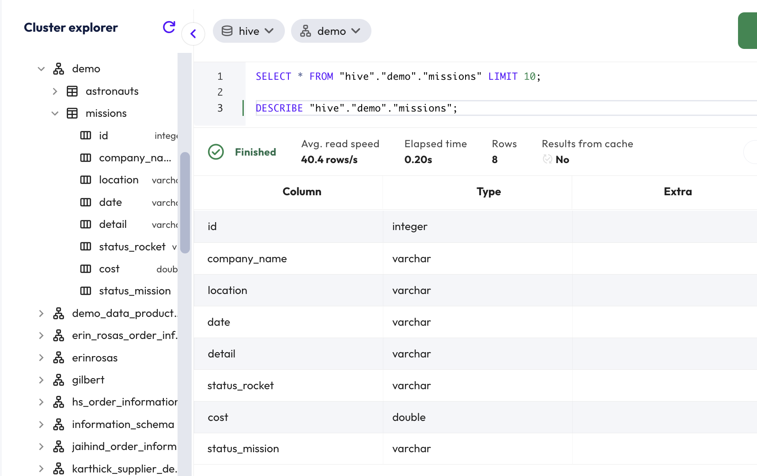

Step 6 - Run SELECT COUNT (*) and SELECT * queries
In the query editor, run a query on the astronauts table to verify there are 1279 rows present.

SELECT COUNT(*)
FROM hive.demo.astronauts;

Then run a query to see the results.

SELECT *
FROM hive.demo.astronauts;

Did you get all the rows?

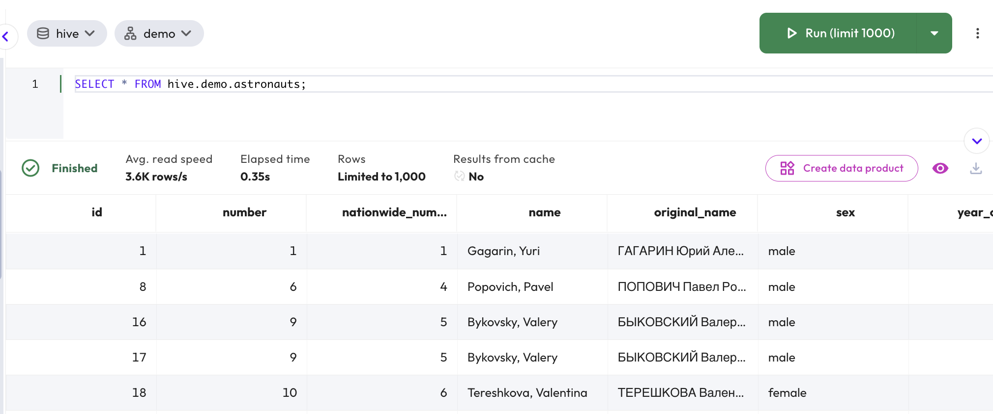

Step 7 - Downloading results
The web UI limited the results to the first 1000 rows. If you want to display more rows, it’s best to download the results in a file. Review the available Run Options and then download a file with all the rows. Were you able to get all of the rows?

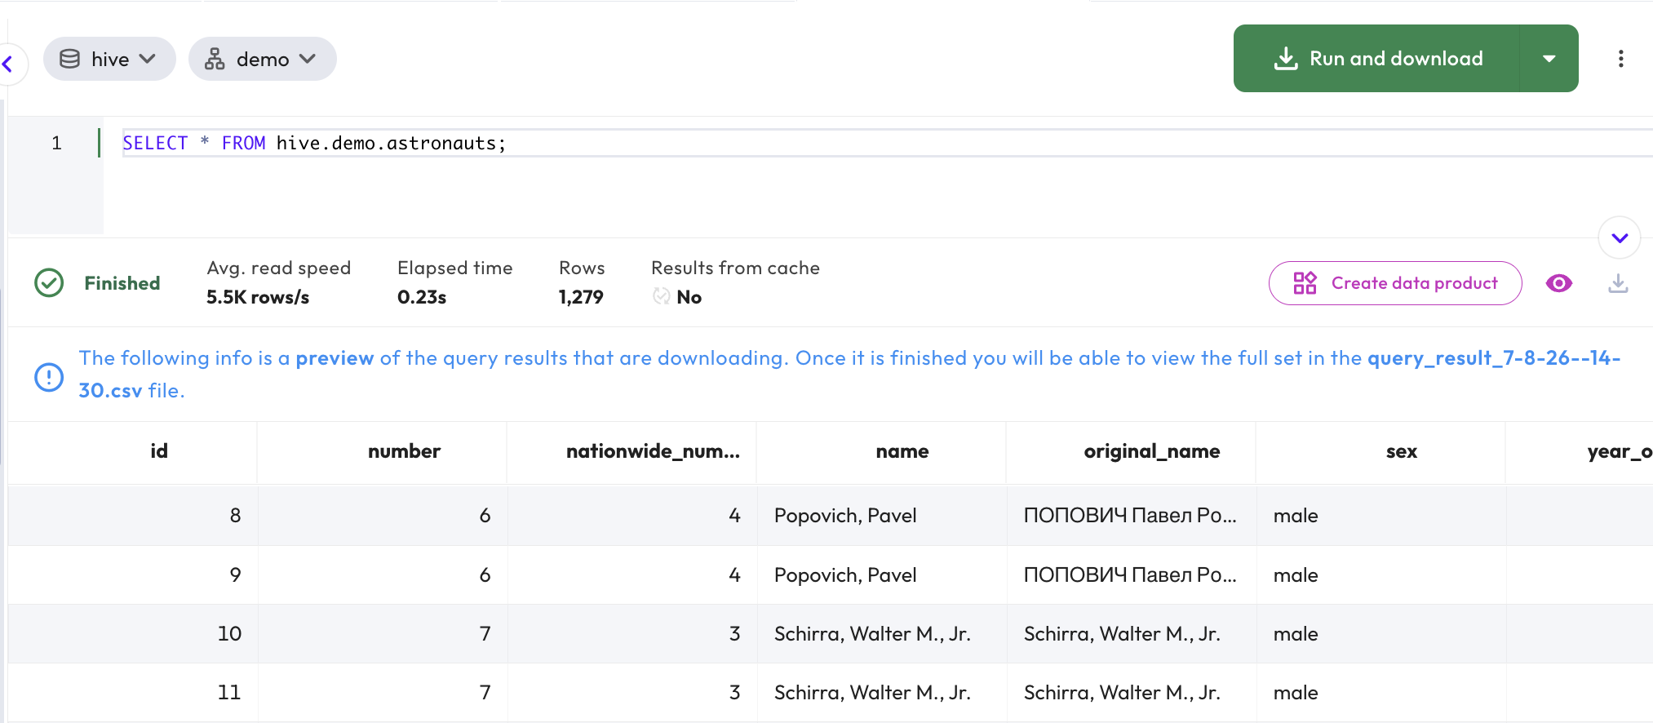

Did you have an extra row? Why do you think that might be there?

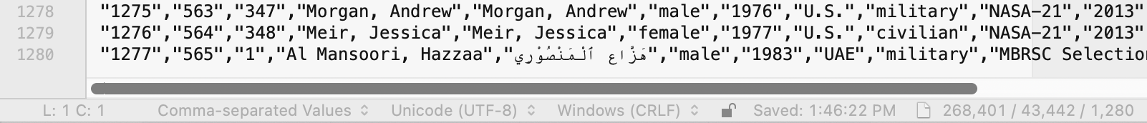

The extra row is due to the downloaded file containing a header row.

Note: Generally speaking, the Query editor is designed for query results that can be limited. The Run and download option is convenient, but it only supports CSV files. If you want to save in another format and/or you are creating a new dataset for further processing, there are better options. Inserting the results into a new or existing table will give you lots of flexibility in this situation.

Back in the Query editor, explore the columns of hive.demo.astronauts along with some of the data in the results pane.

DESCRIBE hive.demo.astronauts;

Step 8 - Selecting specific columns
Select just a few specific columns to help review the data better.

SELECT name, nationality, mission_title, mission_number, hours_mission
FROM hive.demo.astronauts;

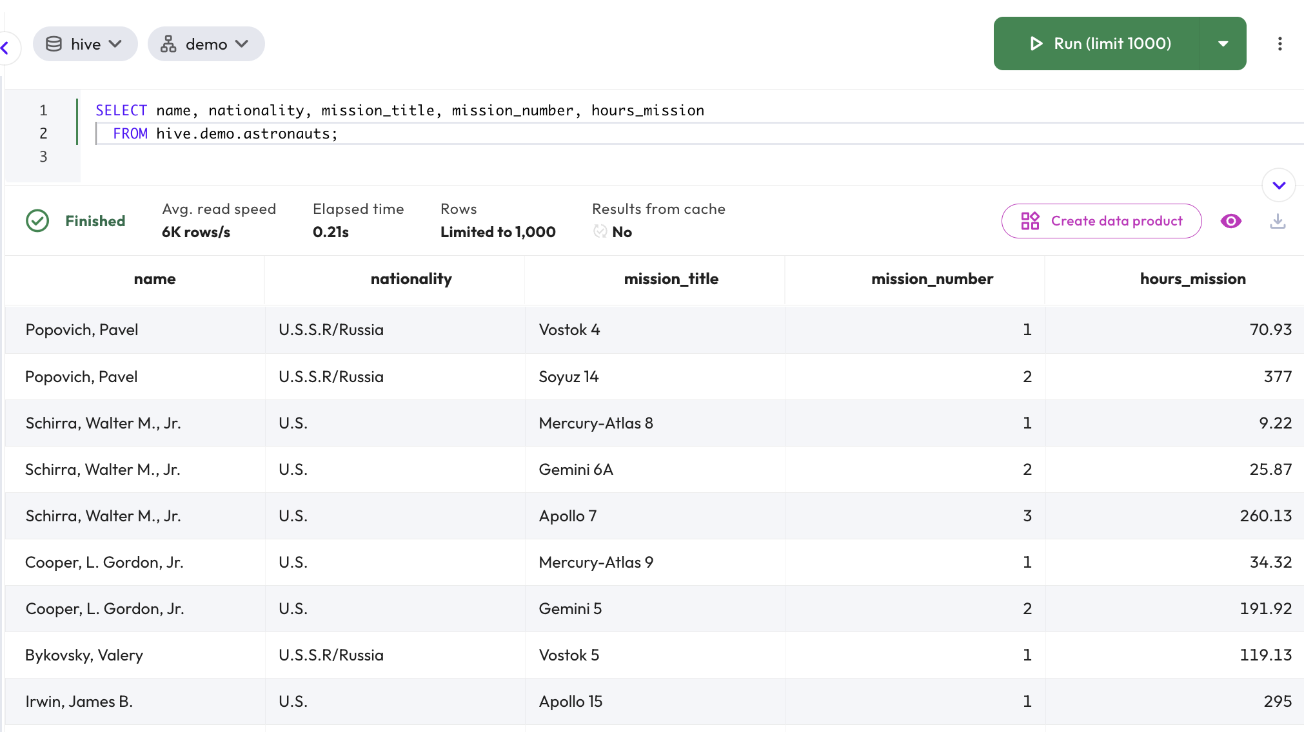

As you can see in the previous results, there are multiple records for the same name instead of a single row for each astronaut. For example, Pavel Popovich is included in the first and second rows.

Each record represents details about unique trips to space by the astronauts (for example, the number of hours the astronaut was on a specific mission). A possible more descriptive table name could have been astronaut_missions.

Step 9 - Filtering results by country or region
As you scroll through your results, you will notice that astronauts come from many different countries. It would be good to see results listed by country of origin or even to exclude one country from a list. For instance, we might want to see all of the non-U.S. results outlined specifically.

To do this, apply the following filter to your query referencing the nationality column.

SELECT name, nationality, mission_title, mission_number, hours_mission
FROM hive.demo.astronauts
WHERE nationality != 'U.S.';

This query eliminates records with a nationality listed as “U.S.”. It will filter out only records from the United States.

Now imagine that you wanted to eliminate records that included any nationality that included the letters “U.S.” in the title. This would include the United States, but it would also include the former U.S.S.R. because its name also includes the letters “U.S.” in the title.

To do this, we can introduce the wildcard character “%,” which broadens the filter to include any results with the specified characters in the nationality field. Replace your previous code with the code below and check the results.

SELECT name, nationality, mission_title, mission_number, hours_mission
FROM hive.demo.astronauts
WHERE nationality NOT LIKE 'U.S.%';

Records from the “U.S.” and “U.S.S.R.” have both been filtered out of the result.

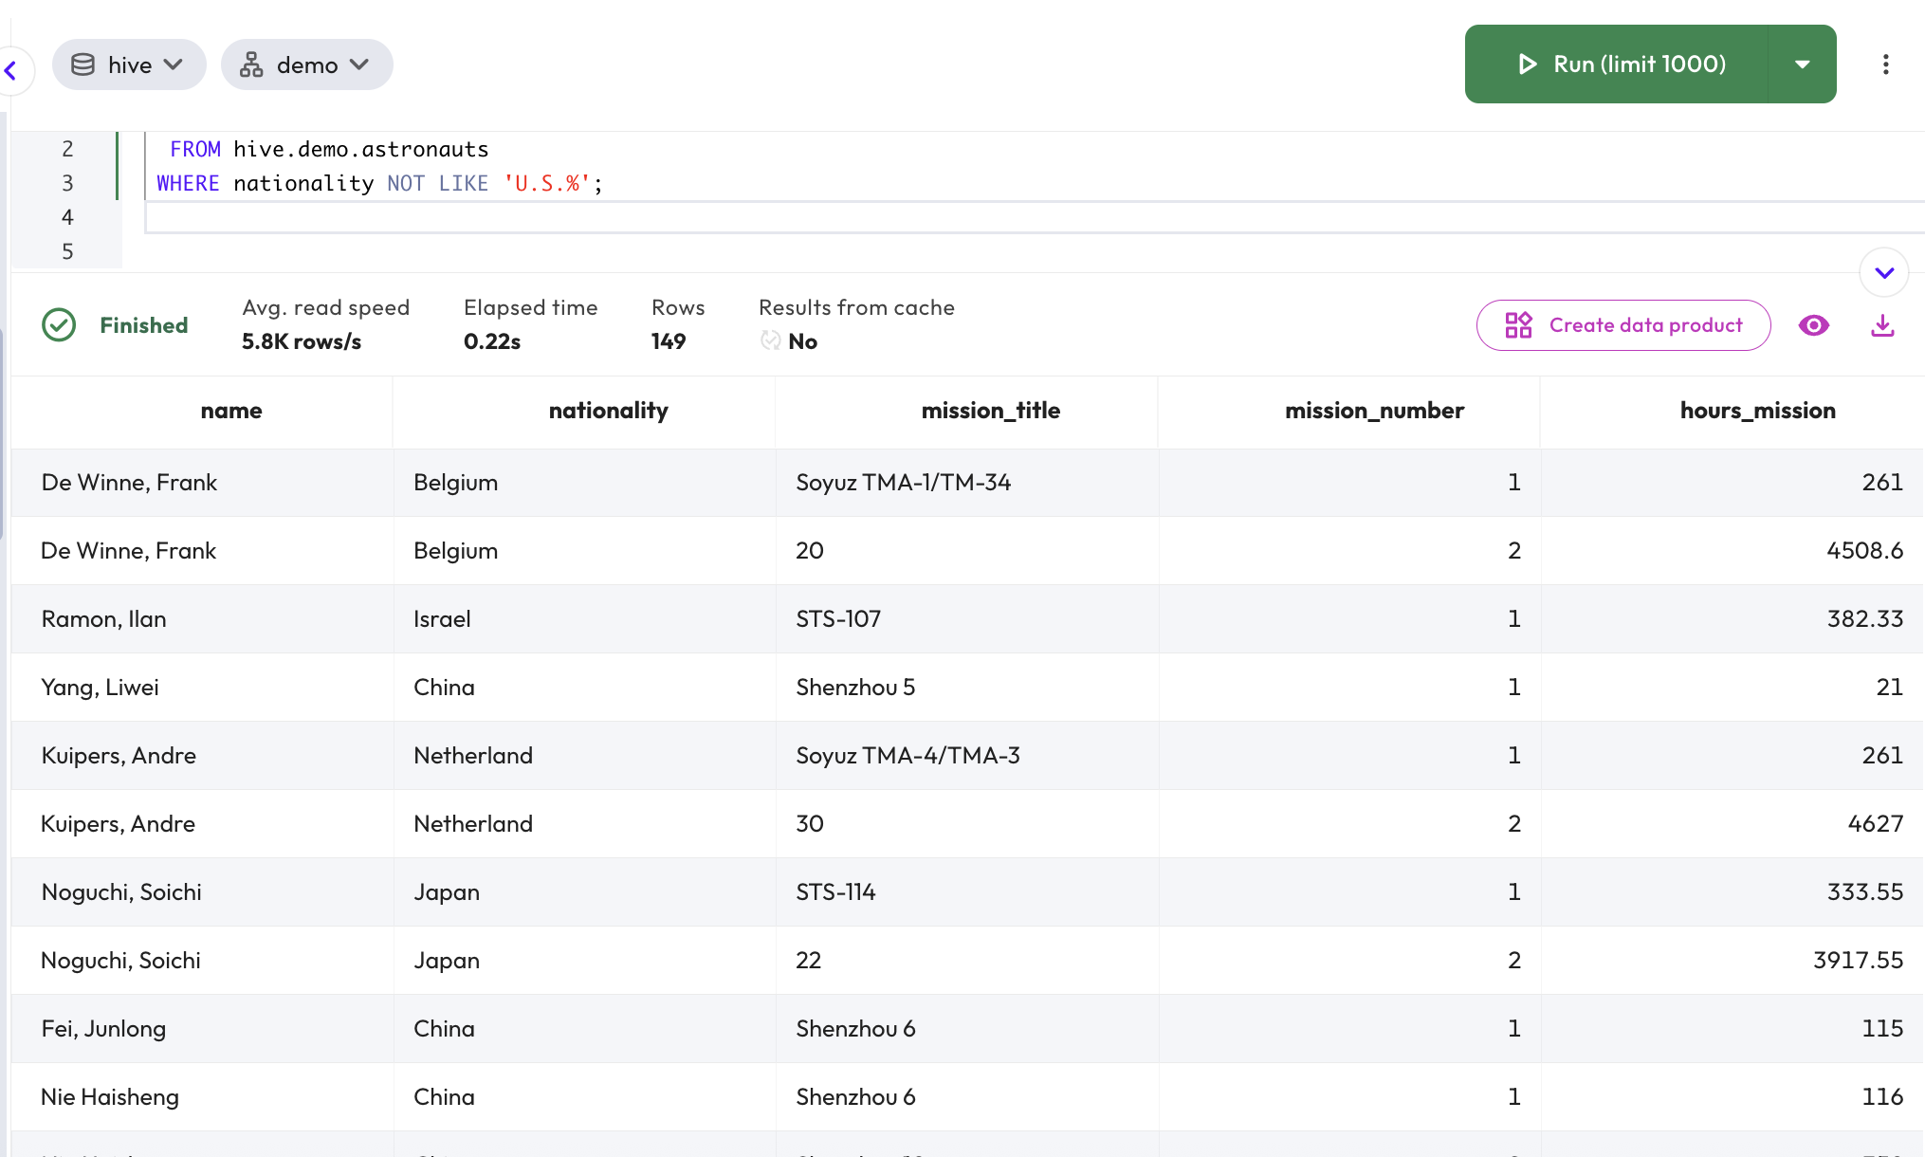

Step 10 - Ordering your query
To aid in your review, you can add an ORDER BY clause to your SQL statement to order the remaining records by nationality. Further refinement of the ordering can be accomplished by including a second column name in your ORDER BY clause.

SELECT name, nationality, mission_title, mission_number, hours_mission
FROM hive.demo.astronauts
WHERE nationality NOT LIKE 'U.S.%'
ORDER BY nationality, name;

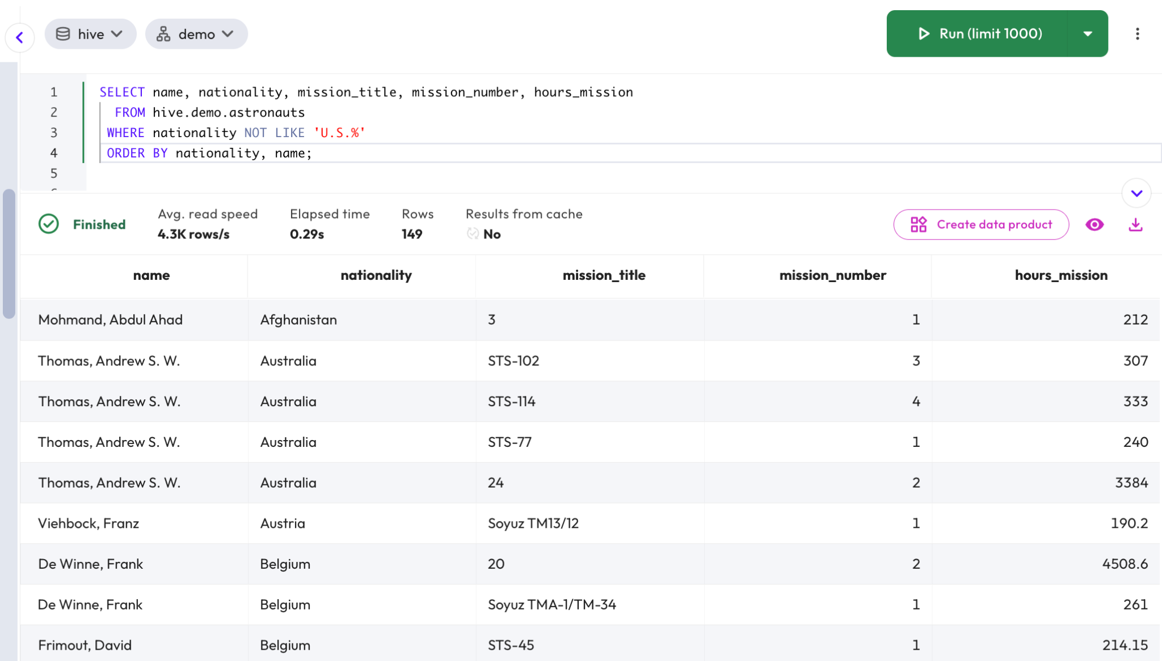

Until this point, your queries have returned individual rows. You will now use an aggregate function to summarize your results into a single value. Review the results from your previous query. Run the following SQL statement to calculate the number of rows contained in the astronauts table and return the maximum and minimum values within the hours_mission column. The results should indicate there are 149 rows in this table.

SELECT COUNT(), MAX(hours_mission), MIN(hours_mission)
FROM hive.demo.astronauts
WHERE nationality NOT LIKE 'U.S.%';

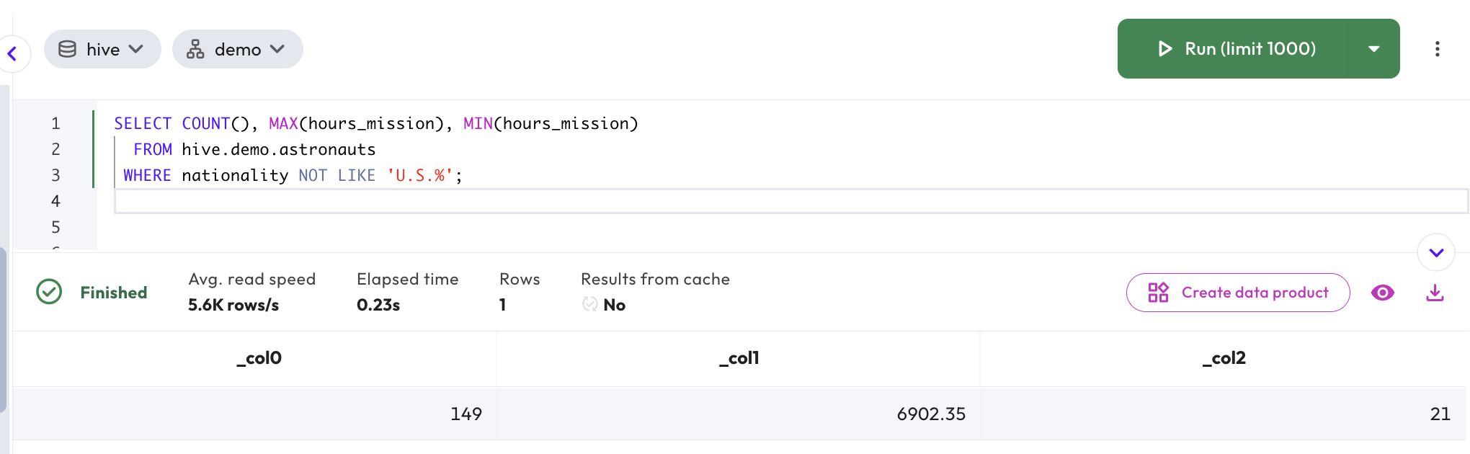

Step 11 - Using the AS keyword
You’ve aggregated your results, but the column names still do not provide enough information to understand what the values represent. You will improve the clarity of your query results by introducing column aliases using the AS keyword.

SELECT COUNT(*) AS number_trips,
MAX(hours_mission) AS longest_time,
MIN(hours_mission) AS shortest_time
FROM hive.demo.astronauts
WHERE nationality NOT LIKE 'U.S.%';

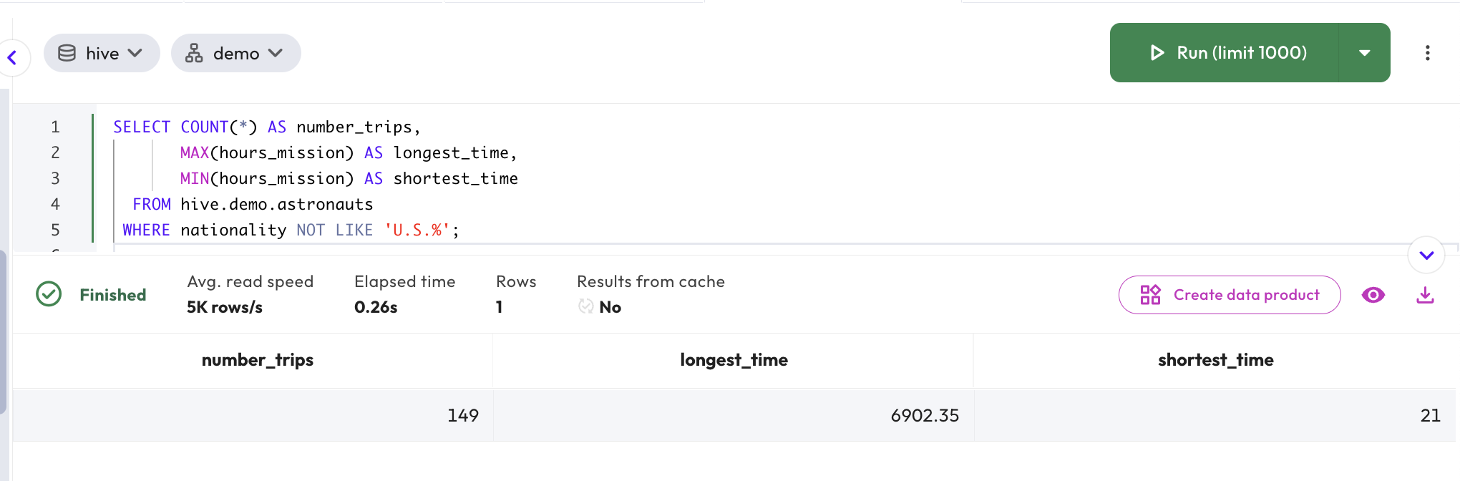

The Starburst web UI has a feature called “Prettify”. You can access Prettify by highlighting your query and right-clicking. This will open a pop-up options menu.

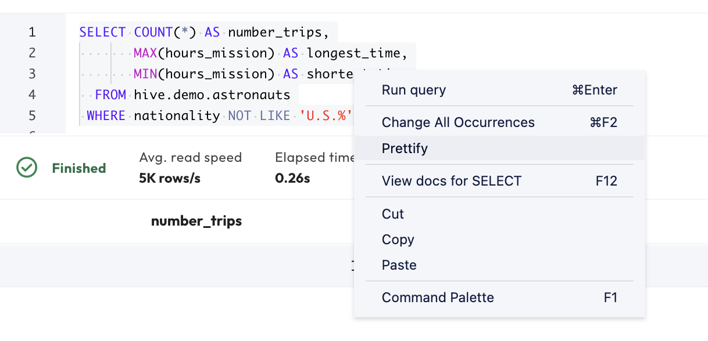

You can also use Prettify by clicking on the editor pane vertical ellipsis menu near the upper-right corner of the UI.

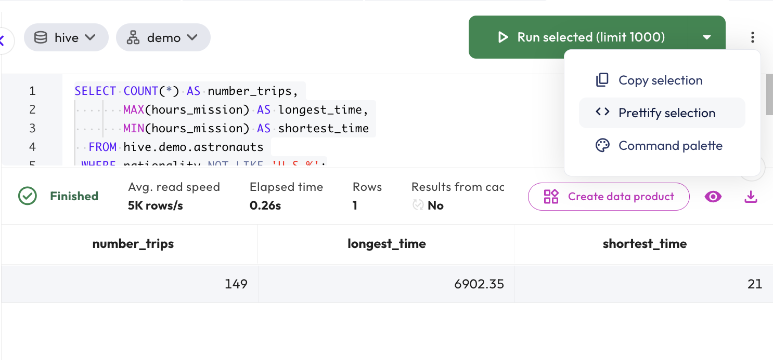

Regardless of which way you exercise this feature, your query should now look similar to this.

SELECT
COUNT() AS number_trips,
MAX(hours_mission) AS longest_time,
MIN(hours_mission) AS shortest_time
FROM
hive.demo.astronauts
WHERE
nationality NOT LIKE 'U.S.%';

Step 12 - Grouping
Aggregate functions are also useful in conjunction with a GROUP BY clause. Update your query to present the records by nationality. Once you’ve successfully returned the records organized by nationality, add sorting options to help you analyze the results. Your query may appear as follows. The changes from the prior presented query are highlighted below.

SELECT
Nationality, COUNT() AS number_trips,
MAX(hours_mission) AS longest_time,
MIN(hours_mission) AS shortest_time
FROM
hive.demo.astronauts
WHERE
nationality NOT LIKE 'U.S.%'
GROUP BY
nationality
ORDER BY
number_trips DESC,
longest_time DESC;

In the results you received, verify the following.
- Japan had the most number of trips with 20.
- There are ~ 20 nations that tied with a single trip each.

Step 13 - Additional UI features
The web UI has additional features to help in creating, executing, and organizing SQL statements. Click the name of the active tab above (it should be a timestamp unless previously edited) and change it to SQL Review.

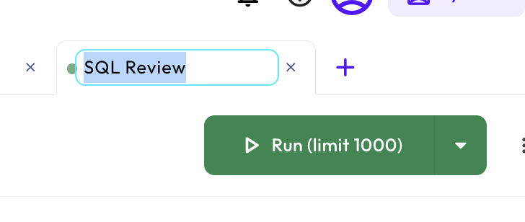

Navigate to Query > Saved queries to verify SQL Review is present under My saved queries.

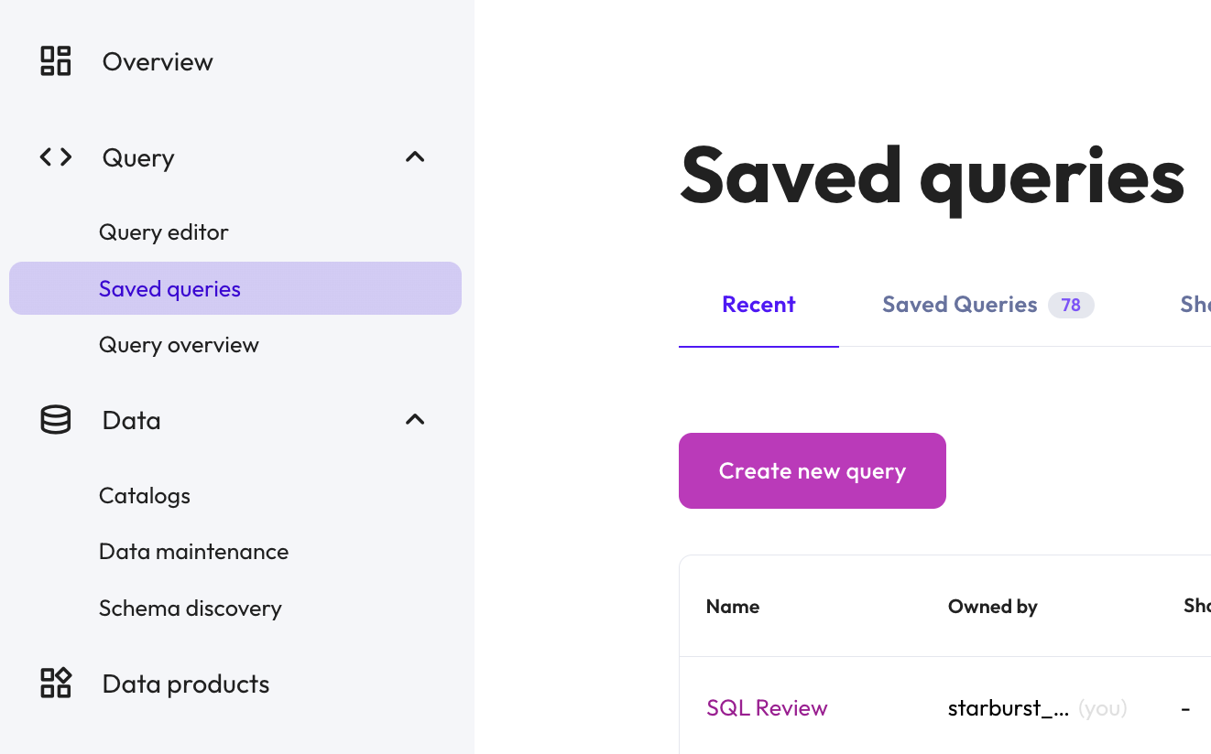

END OF LAB EXERCISE

Lab 2: Exploring federated queries
Estimated completion time
- 15 minutes

Learning objectives
- This lab will take the querying skills used in previous labs and apply them to federated queries. Emphasis will be on showcasing how federation works, what it allows you to do, and how to incorporate it into your workflows.

Activities
- Sign in and verify cluster
- Query bootcamp catalog and tpch_sf1 schema
- View query details
- Query orders table using projection
- Query customer table
- Execute federated query joining two tables
- Federate across three tables

Step 1 - Sign in and verify role
- Sign in and verify that the students role is selected in the upper-right corner of the screen.

Step 2 - Query bootcamp catalog and tpch_sf1 schema
- Navigate to Query > Query editor.
- Open a new tab and rename it as Federation.

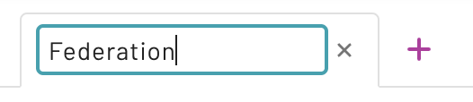

Now, expand the bootcamp catalog. Expand the tpch_sf1 schema. Locate the orders table. Run a query to see ten rows using the command.

SELECT * FROM bootcamp.tpch_sf1.orders LIMIT 10;

The results will look similar to the image below.

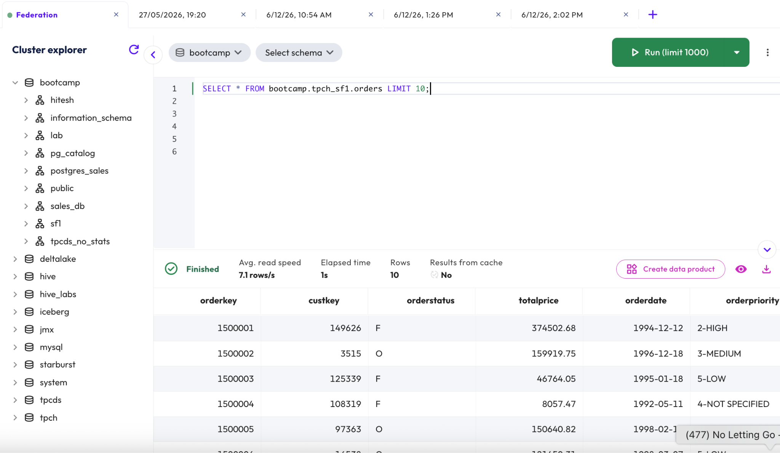

Sometimes the origin of data is unclear. Where do you think this data came from? The tpch_sf1 schema name suggests that this is a copy of the tpch.sf1.orders table.

Note: The bootcamp catalog is connected to a PostgreSQL database.

Step 3 - View query details
Now it’s time to view the query details. To do this, click the View icon on the results status bar as indicated in the image below.



Query details are displayed on the following page with the General tab selected. This will include your last executed SQL statement in the Query text section.

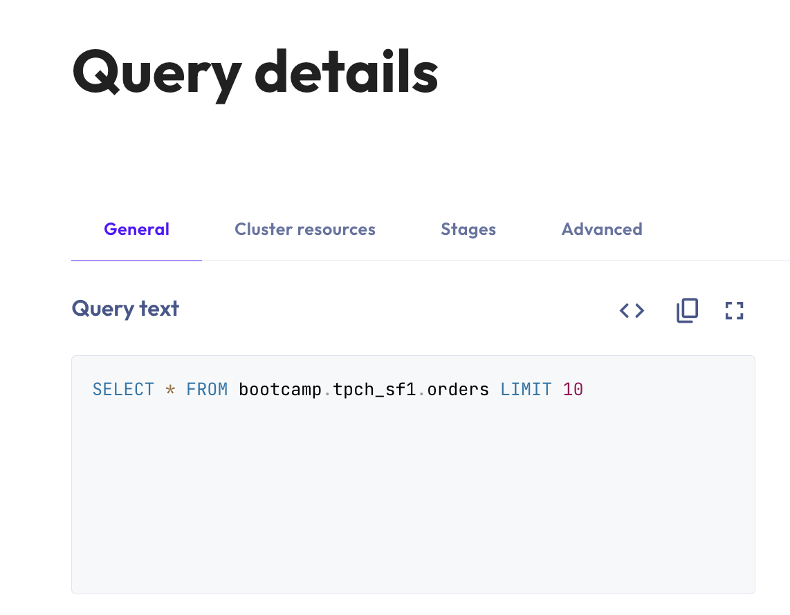

Click the Advanced tab to view more details. Review the Tables section to verify that bootcamp.tpch_sf1.orders was read for this query.

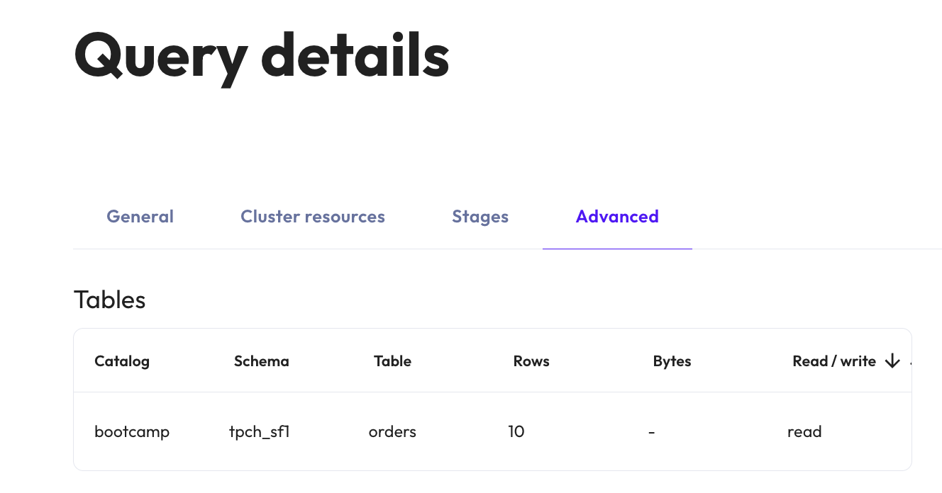

When you have finished viewing query details, click on your browser’s back button to return to precisely where you were in the Query editor.

Step 4 - Query the orders table using projection
Let’s query the orders table again, this time assuming we only need to return specific columns.

You can use projection to narrow down your results. This allows you to select specific columns from a table. Insert the code below into the Query editor.

SELECT
orderkey,
custkey,
totalprice
FROM
bootcamp.tpch_sf1.orders
WHERE
orderkey < 100;

Step 5 - Query customer table
Next, it’s time to look up the related customer table which is located in the tpch catalog.

SELECT
custkey,
nationkey
FROM
tpch.sf1.customer;

Verify from the View icon > Advanced > Tables that only the tpch.sf1.customer table was accessed.

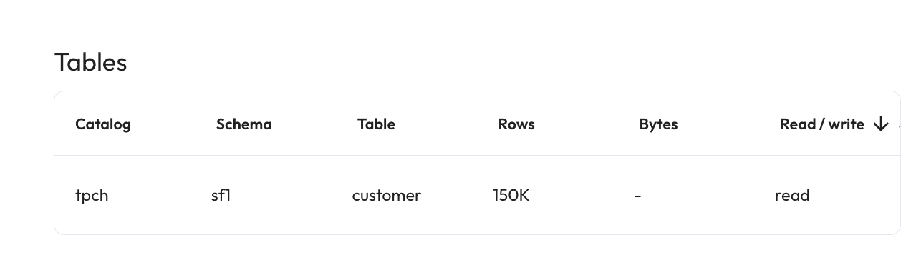

Step 6 - Execute federated query joining two tables
Now it’s time to write a query that’s capable of looking across two tables from different catalogs. This is known as a federated query.

Begin by locating the nation table in the iceberg catalog’s tpch schema.

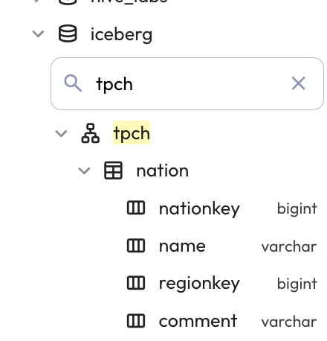

Now, run a federated query that joins the tpch.sf1.customer and iceberg.tpch.nation tables to provide the full name of the country that is associated with each customer.

SELECT
c.custkey,
c.nationkey,
n.name
FROM
tpch.sf1.customer c
JOIN iceberg.tpch.nation n ON c.nationkey = n.nationkey
ORDER BY
c.custkey;

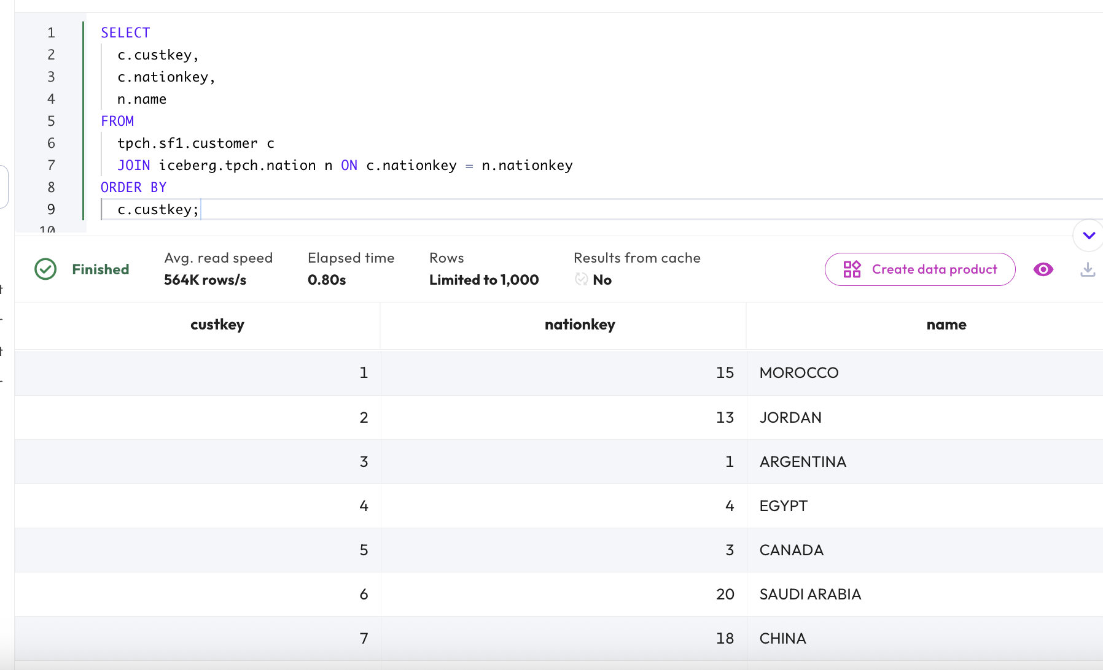

Verify in your Query details that this query is federating content from two different catalogs which use different underlying data sources.

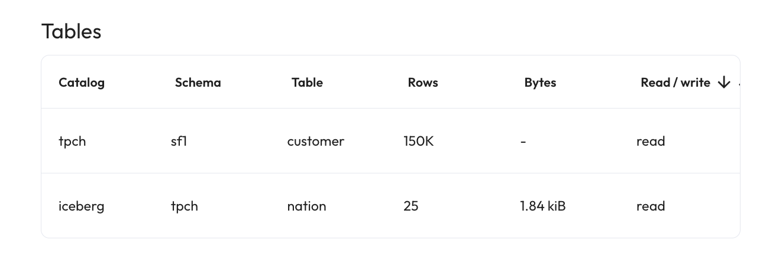

Step 7 - Federate across three tables
Enhance your query by joining a third table, bootcamp.tpch_sf1.orders. Group the results by nation to find out which nations have the most customers.

SELECT
n.name,
count() AS nbr_custs
FROM
bootcamp.tpch_sf1.orders o
JOIN tpch.sf1.customer c ON o.custkey = c.custkey
JOIN iceberg.tpch.nation n ON c.nationkey = n.nationkey
GROUP BY
n.name
ORDER BY
nbr_custs DESC;

Verify from Query details that this query is federating content from three different catalogs which are using different underlying data source connectors.

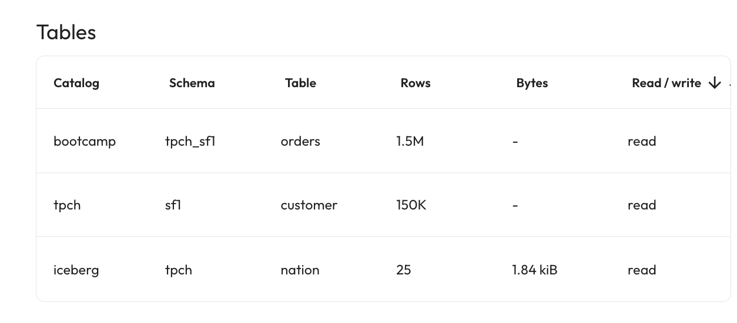

END OF LAB EXERCISE

Data lake tables

Lab 1: Create a schema and tables
Estimated completion time
- 20 minutes

Learning objectives
- This lab will show you how to perform basic database operations with Starburst Enterprise using Hive. This includes the creation of schemas and tables, using a number of different methods. The lab also introduces the concept of Inserts, record updates, and external tables.

Activities
- Sign in and verify cluster
- Create a schema
- Create a table using CREATE TABLE AS
- Verify match between data using the EXCEPT command
- Generate Data Definition Language (DDL)
- Connect catalog
- CTAS region table from tpch.sf1.region
- Create friends table
- Verify file format using SHOW CREATE TABLE
- Add a record to the table using INSERT INTO
- Update a record
- Join friends and nation tables
- Using external tables in Hive

Step 1 - Sign in and verify role
- Sign in and verify the students role is selected in the upper-right corner of the screen.
- Navigate to Query > Query editor.

Step 2 - Create a schema
In the editor pane, create a new schema with the following command. Make sure that you replace yourname with your actual name, or another identifier that you prefer. Only use lowercase characters and numbers; no special characters or spaces.

CREATE SCHEMA hive.yourname
WITH (location = 's3://erin-rosas-may2025/training/hive/yourname/');

Confirm that the schema named hive.yourname that you just created is visible. Expand the hive catalog. Confirm that your new schema is empty, as pictured in the image below. There will be other schemas listed.

Note: Remember, if you named your schema as yourname, create the schema again with the prerequisite lab’s instructions.

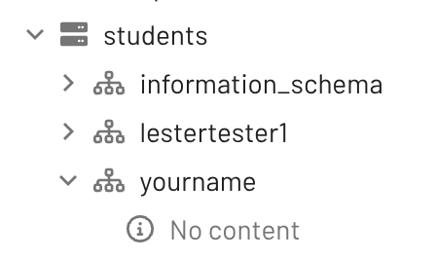

Run the following SQL command to verify your newly created schema is empty. This provides secondary confirmation that there is nothing in it.

SHOW TABLES
FROM
hive.yourname;

Step 3 - Create a table using CREATE TABLE AS
Next, it’s time to create a new table within your student schema following the format and contents of the tpch.sf1.nation table.

To do this, start by running a query against the tpch.sf1.nation table to verify there are 25 rows present. This helps us to ensure that we understand what information is held in the table before we recreate the same information in the student schema.

USE hive.yourname;
SELECT
*
FROM
tpch.sf1.nation;

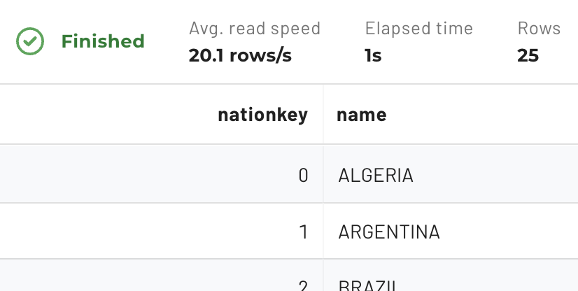

Next, review the CREATE TABLE AS (CTAS) documentation then create a table named nation in your schema that has the same format and content as tpch.sf1.nation.

CREATE TABLE
nation AS
SELECT
*
FROM
tpch.sf1.nation;

Verify in the schema hierarchy that your new table exists and has the correct structure and content. Now use the DESCRIBE command to achieve the same output using SQL.

DESCRIBE nation;

Step 4 - Verify match between data using the EXCEPT command
After running SELECT queries on the original table and your nation table, run the EXCEPT query listed below. It will verify that the two tables contain the same data.

SELECT * FROM nation
EXCEPT
SELECT * FROM tpch.sf1.nation;

Step 5 - Generate Data Definition Language (DDL)
When you create a table, you need to define the data structure that will be employed. This is known as the Data Definition Language (DDL). Starburst helps you automate this process.

In the left-hand navigation bar, click the vertical ellipses menu under the hive.yourname.nation table to generate the Data Definition Language (DDL) for that table.

Select the SHOW CREATE TABLE option shown in the image below.

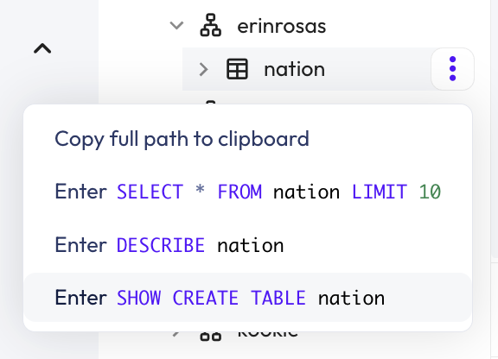

The system generates the following output which has two focus areas.

Output

CREATE TABLE hive.yourname.nation (
nationkey bigint,
name varchar(25),
regionkey bigint,
comment varchar(152)
)
WITH (
format = 'ORC',
)

The first focus area, noted blue, defines the logical representation of the table. It provides information about the schema which will be applied to the table and is similar to the approach used to construct a table in other database systems.

The second focus area, noted in red, defines one other crucial aspect of schema-on-read solutions, specifically:
- The file format being used, in this case, ORC.

Step 6 - Locate the data
Notice that you did not define a specific folder location in the CREATE TABLE statement in the last step. Although a specific location can be defined if needed, it can also be left undefined. When left to the default, it is based on where the schema itself is rooted in the data lake hierarchy.

Note: You do not have access to view the full configuration of catalogs in the UI, nor to view S3 via the AWS management console. Screenshots are presented to aid in your understanding of where the data for the nation table is located.

When you created your schema in Step 2, the following S3 URI was provided:

s3://erin-rosas-may2025/training/hive/yourname/

This means your table’s base directory is training/hive/yourname/nation. If you had access to AWS S3, you would see this directory tree (with your name instead of erinrosas).

The folder contains data files. In this case, you only have a single file because the table only has 25 rows.

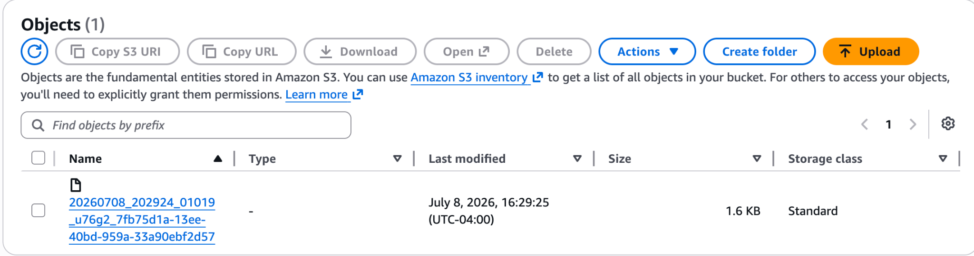

As you can see below, the contents of this ORC file are not in a humanly readable format and cannot be read using a text editor.

Note: The ORC tools jar is a straightforward way to visualize the data within. File format options will be discussed further in the next lesson.

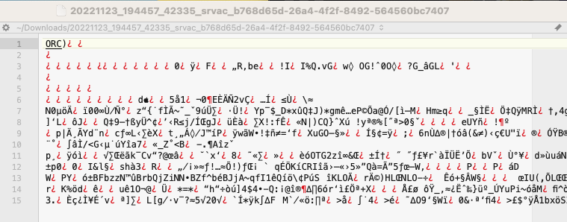

Step 7 - CTAS region table from tpch.sf1.region
Now it’s time to use a similar process to copy the data from the tpch.sf1.region table into a new region table in your schema. Write another CTAS command using the code below.

CREATE TABLE
region AS
SELECT
*
FROM
tpch.sf1.region;

Now join the two tables to determine the number of nations in each region.

SELECT r.name, COUNT() AS nbr_nations
FROM nation n
JOIN region r ON (n.regionkey = r.regionkey)
GROUP BY r.name
ORDER BY nbr_nations DESC;

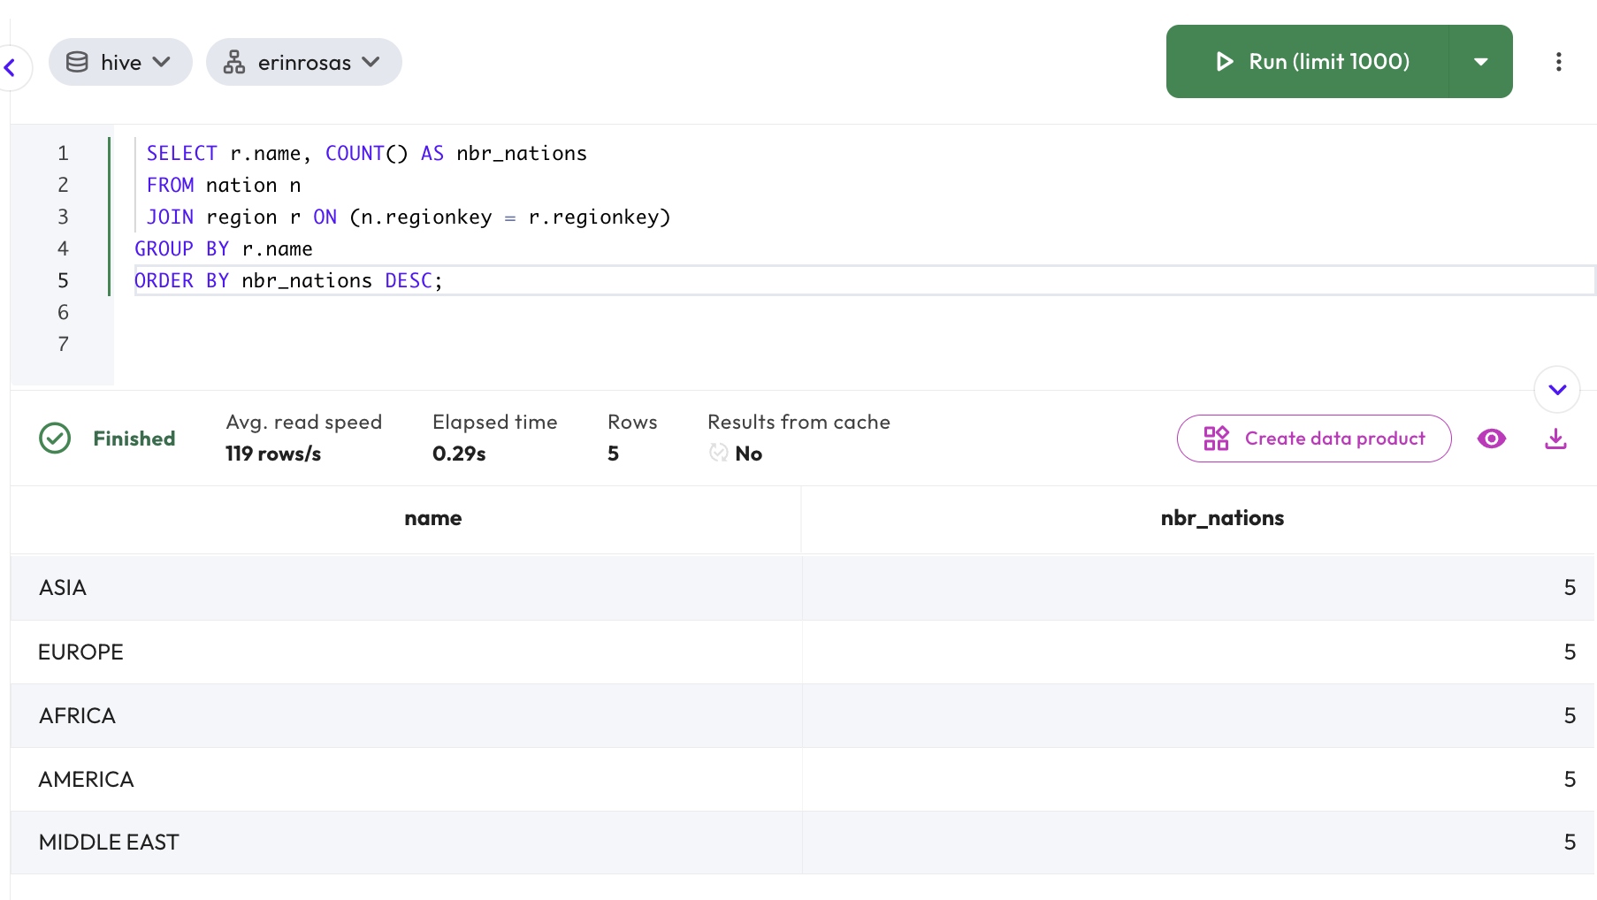

Step 8 - Create friends table
Next, it’s time to create a new table that will contain information about your friends. Use the code below.

CREATE TABLE friends (
name varchar(100),
year_met smallint,
fav_color varchar(50),
nation_born bigint
);

Notice that you did not define the WITH section. The location of the file system will default to s3://erin-rosas-may2025/training/hive/yourname/friends. The folder is created even before the table is populated with data, because you defined the location when you created your schema.

Step 9 - Verify file format using SHOW CREATE TABLE
If the file format is not identified, the table will use the catalog’s default file format. Verify that the file format is ORC by running a SHOW CREATE TABLE statement.

SHOW CREATE TABLE friends;

Your output should look like the following.

Output

CREATE TABLE hive.yourname.friends (
name varchar(100),
year_met smallint,
fav_color varchar(50),
nation_born bigint
)
WITH (
format = 'ORC'
)

Step 10 - Add a record to the table using INSERT INTO
Now that the table is created, you can add records individually to it using the INSERT INTO command.

Add a record to this table using the following data.

INSERT INTO
friends (name, year_met, fav_color, nation_born)
VALUES
('Fred', 2002, 'brown', 13);

When you add a record, it’s considered best practice to check that the record has been successfully added. To do this, run a query to make sure the record was added to the table as intended. You should have all of the information you need to run this, but if you get stuck, review the previous steps or ask the instructor for help.

As before, you do not have access to view the S3 UI directly. These screenshots will help you understand what is present. The S3 object store now contains a single file for this record. It should look similar to the image below.

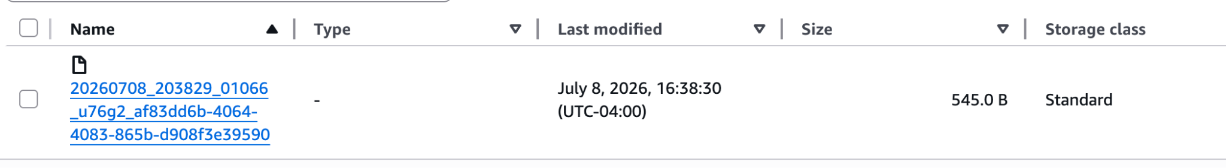

Now that you’ve added one record, try adding three records in the same INSERT INTO command.

INSERT INTO
friends (name, year_met, fav_color, nation_born)
VALUES
('Susie', 2012, 'blue', 9),
('Bertha', 1999, 'pink', 24),
('Franklin', 2019, 'green', 24);

Verify the records have been added by running a query. There should now be four rows in the table.

SELECT * FROM friends;

If you could see the table’s S3 folder you would notice there are two files now similar to the following example.

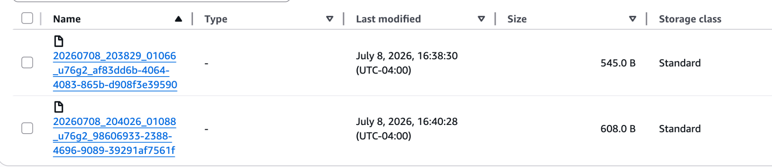

One of the files was created with the original INSERT statement and the other from the second INSERT. The three recently inserted records are all located in the second file. In the next lab, you will explore these files in more detail using the Hive special columns feature.

Run the original INSERT statement again.

INSERT INTO
friends (name, year_met, fav_color, nation_born)
VALUES
('Fred', 2002, 'brown', 13);

Do you see the same record twice?

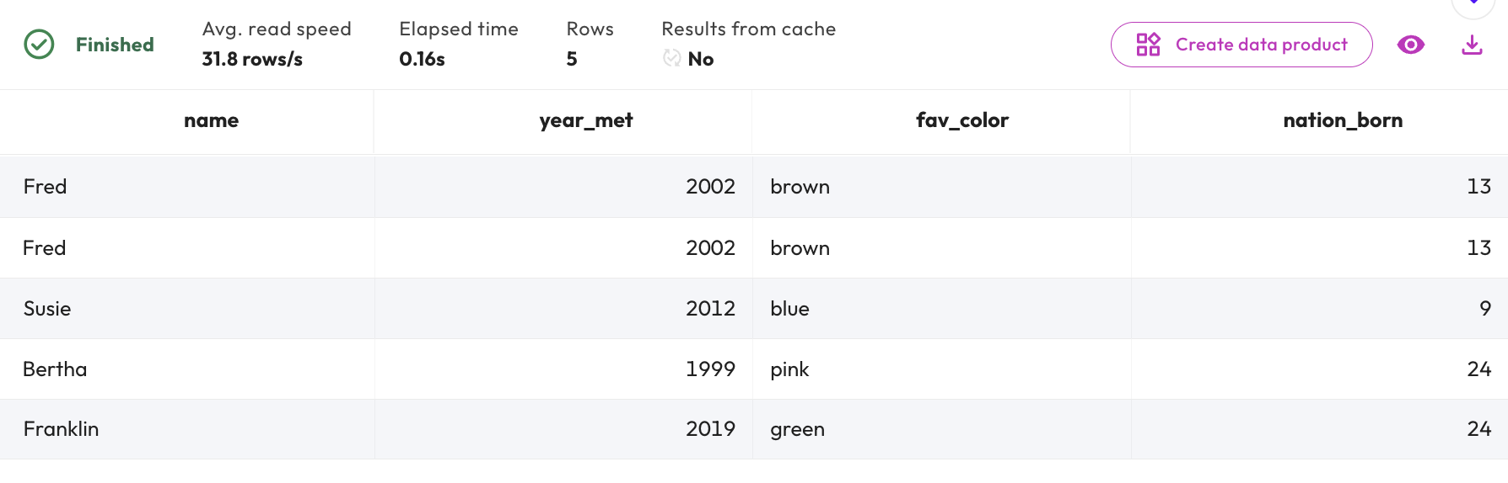

The image above shows that one of your records has been duplicated. This happened because you did not declare a primary key (PK). It highlights a key point: when working with big data schema-on-read tables such as this, you will not have the chance to create (or validate) a primary key. Instead, data integrity activities like this are managed by the process that populates the table. This will be covered in greater detail in the data pipelines lesson.

Step 11 - Update a record
Often, it is necessary to update a record. Try to update one of the records you already created using the code below.

UPDATE friends
SET fav_color = 'purple'
WHERE name = 'Susie';

This raised the following error message.

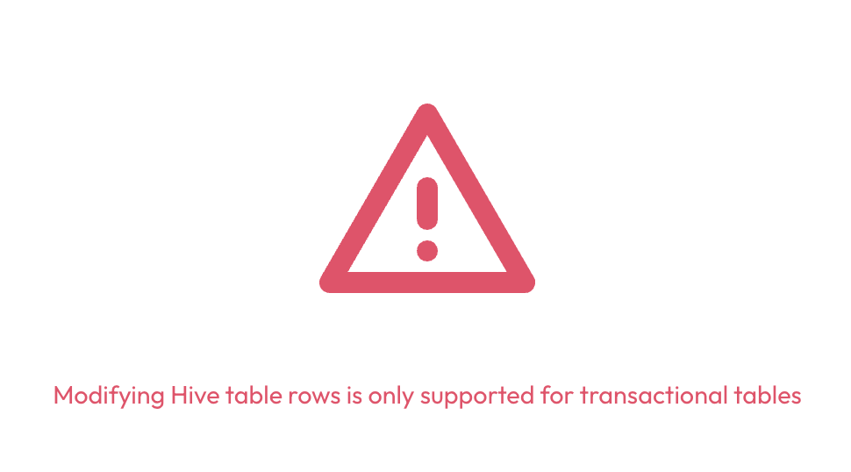

The error message identifies the problem. Do you think there will be a problem with trying a DELETE on this same row? Try it and see.

DELETE FROM friends
WHERE name = 'Susie';

This next error message reads as follows.

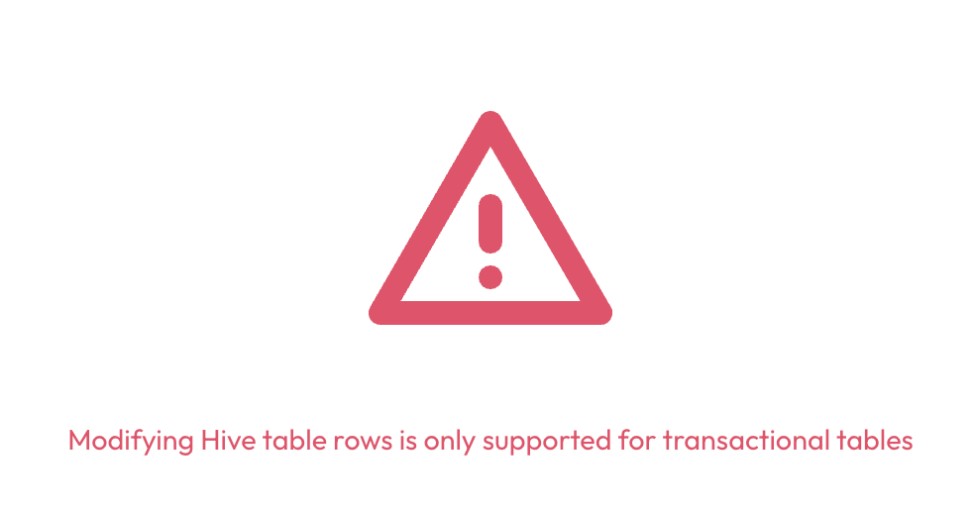

Hive tables are generally insert-only in nature. As mentioned previously, alternate “table formats” which allow full INSERT, UPDATE, and DELETE features, as well as usage of the MERGE command, are covered in a future lesson.

Additional efforts must be employed with Hive tables to recreate the underlying files from which the table gets queried.

Step 12 - Join friends and nation tables
Join the friends table with the nation table you created earlier to determine how many of your friends were born in each nation.

SELECT n.name, COUNT() AS nbr_friends
FROM friends f
JOIN nation n ON (f.nation_born = n.nationkey)
GROUP BY n.name
ORDER BY nbr_friends DESC;

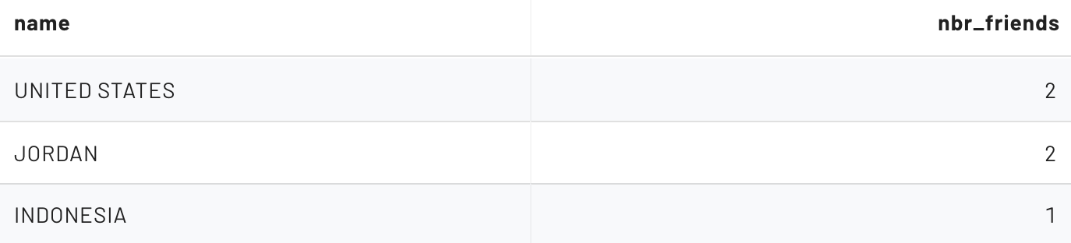

Adjust your query to join your friends on another schema’s (from the students catalog) nation table, such as students.ANOTHERNAME.nation.

Note: If you cannot find a nation table from anyone else’s schema, you can always use the tcph.tiny schema.

With traditional RDBMS software, you can enforce the relationship between these two tables with a foreign key (FK). As with PK constraints, Hive tables do not offer this type of integrity check. This allows you to add a record with a value that is not in the nation table, as illustrated in the following statement.

INSERT INTO
friends (name, year_met, fav_color, nation_born)
VALUES
('John', 2021, 'khaki', 999);

Verify that this is the only record that does not have a matching nation table entry.

SELECT *
FROM friends
WHERE nation_born NOT IN (
SELECT nationkey FROM nation
);

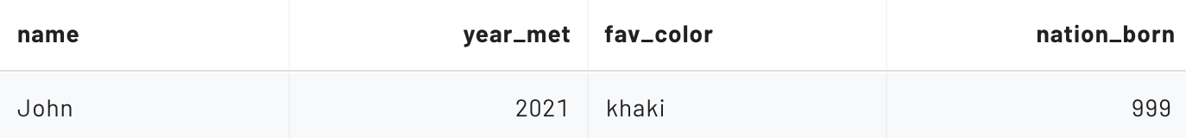

Similar to the PK, the burden of ensuring a logical FK constraint is not introduced into the data to be queried is the responsibility of the data pipeline process.

Step 13 - Using external tables in Hive
Up to this point, you have been creating Hive tables that are sometimes called managed tables. Generally speaking, you let the system identify where the underlying location will be, as the earlier example explained. While each table is configured to a specific directory and has a known file type, you do not typically place files on the filesystem directly. The Trino engine does the heavy lifting for us as a result of a command such as INSERT.

Additionally, when a DROP TABLE command is issued on a managed table, the underlying data is deleted along with the table’s metadata.

External tables are the other primary type of Hive tables. External tables are often located in an alternate data lake location than where Trino would typically store them. You can identify these tables by the presence of the external_location property in the DDL. Review and execute the query below.

CREATE TABLE
external_logs (
event_time TIMESTAMP,
ip_address VARCHAR (15),
app_name VARCHAR (25),
process_id SMALLINT,
log_type VARCHAR (15),
log_level VARCHAR (15),
message_id VARCHAR (15),
message_details VARCHAR (555)
)
WITH
(
external_location = 's3://erin-rosas-may2025/serverlogs/logs_5min_ingest_csv/',
format = 'TEXTFILE',
textfile_field_separator = ','
);

Verify the results from a SELECT statement against this new table look appropriate.

SELECT * FROM external_logs LIMIT 10;

External tables are often utilized when another system is creating the files. For example, a frequent scenario is an external table being used for recently ingested files that are being loaded into the data lake. In addition to allowing other systems to populate data into the table, these data lake files are easily consumable from other frameworks and systems.

In the ingestion model, you often see similar-sized files placed in the table’s underlying directory periodically. Starburst does not care what these files are named, but depending on the system saving the files, you may get some heuristic information from the file names. You might be able to decipher the pattern from these example files being used in the table you just created.

Remember, you do not have access to S3 directly and these screenshots are presented to aid in your understanding.

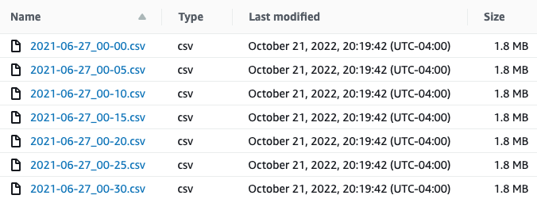

Note: you will see these files again in the next lab as the basis of some of your performance enhancement techniques.

Another huge difference with external tables is related to when the table is dropped. Only the metadata is removed. The actual data is left alone. To validate this, drop the external_logs table you just created. Recreate it and confirm the data is still available.

END OF LAB EXERCISE

Lab 2: Investigate Hive’s special columns
Estimated completion time
- 15 minutes

Learning objectives
- This lab will explore Hive’s use of columns and special columns. The goal is to show the kind of metadata captured in special columns, how you can access that data, and some of the formatting that you can apply to the output from these columns. You will then create a test table to simulate testing in real-world scenarios.

Activities
- Prepare for the exercise
- Understanding special columns in Hive
- Show location of table data
- Return special column values
- Remove duplicate results using DISTINCT command
- Locate results file
- Use common table expression and string functions
- Create table to test hidden columns
- Improve clarity of results
- Add more records

Step 1 - Prepare for the exercise
- Sign in and verify the students role is selected in the upper-right corner.

Note: If you did not previously create a schema, execute the following SQL statement. Make sure that you replace yourname with your actual name, or another identifier that you prefer. Only use lowercase characters and numbers; no special characters or spaces.

CREATE SCHEMA hive.yourname
WITH (location = 's3://erin-rosas-may2025/training/hive/yourname/');

Step 2 - Understanding special columns in Hive
This lab will explore the special columns functionality available for Hive tables.

In addition to defined columns, the Hive connector automatically exposes the metadata for several hidden columns in each table. These include:
- $bucket: Bucket number for this row
- $path: Full file system path name of the file for this row
- $file_modified_time: Date and time of last modification of the file for this row
- $file_size: Size of the file for this row
- $partition: Partition name for this row

This lab will focus on the $path and $file_size hidden columns. Additional hidden columns will be explored in a later exercise.

Step 3 - Show location of table data
- Navigate to the Query editor.
- Run the following command to see the location of the hive.global.nation table’s data.

SHOW CREATE TABLE hive.global.nation;

Unfortunately, the output does not clarify where this data is located.

Output

CREATE TABLE hive.global.nation (
nationkey bigint,
name varchar(25),
regionkey bigint,
comment varchar(152)
)
WITH (
format = 'ORC'
)

Step 4 - Return special column values
There are only 25 rows in this table. Let’s find the values of a few of these special columns.

The following code returns the $path, $file_size, and $file_modified_time values, as pictured in the image below.

SELECT
nationkey,
"$path",
"$file_size",
"$file_modified_time"
FROM
hive.global.nation;

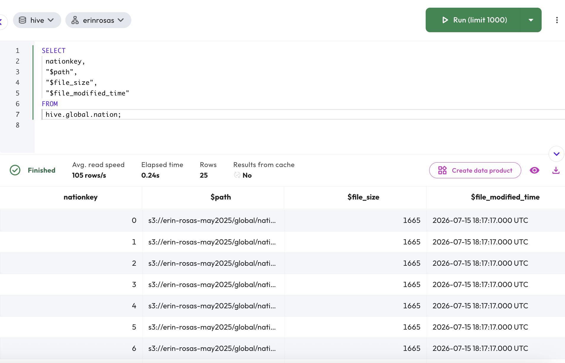

Step 5 - Remove duplicate results using DISTINCT command
The query results pane makes it hard to read the value(s) from the $path hidden column. To fix this, you can remove duplicates and limit the results to show only the column’s value(s) using the DISTINCT command. Try it now and see the difference.

SELECT DISTINCT("$path")
FROM hive.global.nation;

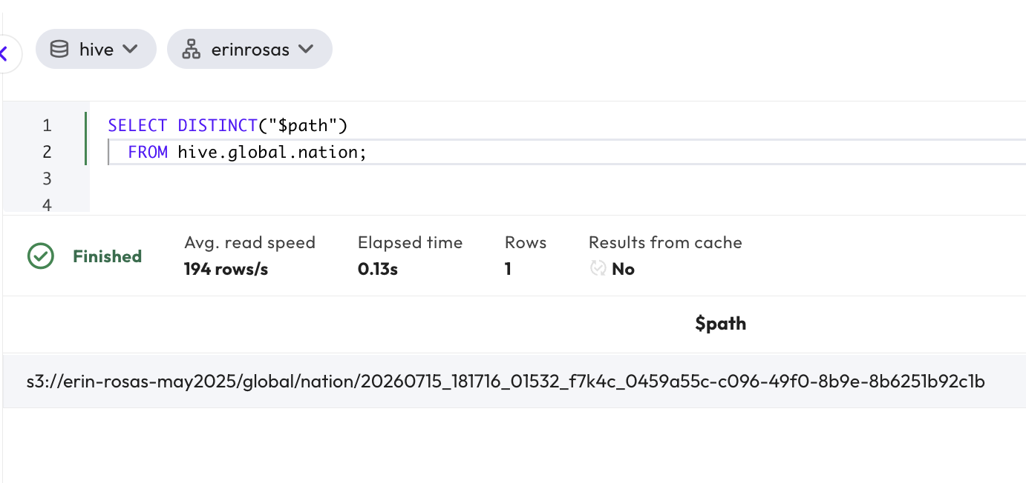

Step 6 - Locate the results file
The results are output to a single file held in an S3 bucket. In this example, the file is located in the s3://erin-rosas-may2025/global/nation/ directory.

The images below are from the instructor’s AWS console showing an example of the location and the files list.

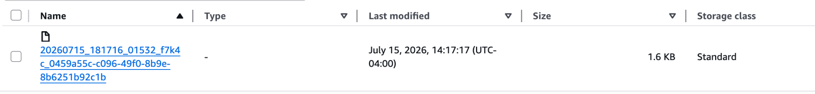

Step 7 - Common table expression and string functions
You can use a common table expression (CTE) and string functions to display the folder location. This makes the path easier to view.

Use the following query to return the path down to the directory that contains the file. The result should resemble the image below.

Note: This SQL is presented as an aid to review the underlying contents on the data lake and there is no need to focus on interpreting it at this time.

WITH
distinct_paths AS (
SELECT DISTINCT
("$path") AS full_path
FROM
hive.global.nation
)
SELECT
REVERSE(
SUBSTRING(
REVERSE(full_path),
POSITION('/' IN REVERSE(full_path))
)
) AS dir_name
FROM
distinct_paths;

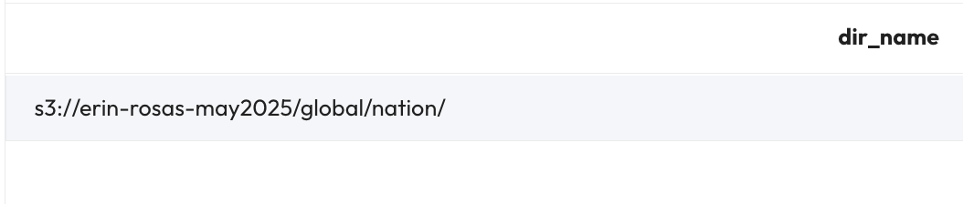

Step 8 - Create table to test hidden columns
Now it’s time to test the hidden columns. To do this, you will need to create a new table using the code below.

USE hive.yourname;

CREATE TABLE hidden_cols_test (
row_nbr int, ins_nbr int
);

Now add one record using the INSERT statement. This will create the first file (holding this single record) in the table’s data lake folder.

INSERT INTO
hidden_cols_test (row_nbr, ins_nbr)
VALUES
(1, 1);

Now it’s time to verify that the single file exists in the hidden_cols_test table using the code below.

SELECT
row_nbr, ins_nbr, "$path"
FROM
hidden_cols_test
ORDER BY
row_nbr, ins_nbr;

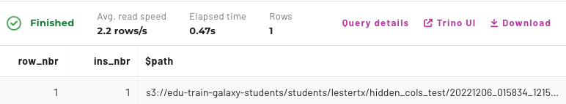

Step 9 - Improve clarity of results
The clarity of the query results displaying this hidden column could still be improved further. Assume that you want to show just the file name. The statement below is an enhancement of the one presented in Step 7 and will display a file name only, without the directory listed.

Note: As before, this SQL is presented as an aid to review the underlying contents on the data lake and there is no need to focus on interpreting it at this time.

--NOTE: Convenience SQL (NO NEED TO REVIEW THIS!!)
WITH
all_rows_file_names AS (
SELECT row_nbr, ins_nbr AS file_nbr,
("$path") AS full_path
FROM hidden_cols_test
)
SELECT
row_nbr, file_nbr,
SPLIT_PART(full_path, '/', 8) AS file_name
FROM all_rows_file_names
ORDER BY row_nbr;

The output above shows us that the first INSERT statement (of a single row) was recorded in a single file.

Step 10 - Add more records
Now it’s time to add results and view the impact on the test tables. Add two more records with a second INSERT statement.

INSERT INTO
hidden_cols_test (row_nbr, ins_nbr)
VALUES
(2, 2),
(3, 2);

Run the Step 9 query again to verify that this second INSERT statement (of two more rows) wrote another file containing both values.

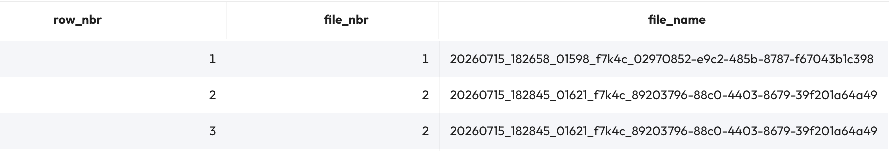

Now add three more records with a third INSERT statement.

INSERT INTO
hidden_cols_test (row_nbr, ins_nbr)
VALUES
(4, 3),
(5, 3),
(6, 3);

Running the Step 9 query one last time verifies this third INSERT statement (of three rows) wrote one final file with all three values.

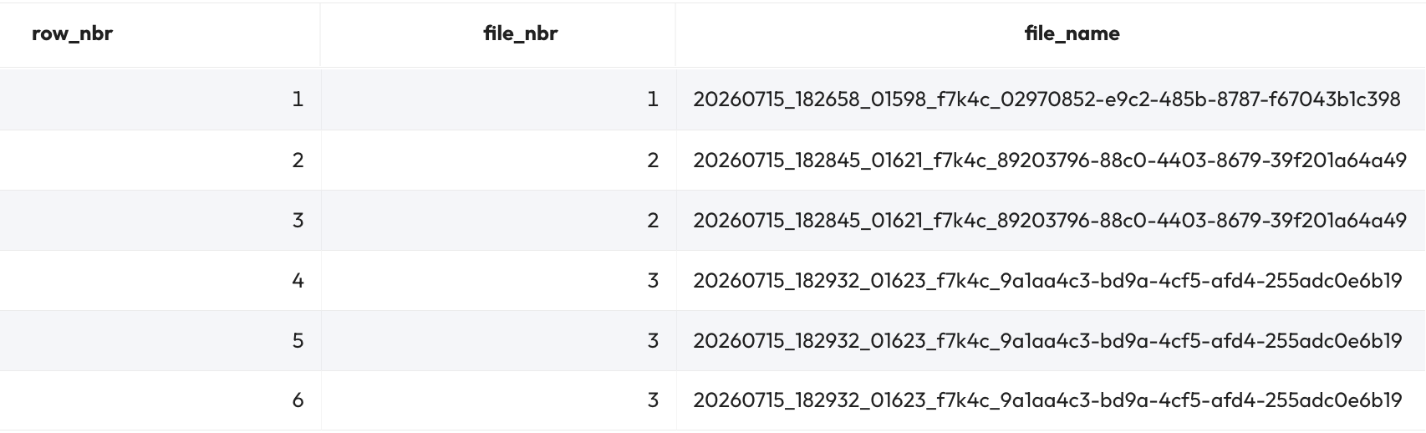

You cannot view S3, but here is a view from the instructor’s AWS console. You can see that the three distinct file names above are exactly how they are stored in S3.

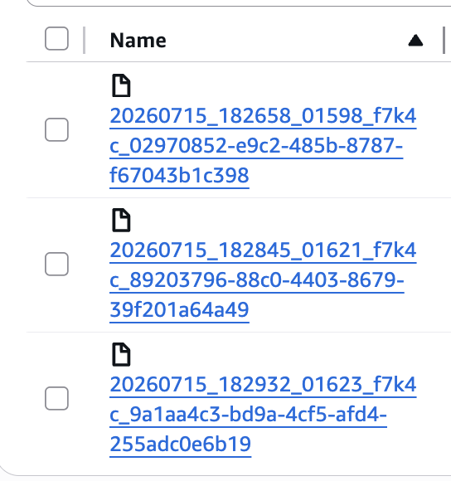

END OF LAB EXERCISE

Apache Iceberg

Lab 1: Create and populate Iceberg tables
Estimated completion time
- 30 minutes

Learning objectives
- In this lab, you will be introduced to the Iceberg table format and its many advantages. You will learn how to create Iceberg tables using Parquet and other file types, and explore how to create tables, add records, download results, and query values using Iceberg. You will also explore how conditional logic can be used to return precise results and how this is important for efficiency.

Activities
- Prepare for the exercise
- Create Iceberg tables using Parquet
- Research Iceberg connector documentation
- Create Iceberg table without defining format
- Add records to Iceberg table
- Simplify file list results
- Find distinct values
- Review documentation and list files
- Add additional records to table
- Add records using logical conditions

Step 1 - Prepare for the exercise
- Sign in and verify the students role is selected in the upper-right corner.
- Create a new schema in the iceberg catalog. Make sure that you replace yourname with your actual name, or another identifier that you prefer. Only use lowercase characters and numbers; no special characters or spaces.

CREATE SCHEMA iceberg.yourname_iceberg
WITH (location = 's3://erin-rosas-may2025/training/iceberg/yourname/');

Step 2 - Create Iceberg tables using Parquet
Create a new table in your schema named my_iceberg_tbl as shown below.
USE iceberg.yourname_iceberg;

CREATE TABLE my_iceberg_tbl (
id integer,
name varchar(55),
description varchar(255)
) WITH (
FORMAT = 'parquet'
);

Step 3 - Research Iceberg connector documentation
Reference the Iceberg connector — Starburst Enterprise metadata table documentation for this exercise. You will use several of these tables in this lab, and you can also explore others on your own that may not be utilized in these instructions.

Note: You will have to reference tables by their name only, not by their fully qualified 3-part catalog.schema.table name. Leverage the USE catalog.schema command or select appropriate values from the Select catalog and Select schema pulldowns in the upper-left of the UI.

Verify the file format type for this table.

SELECT * FROM "my_iceberg_tbl$properties";

Step 4 - Create Iceberg table without defining format
Create another table like the last one, but do not provide a file format.

CREATE TABLE my_iceberg_tbl_dff (
id integer,
name varchar(55),
description varchar(255)
);

See what the $properties for this new table report was used for the default file format.

SELECT * FROM "my_iceberg_tbl_dff$properties";

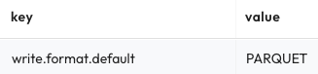

As shown above, the Parquet file format is the default file format.

Step 5 - Add records to Iceberg table
Add three new records to the table using the code below.

INSERT INTO my_iceberg_tbl
(id, name, description)
VALUES
(101, 'Leto', 'Ruler of House Atreides'),
(102, 'Jessica', 'Wife of the Duke'),
(103, 'Paul', 'Son of Leto (aka Dale Cooper)');

Find out what file(s) these records are stored in.

SELECT
name,
"$path"
FROM
my_iceberg_tbl;

How many files are present? If it is hard to tell from the UI due to the long values for the $path special column, you could perform one or more of the following steps to help yourself.

Step 6 - Simply file list results
Trim down the value to only pick up after /data/ is found in the full path using the code below.

SELECT
name,
substring("$path", position('/data/' IN "$path") + 6)
FROM
my_iceberg_tbl;

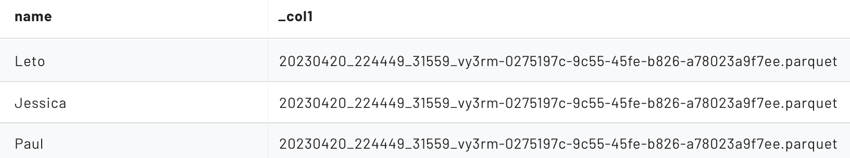

With a quick look, it should appear that all three of these records are referencing the same file on the data lake.

Step 7 - Find distinct values
Use the code below to return a list of distinct values.

SELECT
DISTINCT(substring("$path", position('/data/' IN "$path") + 6))
FROM
my_iceberg_tbl;

Verify you have a single Parquet file for the three records inserted.

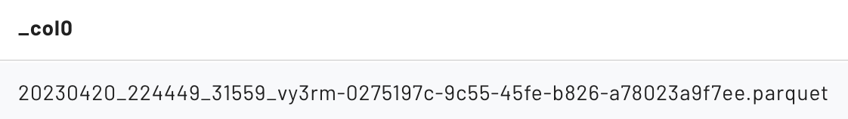

Step 8 - Review documentation and list files
Starburst Documentation outlines several ways to list the files corresponding to all of the rows in a table.

Review the material in the Iceberg connector — Starburst Enterprise section, and then query your table using the code below.

SELECT * FROM "my_iceberg_tbl$files";

You should see a single file – the same one from Step 7. Return specific fields for deeper review.

SELECT
substring(file_path, position('/data/' IN file_path) + 6),
record_count,
value_counts,
null_value_counts,
lower_bounds,
upper_bounds
FROM
"my_iceberg_tbl$files";

Column | Value | Notes
file_path | 20221224...shortened...f6e3.parquet | A specific file name. The remainder of the columns relate to this particular file
record_count | 3 | There are 3 records in the file
value_counts | { 1 = 3, 2 = 3, 3 = 3 } | Each of the 3 columns has 3 values
null_value_counts | { 1 = 0, 2 = 0, 3 = 0 } | None of the columns have any null values present
lower_bounds | { 1 = 101, 2 = Jessica, 3 = Wife of the } | > The id field ranges from 101 to 103  > The name field ranges from Jessica to Paul  > The description field ranges from Wife to Son…
upper_bounds | { 1 = 103, 2 = Paul, 3 = Son of Leto }

Step 9 - Add additional records to table
Add a few more rows.

INSERT INTO my_iceberg_tbl
(id, name, description)
VALUES
(104, 'Thufir', 'Mentat'),
(201, 'Vladimir', 'Ruler of House Harkonnen'),
(202, 'Rabban', 'Ruthless nephew of Vladimir'),
(203, 'Feyd-Rautha', 'Savvy nephew of Vladimir (played by Sting)'),
(301, 'Reverend Mother Gaius Helen Mohiam', null);

Run the $files query again from Step 8 and review your findings from the new data file just created.

Column | Value | Notes
file_path | 20221224...shortened...g2m3e.parquet | A specific file name. The remainder of the columns relate to this particular file
record_count | 5 | There are 3 records in the file
value_counts | { 1 = 5, 2 = 5, 3 = 5 } | Each of the 3 columns has 5 values
null_value_counts | { 1 = 0, 2 = 0, 3 = 1 } | One of the rows has a null for the description field
lower_bounds | { 1 = 104, 2 = Feyd-Rautha, 3 = Mentat } | > The id field ranges from 104 to 301  > The name field ranges from Feyd-Rautha to Vladimir  > The description field ranges from Mentat to Savy nephew…
upper_bounds | { 1 = 301, 2 = Vladimir, 3 = Savvy nephew of! }

END OF LAB EXERCISE

Lab 2: Explore partitions with Iceberg
Estimated completion time
- 30 minutes

Learning objectives
- In this lesson, you will explore partitioning with Iceberg tables using a public bicycle-sharing dataset known as Bluebikes. You will learn how to access these tables and partition them in different ways. You will also compare how the Hive table format differs from the Iceberg table format, deploying a series of tests and checking the results.

Activities
- Prepare for the exercise
- Review Bluebikes dataset
- Inspect column types
- Count number of stations in each district
- Partition table by district
- Reorder columns to fit Hive requirements
- Partition Iceberg table without changing order of columns
- Investigate files
- Query partitions table
- Reformat output
- Query trips table
- Partitioning start_time field
- Understanding conditional logic and the WHERE clause
- Create partitioned table
- Copy data into table
- Apply conditional logic using WHERE clause on source table
- Compare results with newly partitioned table

Step 1 - Prepare for the exercise
- Sign in and verify the students role is selected in the upper-right corner.

Note: If you did not previously create an iceberg schema, execute the following SQL statement. Make sure that you replace yourname with your actual name, or another identifier that you prefer. Only use lowercase characters and numbers; no special characters or spaces.

CREATE SCHEMA iceberg.yourname_iceberg
WITH (location = 's3://erin-rosas-may2025/training/iceberg/yourname/');

Step 2 - Review Bluebikes dataset
For this lab, you will use the publicly available Bluebikes - Hubway dataset. Read more information about Blue Bikes Boston, a bicycle-sharing program based in Boston since 2011.

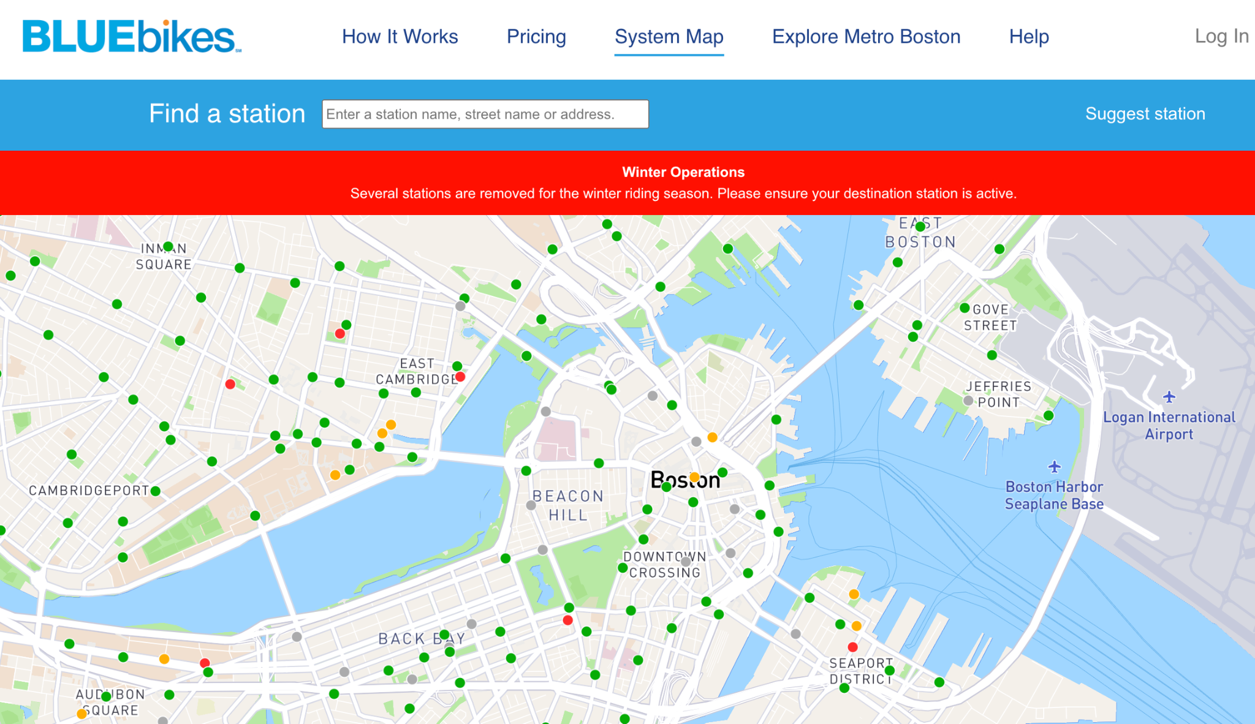

The two tables you will use are:
- hive.bluebikes.stations
  - A list of the current docking stations available
  - Data current as of December 5, 2022
- hive.bluebikes.trips
  - Transactional records of bike trips from start to finish
  - Contains all rides from January - November of 2022

Note: There are tables present whose names begin with raw_ as well. The two tables above are examples of transformed/enriched/augmented/cleansed/etc. data that will be explored later in the data pipelining workshop.

Step 3 - Inspect column types
Familiarize yourself with these two tables by inspecting the column types and running a few queries to see some sample data. More details on specific columns can be found at Bluebikes System Data | Blue Bikes Boston.

Step 4 - Count number of stations in each district
Determine how many stations are assigned to each district. To do this, use a SELECT statement in conjunction with the count(), GROUP BY, and ORDER BY modifiers to introduce the desired logic.

SELECT
district,
count() as nbr_stations
FROM
hive.bluebikes.stations
GROUP BY
district
ORDER BY
nbr_stations DESC;

Step 5 - Partition table by district
Run the following code to see the full CREATE TABLE statement for the stations table.

SHOW CREATE TABLE hive.bluebikes.stations;

Modify the output to create a new table partitioned by district in this first example. Notice how the SQL below specifically calls for a partitioning strategy by district.

USE hive.yourname;

CREATE TABLE stations_orc_partby_district (
station_nbr varchar,
name varchar,
latitude decimal(8, 6),
longitude decimal(9, 6),
district varchar,
public boolean,
total_docks smallint,
deployment_year smallint
)
WITH (
format = 'ORC', partitioned_by = ARRAY['district']
);

You should receive an error message similar to the image below. In this case, the partition keys must be the last column in the table, and listed in the same order as the table properties. Since this is not the case, the system generates an error.

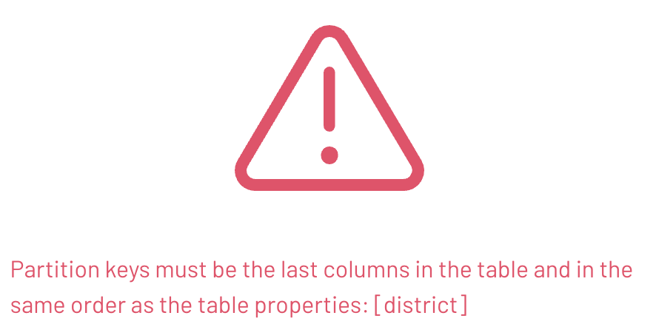

Step 6 - Reorder columns to fit Hive requirements
The Hive table format is very particular about the placement of the partition column(s). To fix this, put it as the last column in the list using the code below.

CREATE TABLE stations_orc_partby_district (
station_nbr varchar,
name varchar,
latitude decimal (8, 6),
longitude decimal (9, 6),
public boolean,
total_docks smallint,
deployment_year smallint,
district varchar
)
WITH
(
format = 'ORC', partitioned_by = ARRAY['district']
);

Note: You can populate this new table for investigation, but it is not necessary for the remainder of the exercise. The point to remember is the Hive table format requires the partition column(s) to be the last column(s) and in the same order.

Step 7 - Partition Iceberg table without changing order of columns
Use the following Data Definition Language (DDL) to create a partitioned Iceberg table. Note that the code below will partition the column without changing their order.

--Set the session to your iceberg table and schema
USE iceberg.yourname_iceberg;

CREATE TABLE stations_p_district (
station_nbr varchar,
name varchar,
latitude decimal (8, 6),
longitude decimal (9, 6),
district varchar,
public boolean,
total_docks smallint,
deployment_year smallint
)
WITH
(
format = 'ORC',
partitioning = ARRAY['district']
);

Now copy the non-partitioned table’s data into the partitioned Iceberg table you created.

INSERT INTO
stations_p_district
SELECT
*
FROM
hive.bluebikes.stations;

Step 8 - Investigate files
Take a look at the underlying files that were created using the code below.

SELECT
substring(file_path, position('/data/' IN file_path) + 6),
record_count
FROM
"stations_p_district$files";

You were returned 14 rows as shown below. When you look closely you will see that the start of each of the file names begin with district=. These are the partitions that were created for the 14 unique distinct values you determined in the count of stations by district query you ran in Step 4. Additionally, the totals from that step are also referenced appropriately in the record_count column values below.

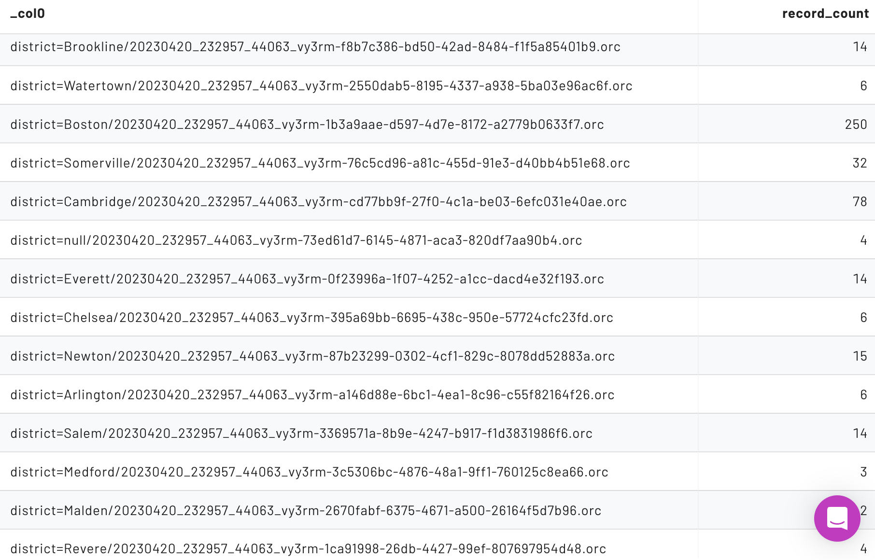

You should also notice that the partition directory naming scheme is similar to that of the Hive table format. They both use the name=value format for the subdirectories.

Step 9 - Query partitions table
Review the Iceberg metadata tables. Iceberg tables include a $partitions table.

Use the code listed in the image below to query the $partitions table.

Note: The total number of records for each partition will be easier to obtain from this query than the prior one when we have more than a single file per partition.

SELECT * FROM "stations_p_district$partitions";

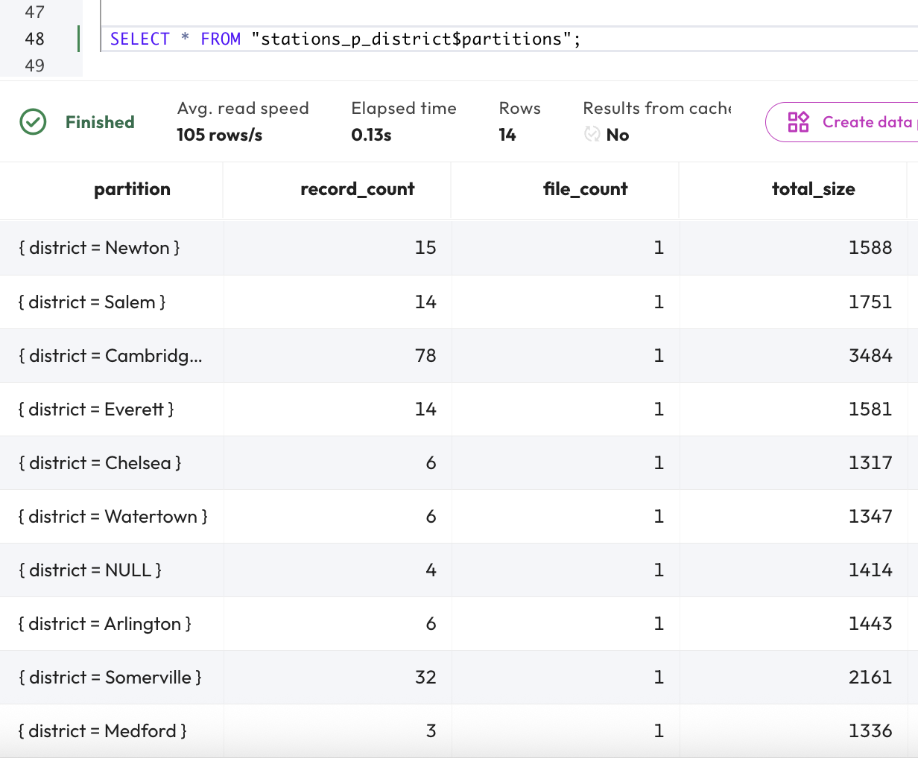

Now look at the data column. It represents the column-level statistics across all the data files in a given partition folder.

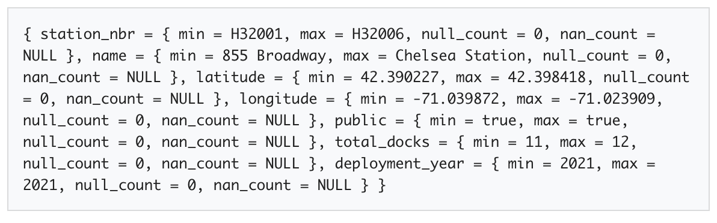

Step 10 - Reformat output
With some simple formatting, it is easier to consume the column-level metadata for a particular partition.

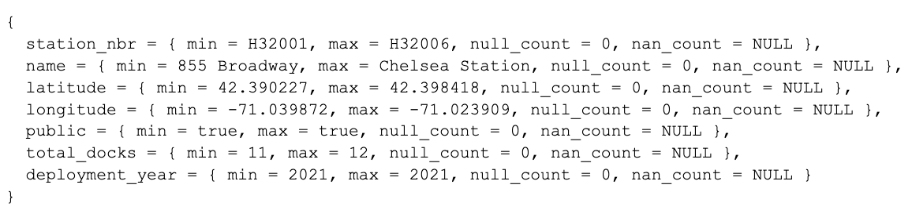

Since the partitioning was defined on the district column, Iceberg does not need to store any column statistics for that particular column. Mainly because there is only a single value, the district value, for the whole partition. The example above was from district=Chelsea.

Step 11 - Query trips table
It’s time to turn your attention to the hive.bluebikes.trips table. SELECT all records from the table using the code below.

SELECT * FROM hive.bluebikes.trips;

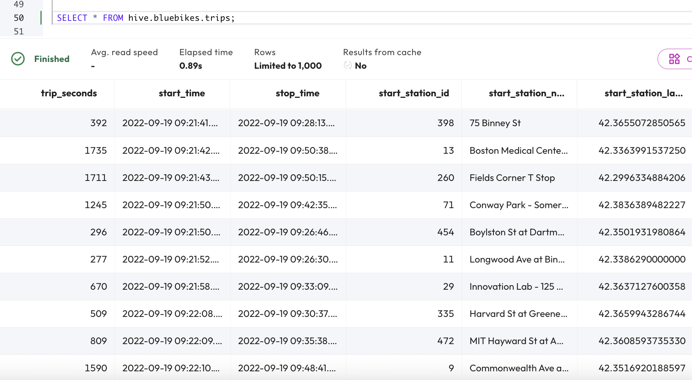

Notice that the timestamp fields listed correspond to the start of each ride.

Step 12 - Partitioning start_time field
You know that the start_time data is immutable. You also know that many analytic queries include a filter targeting trips within a range of 1-180 days.

Based on these facts, it would be a good idea to consider partitioning based on the start_time field. Importantly, you cannot use discrete values to do this. This approach would be too granular and create too many folders containing only a single trip, introducing the small files problem.

Step 13 - Understanding conditional logic and the WHERE clause
Adopting a partitioning strategy based on month would be best in this case. The Hive table format allows you to abstract the level of precision from the start_time field and put that value in a new, partitioned column. The result will be a start_time_month field with a value format of YYYY-MM.

To use this approach efficiently, you will need to understand how these two columns are best utilized, balancing precision against efficiency. The goal is to target the smallest amount of data possible while still achieving a good result.

More directly, the Hive table format often causes confusion in scenarios like this by having two different columns (start_time and start_time_month) representing the same information.

Step 14 - Create partitioned table
Iceberg offers a much simpler solution to solve the problem in the previous step. The approach in the DDL below shows there are timestamp-based transform functions that can be used that do not require you to actually create & populate another dedicated column to achieve partitioning at a more coarse-grained level such as at the month level.

The user then does not have the opportunity to get confused about having two similar, but functionally different, date/timestamp fields. The user just applies the appropriate WHERE clause on the timestamp field.

Create a new table, partitioned by month using the code below. Make sure your session is set to use your iceberg schema.

CREATE TABLE trips_p_start_month (
trip_seconds integer,
start_time timestamp(6),
stop_time timestamp(6),
start_station_id integer,
start_station_name varchar,
start_station_latitude decimal(15, 13),
start_station_longitude decimal(16, 13),
end_station_id integer,
end_station_name varchar,
end_station_latitude decimal(15, 13),
end_station_longitude decimal(16, 13),
bike_id integer,
user_type varchar,
postal_code varchar
)
WITH (
format = 'ORC',
partitioning = ARRAY['month(start_time)']
);

Step 15 - Copy data into table
Now it’s time to copy the original data into your new table. Use the code below:

INSERT INTO trips_p_start_month
SELECT * FROM hive.bluebikes.trips;

Step 16 - Apply conditional logic using WHERE clause on source table
From the source table from the prior query, hive.bluebikes.trips, determine how many trips were started in March 2022.

SELECT COUNT(*) FROM hive.bluebikes.trips
WHERE start_time >=
from_iso8601_timestamp('2022-03-01T00:00:00')
AND start_time <
from_iso8601_timestamp('2022-04-01T00:00:00');

You will see there are 182,421 results from that time range on the original table.

Step 17 - Compare results with newly partitioned table
Compare those results from what is seen in the $partitions metadata table. Use the code listed below.

SELECT * FROM "trips_p_start_month$partitions";

You can see that the start_time_month= partitions are not as straightforward as the purpose-built ones that you saw previously. The documentation notes the following:

Note: A partition is created for each month of each year. The partition value is the integer difference in months between the timestamp and January 1, 1970.

January 1, 1970, is the date known as the Unix Epoch, which is used as the start date for many systems, including this one. In your case, there are 52 years and 2 months before March 1, 2022 and the Unix Epoch, so the number you are looking for is 626. (12 * 52 + 2 = 626).

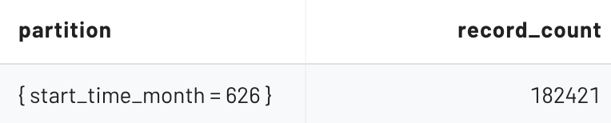

This shows the metadata table identifying the correct number of records for the month of March 2022 from the appropriate partition of the newly partitioned table that we saw from the source table in Step 16.

Run the query again, this time on the partitioned table, to make sure the same 182,421 count is being returned.

SELECT COUNT(*) FROM trips_p_start_month
WHERE start_time >=
from_iso8601_timestamp('2022-03-01T00:00:00')
AND start_time <
from_iso8601_timestamp('2022-04-01T00:00:00');

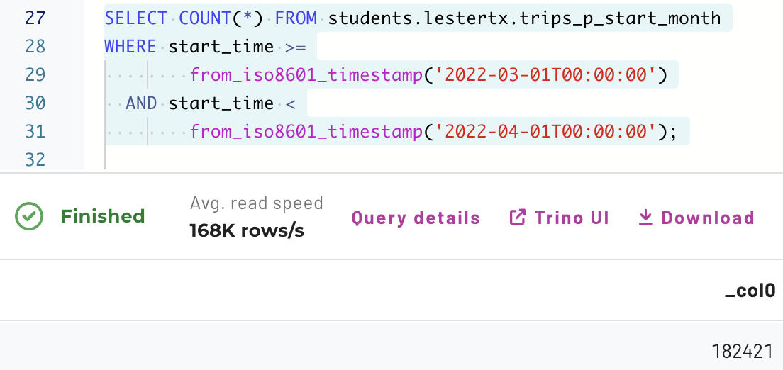

END OF LAB EXERCISE

Lab 3: Data modifications and snapshots with Iceberg
Estimated completion time
- 30 minutes

Learning objectives
- In this lesson, you will explore how Iceberg uses snapshot files to create a comprehensive picture of changes made to tables. To do this, you will set up a table, make changes, then view the impact that this has on snapshot files. You will then query the snapshot files using the Iceberg time travel feature, which allows you to view results from the database at various moments in time or even roll the table back to a previous state.

Activities
- Prepare for the exercise
- Create testing table
- Add historical order records from a week ago
- Add activation records from six days ago
- Add an error record from five days ago
- Modify some previous records
- Understanding snapshot files
- Time travel queries with snapshot id
- Time travel queries against a point in time
- Rolling back to a previous state using snapshot files

Step 1 - Prepare for the exercise
- Sign in and verify the students role is selected in the upper-right corner.

Note: If you did not previously create an iceberg schema, execute the following SQL statement. Make sure that you replace yourname with your actual name, or another identifier that you prefer. Only use lowercase characters and numbers; no special characters or spaces.

CREATE SCHEMA iceberg.yourname_iceberg
WITH (location = 's3://erin-rosas-may2025/training/iceberg/yourname/');

Step 2 - Create testing table
Create a new table in your schema with the following Data Definition Language (DDL).

USE iceberg.yourname_iceberg;

CREATE TABLE phone_provisioning (
phone_nbr bigint,
event_time timestamp(6),
action varchar(15),
notes varchar(150)
)
WITH (
partitioning=ARRAY['day(event_time)']
);

Verify that a snapshot was created for the table creation.

SELECT * FROM "phone_provisioning$snapshots";

This returns a single row representing the first snapshot which captures the table creation itself. The following is the value of the summary column.

This indicates that no data changes happened as part of this snapshot. In fact, it also shows there are zero total-records as you would expect having only run the DDL.

Step 3 - Add historical order records from a week ago
Add historical records from a week ago to capture the initial orders for two new phone numbers.

INSERT INTO
phone_provisioning (phone_nbr, event_time, action, notes)
VALUES
(
1111111, current_timestamp(6) - interval '7' day, 'ordered', null
),
(
2222222, current_timestamp(6) - interval '7' day, 'ordered', null
);

Verify the two records are present as expected.

SELECT * FROM phone_provisioning ORDER BY event_time DESC;

Verify a new snapshot was created.

SELECT * FROM "phone_provisioning$snapshots";

There is now a second row with a new snapshot_id. More analysis of this metadata will be discussed in Step 7.

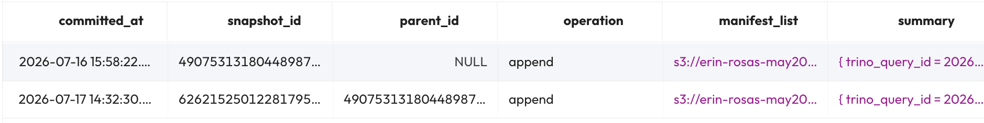

Step 4 - Add activation records from six days ago
Add historical records from six days ago to capture the activation activity for the same two phone numbers.

INSERT INTO
phone_provisioning (phone_nbr, event_time, action, notes)
VALUES
(
1111111, current_timestamp(6) - interval '6' day, 'activated', null
),
(
2222222, current_timestamp(6) - interval '6' day, 'activated', null
);

Verify the records are present as expected, and a new snapshot was created, by running the last two SELECT statements in Step 3. There will be two more records added to the phone_provisioning table and the $snapshot table will now have a third record.

Reviewing the summary column for the new record in $snapshot details that 2 records were added as part of this snapshot.

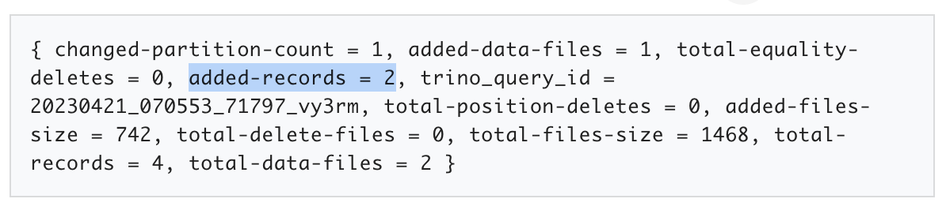

More analysis will be presented in Step 7.

Step 5 - Add an error record from five days ago
Add historical activation records from five days ago to capture an error that was reported on phone number 2222222.

INSERT INTO
phone_provisioning (phone_nbr, event_time, action, notes)
VALUES
(2222222, current_timestamp(6) - interval '5' day, 'errorReported',
'customer reports unable to initiate call');

Once again, verify the records are present as expected and a new snapshot was created.

Step 6 - Modify some previous records
Four days ago, a system error prevented the notes column from being populated correctly before it was fixed. Upon review of the problem, it was determined that the following two INSERT commands are needed to modify the affected records.

UPDATE phone_provisioning
SET notes = 'customer requested new number'
WHERE action = 'ordered'
AND notes is null;

UPDATE phone_provisioning
SET notes = 'number successfully activated'
WHERE action = 'activated'
AND notes is null;

Review all rows again.

SELECT * FROM phone_provisioning ORDER BY event_time DESC;
Your event_time values will be different, but the rows shown below should be similar to your results.

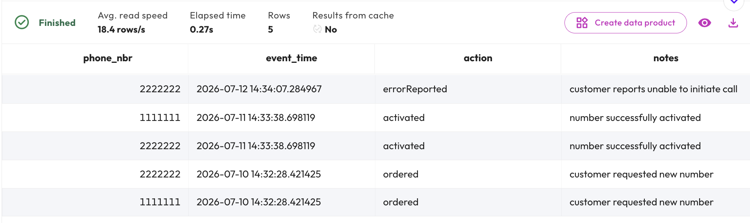

Query the $snapshots table again.

SELECT * FROM "phone_provisioning$snapshots";

Two new snapshots were created from the two UPDATE statements, as shown at the bottom of the list below.

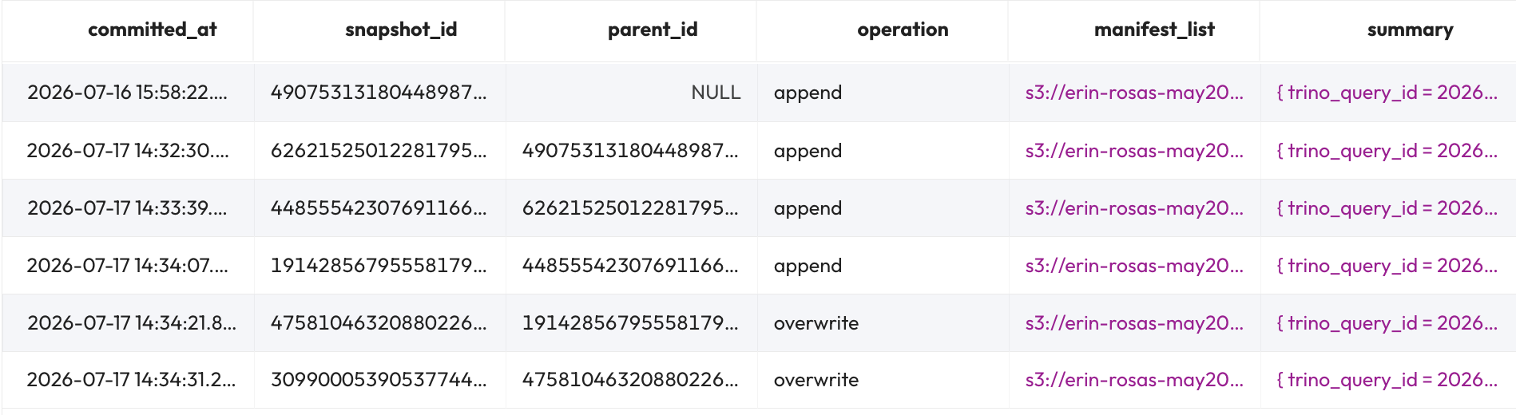

Step 7 - Understanding snapshot files
Iceberg records changes to a table as snapshots. For example, each of the 2 UPDATE statements executed created their own snapshot with an operation value of overwrite. Iceberg cannot perform an in-place update to the underlying immutable data files.

The phrase “overwrite”, instead of “update”, is more appropriate as Iceberg has to create a file referencing the location in the existing file(s) that contain the record(s) to be updated. This is called a “delete file”.

Then, as part of an atomic operation, Iceberg creates a new data file that has the full record being “updated”. It essentially is an “add” of the record with all updated columns as well as the existing values for columns not updated.

These new delete files and data files that are created will be read after the preceding data files are. This allows Iceberg to modify the data prior to returning it by applying the delete files (i.e. delete the records) and then including the new data files (which will look like net-new records).

This is somewhat analogous to RDBMS “transaction logs” that store a running history of modifications into. The difference is that the classical databases are creating their transaction logs for recovery & replication purposes. Iceberg creates a series of deltas that will be used in a “merge on read” strategy when the table is queried.

To understand this better, click on the summary value for the last snapshot in the list. The Output identified below is a subset of all the properties present. They are the ones most important to this discussion.
Output

{
total-position-deletes = 2,
total-delete-files = 1,

added-records = 2,
added-data-files = 1,
}

These totals are for the UPDATE statement that had action = 'activated' AND notes is null within it. It logically changed two records.

With Iceberg’s inability to perform in-place updates on the underlying files, total-position-deletes = 2 indicates that 2 records were marked for deletion. Fortunately, both of these were placed in a single delete file.

Closely following those deletes, added-records = 2 indicates the records deleted are being re-added as essentially new inserts. As before, these were assembled into a single new data file.

More information on delete files and the overall strategy around handling the UPDATE statement can be found in the Iceberg Specification.

Step 8 - Time travel queries with snapshot id
So, what can you do with snapshot files? One useful feature is called “time travel”. This allows you to query prior versions of the table via the snapshot_id. The second row in the results below relates to the second snapshot. The first snapshot was at the empty table creation. The second was the initial INSERT statement.

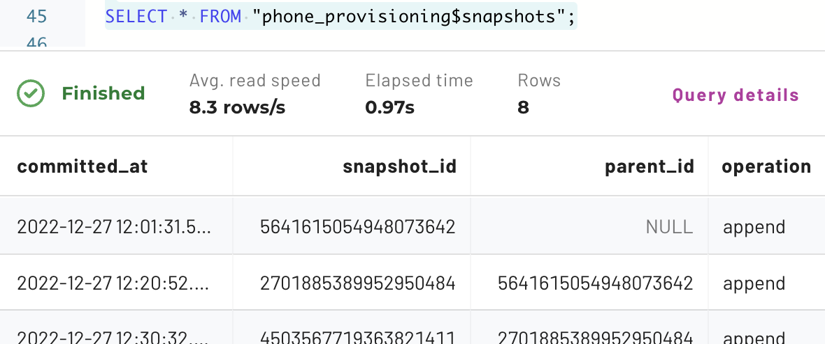

Replace 1234567890 in the following query with your second snapshot_id to see what the table looked like back at that point.

SELECT * FROM phone_provisioning
FOR VERSION AS OF 1234567890
ORDER BY event_time DESC;

You should see the first two records initially added, similar to the image pictured below.

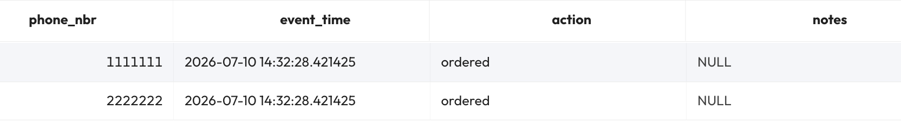

Step 9 - Time travel queries against a point in time
Another alternative mechanism to leverage time travel is to run a query based on a past point in time. You can exercise this by swapping VERSION above with TIMESTAMP and replacing the snapshot_id with a timestamp.

Familiarize yourself with the documentation on time travel. Many unique use-cases make this feature invaluable.

Previously, we added a record with a timestamp that was 5 days in the past. Run a query to see what that table’s contents were 5.5 days ago.

SELECT * FROM phone_provisioning
FOR TIMESTAMP AS OF current_timestamp(6) - interval '132' hour
ORDER BY event_time DESC;

You should have received an error like the following.

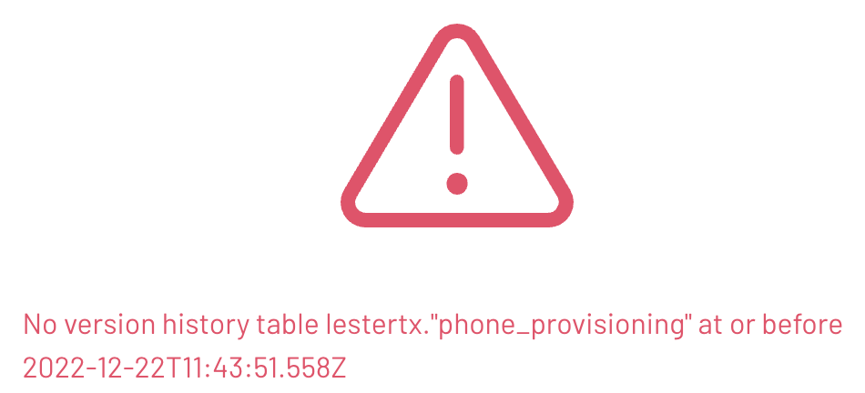

Do you understand what happened here? The query above assumed that the event_time column’s timestamp was being used, but it is only a timestamp-based column and is not directly related to the versioning information. The rows from the $snapshots metadata table have a committed_at timestamp which is leveraged when FOR TIMESTAMP AS OF is utilized.

Run the last query again after changing the interval type from hour to minute and plug in a single-digit number instead of 132. Increment and/or decrement the number until you get the results you are looking for.

Hint: use an appropriate number of minutes that would make the timestamp slightly before the committed_at column value from $snapshots for the snapshot you are trying to read the data from.

Step 10 - Rolling back to a previous state using snapshot files
Time travel also provides the ability to roll a table back to a previous snapshot. Use the following steps to determine the current snapshot_id and copy it into your query editor for later use.

To begin, query $snapshots again and get the snapshot_id value from the row with the most recent committed_at timestamp to be the snapshot to rollback to. You could also look for the most recent snapshot_id in the $history metadata table.

-- save the snapshot_id value in the editor
SELECT snapshot_id FROM "phone_provisioning$history"
ORDER BY made_current_at DESC LIMIT 1;

Next, execute a SELECT * query using the specific snapshot_id just identified to ensure the results are what are present where running a query without the FOR VERSION AS OF clause (replace 1234567890 with your current snapshot_id).

SELECT * FROM phone_provisioning
EXCEPT
SELECT * FROM phone_provisioning
FOR VERSION AS OF 1234567890;

Run the following query to remove all the records for one of the phone numbers.

DELETE FROM phone_provisioning
WHERE phone_nbr = 2222222;

Verify that 3 of the 5 rows were deleted.

SELECT * FROM phone_provisioning ORDER BY event_time DESC;

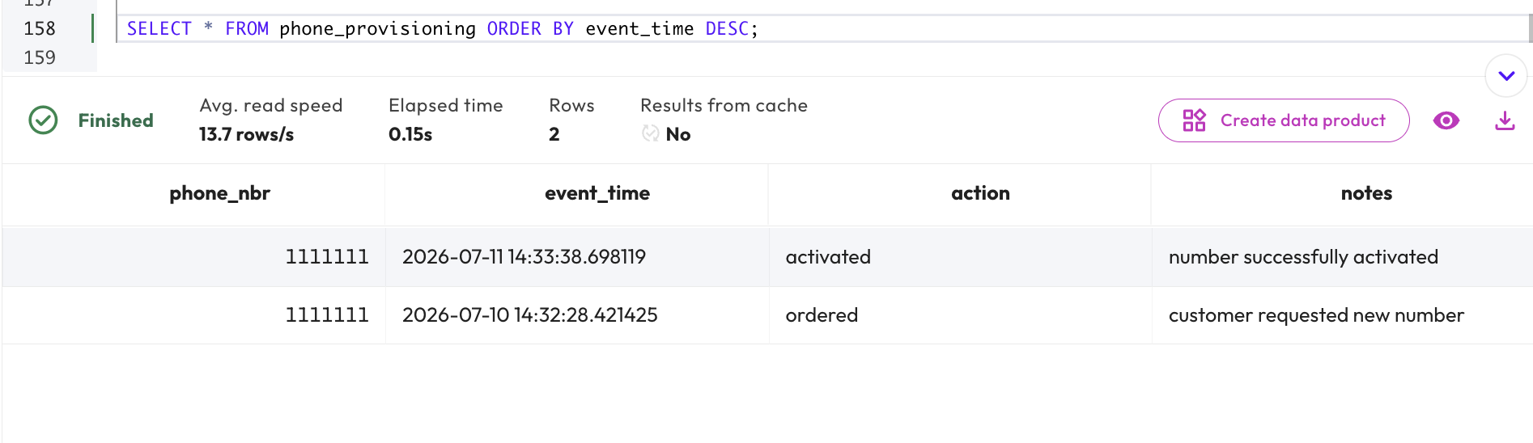

It was determined that the DELETE was a mistake and needs to be recovered from. Use the snapshot_id you saved earlier in the following command that rolls the table back to before the deletions.

CALL iceberg.system.rollback_to_snapshot(
'yourname_iceberg', 'phone_provisioning',
1234567890);

Finally, verify the rows have been recovered.

SELECT * FROM phone_provisioning ORDER BY event_time DESC;

The result should look similar to the image below.

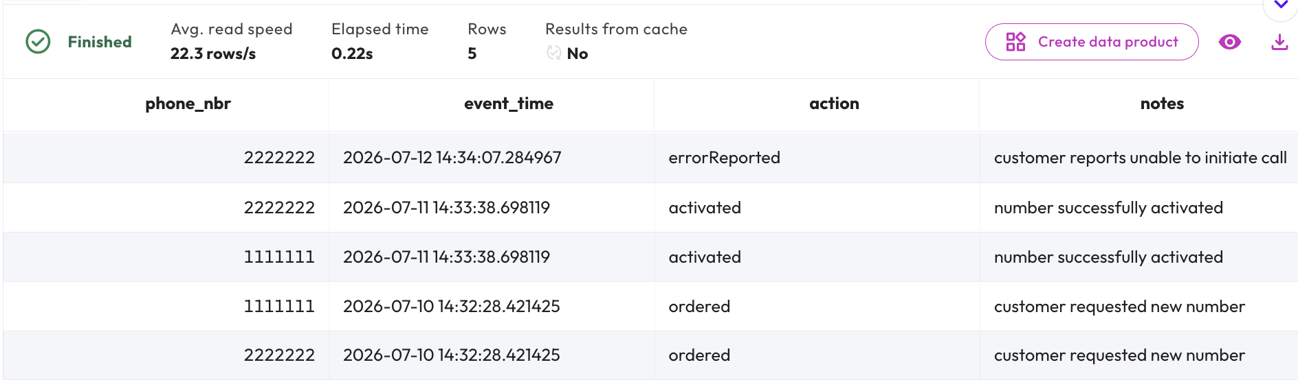

END OF LAB EXERCISE

Advanced Iceberg

Lab 1: Utilize Iceberg’s MERGE statement
Estimated completion time
- 30 minutes

Learning objectives
- In this lesson, you will learn how to use the MERGE statement using Iceberg tables. To do this, you will create an Iceberg table, populate it with records, and record the behavior as changes are made. You will then explore the concept of Slowly Changing Dimensions (SCD) before using UNION ALL statements in conjunction with MERGE to enact a complete merge of Iceberg tables.

Activities
- Prepare for the exercise
- Create Iceberg table
- Add records to table
- Create table to record changes
- Create changes upstream and view impact on records table
- Merge change logs into table base
- Understanding Slowly Changing Dimensions (SCD)
- Populate records and mark as active
- Understanding MERGE
- Using the UNION ALL statement
- Wrap UNION query with existing MERGE query
- Mark records as inactive
- Insert unmatched records and set as active
- Run full MERGE command

Step 1 - Prepare for the exercise
- Sign in and verify the students role is selected in the upper-right corner.

Note: If you did not previously create an iceberg schema, execute the following SQL statement. Make sure that you replace yourname with your actual name, or another identifier that you prefer. Only use lowercase characters and numbers; no special characters or spaces.

CREATE SCHEMA iceberg.yourname_iceberg
WITH (location = 's3://erin-rosas-may2025/training/iceberg/yourname/');

Step 2 - Create Iceberg table
Create a new table in your schema with the following Data Definition Language (DDL).

USE iceberg.yourname_iceberg;

CREATE TABLE cust_type1 (
cust_id bigint,
cust_name varchar(50),
country varchar(50),
vip_ind boolean
);

Step 3 - Add records to table
Load it with some initial records.

INSERT INTO cust_type1
(cust_id, cust_name, country, vip_ind)
VALUES
(101, 'Fred', 'United States', false),
(102, 'Wilma', 'United States', false),
(103, 'Pebbles', 'United States', false);

Step 4 - Create table to record changes
Create a table to hold the log-based changes being populated upstream.

CREATE TABLE cust_chg_log (
cust_id bigint,
cust_name varchar(50),
country varchar(50),
vip_ind boolean
);

Step 5 - Create changes upstream and view impact on records table
Simulate an upstream event that populates this table with a mix of new and updated records.

Note: this use case does not have an indicator to declare if the record is a change to an existing record or a new record.

INSERT INTO cust_chg_log
(cust_id, cust_name, country, vip_ind)
VALUES
(101, 'Fred', 'United States', true),
(104, 'Betty', 'United States', true),
(105, 'Barney', 'United States', false),
(106, 'Bam-Bam', 'United States', false),
(103, 'Pebbles', 'Canada', false);

From reviewing the current state of cust_type1, you can determine the first and last records are updates to Fred and Pebbles while the middle three are held in new records.

Step 6 - Merge change logs into table base
The MERGE statement begins with identifying you want to merge the change log records into the base table as shown below. Notice that it calls for the cust_chg_log records to be read and then merged into the cust_type1 table.

MERGE INTO cust_type1 AS cust  USING cust_chg_log AS log | 
The next part is identifying the criteria used to determine a match. For our simple example, this is solely based on the cust_id values from both tables.

ON (cust.cust_id = log.cust_id)
When a match is found, an UPDATE needs to be performed to overwrite the entire record.

WHEN MATCHED THEN
UPDATE
SET
cust_id = log.cust_id,
cust_name = log.cust_name,
country = log.country,
vip_ind = log.vip_ind

Conversely, when no match is made an INSERT needs to be executed to add the new record.

WHEN NOT MATCHED THEN
INSERT (cust_id, cust_name, country, vip_ind)
VALUES
(log.cust_id, log.cust_name, log.country, log.vip_ind);

Putting it all together, you have this completed statement to be executed.

MERGE INTO cust_type1 AS cust
USING cust_chg_log AS log
ON (cust.cust_id = log.cust_id)
WHEN MATCHED THEN
UPDATE
SET
cust_id = log.cust_id,
cust_name = log.cust_name,
country = log.country,
vip_ind = log.vip_ind
WHEN NOT MATCHED THEN
INSERT (cust_id, cust_name, country, vip_ind)
VALUES (log.cust_id, log.cust_name, log.country, log.vip_ind);

After running the MERGE statement, review the contents of cust_type1.

SELECT * FROM cust_type1 ORDER BY cust_id;

Verify that the 3 new records were added as well as the modifications made to the Fred and Pebbles records. It should resemble the image below.

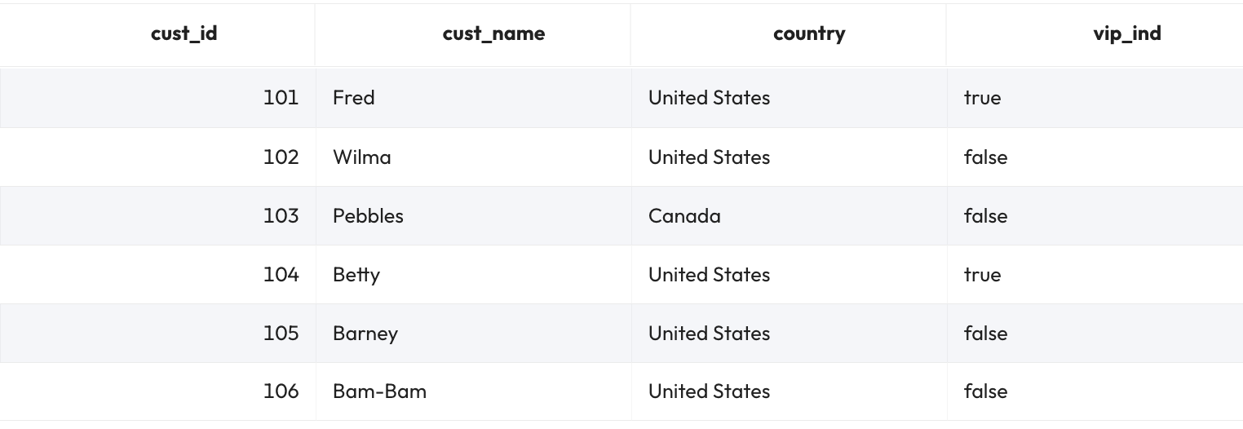

Step 7 - Understanding Slowly Changing Dimensions (SCD)
This approach of overwriting the data when a change is detected is often referred to as a Slowly Changing Dimensions (SCD) Type 1 strategy. SCD Type 2 maintains history by updating the current record to indicate it is not the most current and creating a new record with the current values.

Note: Although there are six types, in practice, Type 1 and Type 2 are the most commonly used.

Run the code below to create a table that includes additional columns. This will allow for a Type 2 solution to be implemented.

CREATE TABLE cust_type2 (
cust_id bigint,
cust_name varchar(50),
country varchar(50),
vip_ind boolean,
active_ind boolean,
active_start_ts timestamp(6),
active_stop_ts timestamp(6)
);

Step 8 - Populate records and mark as active
Populate the same initial three records as before, but this time, mark them active and set the date of this status beginning one month ago.

INSERT INTO cust_type2
(cust_id, cust_name, country, vip_ind,
active_ind, active_start_ts, active_stop_ts)
VALUES
(101, 'Fred', 'United States', false,
true, current_timestamp - INTERVAL '1' month, null),
(102, 'Wilma', 'United States', false,
true, current_timestamp - INTERVAL '1' month, null),
(103, 'Pebbles', 'United States', false,
true, current_timestamp - INTERVAL '1' month, null);

For this use case, you will still use the previously created cust_chg_log table with its simulated new and modified records.

Note: No additional information is needed. These records will become active when the MERGE statement executes.

Step 9 - Understanding MERGE
Review the documentation Supporting MERGE. Notice that only UPDATE and DELETE operations are possible for WHEN MATCHED. All WHEN NOT MATCHED cases only allow for INSERT operations. This approach works for all new records in the change log.

This presents a challenge in cases where a given record already has a change log present in the base table. In such cases, it is necessary to add the updated record, mark it as active, and mark the old record as inactive.

Step 10 - Using the UNION ALL statement
Let’s unpack this process further. To get things ready for MERGE, you have to do a bit of groundwork to ensure that the change logs conform to the specifications above. To do this, you will use a new expression known as UNION ALL, which combines the result set of two or more SELECT statements.

Begin by constructing a Common Table Expression (CTE) using a UNION ALL statement.
The first query to be unioned adds an “is a match” column (set to null) to the cust_chg_log records. It also populates the additional cust_type2 columns with appropriate values. This takes all the rows in the change log and adds the additional columns we need to have to track for type 2.

SELECT null as cust_id_match, cust_id,
cust_name, country, vip_ind,
true as active_ind,
current_timestamp as active_start_ts,
null as active_stop_ts
FROM cust_chg_log

The second query to be unioned identifies only records in the base table that need to be updated by those in the change log. This will confirm customers in the change log already exist in the customer table.

SELECT cust_id AS cust_id_match, cust_id,
cust_name, country, vip_ind,
active_ind,
active_start_ts,
active_stop_ts
FROM cust_type2
WHERE cust_id IN (SELECT cust_id FROM cust_chg_log)

Now it’s time to pull it all together. Run the full UNION query as listed below. The results should look similar to the image beneath.

SELECT null as cust_id_match, cust_id,
cust_name, country, vip_ind,
true as active_ind,
current_timestamp as active_start_ts,
null as active_stop_ts
FROM cust_chg_log
UNION ALL
SELECT cust_id AS cust_id_match, cust_id,
cust_name, country, vip_ind,
active_ind,
active_start_ts,
active_stop_ts
FROM cust_type2
WHERE cust_id IN (SELECT cust_id FROM cust_chg_log);

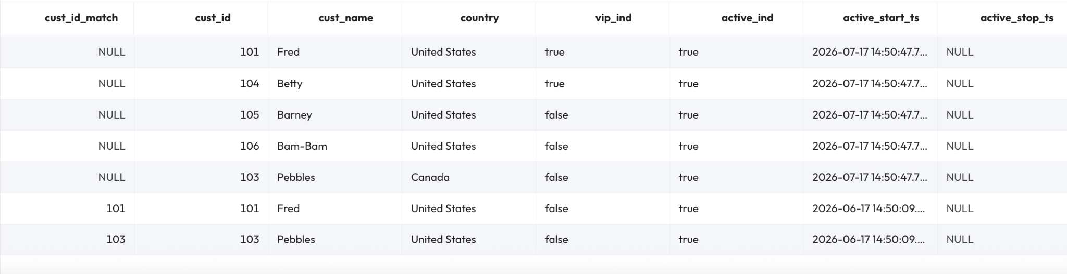

The results show two rows with values in the cust_id_match column. These are the existing Fred and Pebbles records that need to be marked inactive. The results also show 5 rows with null in the match field. These are the 5 rows from cust_chg_log.
- Two of them are the new records for Fred and Pebbles that represent their newly active values.
- The other three are the new records (Barney, Betty, and Bam-Bam) that need to be added to the base table.

Step 11 - Wrap UNION query with existing MERGE query
Wrap the UNION query above with the following SQL above and below your existing query. This allows you to find both records that already exist.

MERGE INTO cust_type2 AS cust
USING (
-- keep your UNION ALL query here
) AS scd_changes
ON (cust.cust_id = scd_changes.cust_id AND
cust.cust_id = scd_changes.cust_id_match)

Step 12 - Mark records as inactive
Now mark these records as inactive.

WHEN MATCHED AND cust.active_ind = true THEN
UPDATE SET active_ind = false,
active_stop_ts = current_timestamp

Note: The additional check above takes into consideration that there may be more than one inactive record already existing.

Step 13 - Insert unmatched records and set as active
The unmatched records include both completely new records and new values for existing cust_id records. Insert them as active records using the code below.

WHEN NOT MATCHED THEN
INSERT (cust_id, cust_name, country,
vip_ind, active_ind,
active_start_ts, active_stop_ts)
VALUES (scd_changes.cust_id,
scd_changes.cust_name, scd_changes.country,
scd_changes.vip_ind, scd_changes.active_ind,
scd_changes.active_start_ts,
scd_changes.active_stop_ts)

Step 14 - Run full MERGE command
Run the fully assembled MERGE command for this SCD Type 2 implementation.

MERGE INTO cust_type2 AS cust
USING (
SELECT null as cust_id_match, cust_id,
cust_name, country, vip_ind,
true as active_ind,
current_timestamp as active_start_ts,
null as active_stop_ts
FROM cust_chg_log
UNION ALL
SELECT cust_id AS cust_id_match, cust_id,
cust_name, country, vip_ind,
active_ind,
active_start_ts,
active_stop_ts
FROM cust_type2
WHERE cust_id IN (SELECT cust_id FROM cust_chg_log)
) AS scd_changes
ON (cust.cust_id = scd_changes.cust_id AND
cust.cust_id = scd_changes.cust_id_match)
WHEN MATCHED AND cust.active_ind = true THEN
UPDATE SET active_ind = false,
active_stop_ts = current_timestamp
WHEN NOT MATCHED THEN
INSERT (cust_id, cust_name, country,
vip_ind, active_ind,
active_start_ts, active_stop_ts)
VALUES (scd_changes.cust_id,
scd_changes.cust_name, scd_changes.country,
scd_changes.vip_ind, scd_changes.active_ind,
scd_changes.active_start_ts,
scd_changes.active_stop_ts);

Review the output. It should look similar to the image below, reporting seven updated rows.

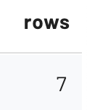

Review the merged results.

SELECT * FROM cust_type2 ORDER BY cust_id, active_start_ts;

The table is correctly populated.
- Fred has been updated to now be a VIP and the original record has been marked inactive.
- Wilma still only shows the original record.
- Pebbles’ country has been updated and the original record is marked inactive.
- The final 3 records are the completely new records from the change log.

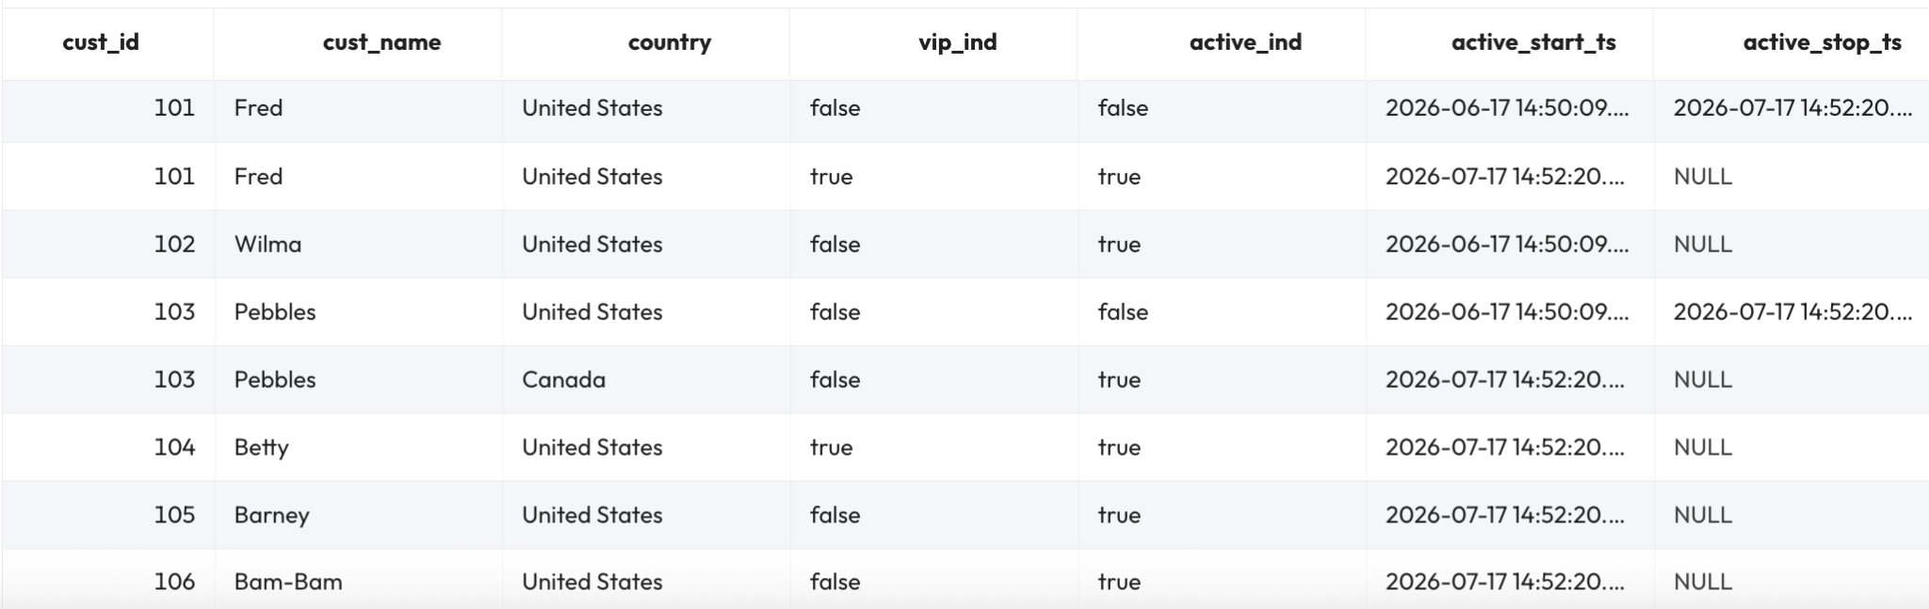

END OF LAB EXERCISE

Lab 2: Exercise advanced features of Iceberg
Estimated completion time
- 30 minutes

Learning objectives
- In this lab, you will explore Iceberg’s advanced features using an airplane dataset. Specifically, you will learn how tables can evolve in specific ways, including renaming columns, adding additional columns, renaming partitions, and eliminating partitions. At each step, you will see what impact these changes have on the records in the table and investigate how these changes are tracked by Iceberg using snapshot files.

Activities
- Prepare for the exercise
- Create table
- Insert records
- Change column name using ALTER TABLE
- Add new records
- Add additional columns using ALTER TABLE
- Modify existing records using new column layout
- Rename and partition table
- Add two new helicopters into modified table
- Check partition metadata
- Eliminate partitions
- Add new record to table after partitions eliminated
- Compaction

Step 1 - Prepare for the exercise
- Sign in and verify the students role is selected in the upper-right corner.

Note: If you did not previously create an iceberg schema, execute the following SQL statement. Make sure that you replace yourname with your actual name, or another identifier that you prefer. Only use lowercase characters and numbers; no special characters or spaces.

CREATE SCHEMA iceberg.yourname_iceberg
WITH (location = 's3://erin-rosas-may2025/training/iceberg/yourname/');

Step 2 - Create table
In this lab, you will build and populate a table with airplane data.

Create an initial table layout in your schema with the following Data Definition Language (DDL).

USE iceberg.yourname_iceberg;

CREATE TABLE planes (
tail_number varchar(15),
name varchar(150),
color varchar(15)
);

Step 3 - Insert records
Insert two new records into the table using the code below.

INSERT INTO planes (tail_number, name)
VALUES
('N707JT', 'John Travolta''s Boeing 707'),
('N1KE', 'Nike corp jet');

Step 4 - Change column name using ALTER TABLE
At this point, you realize the name is really more of a description. Change the column name using the code below. Note the use of the ALTER TABLE syntax.

ALTER TABLE planes RENAME COLUMN name TO description;

Verify all is reporting correctly.

SELECT * FROM planes;

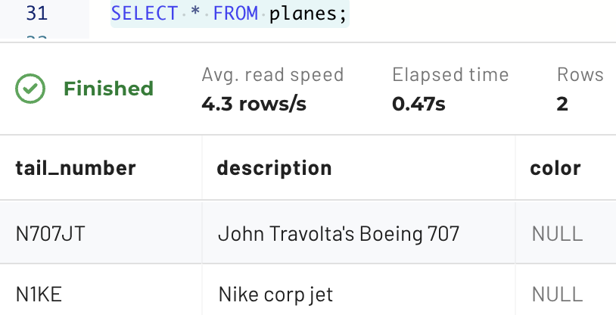

Step 5 - Add new records
Add another plane.

INSERT INTO planes (tail_number, color, description)
VALUES
('N89TC', 'white',
'1975 Bombardier Learjet 35 w/Light Jet classification');

Step 6 - Add additional columns using ALTER TABLE
At this point, you realize some additional columns are appropriate. Add them now using the code below.

ALTER TABLE planes ADD COLUMN class varchar(50);
ALTER TABLE planes ADD COLUMN year_made integer;
ALTER TABLE planes ADD COLUMN make varchar(100);
ALTER TABLE planes ADD COLUMN model varchar(100);

Additionally, the color column is not relevant enough to be maintained.

ALTER TABLE planes DROP COLUMN color;

Step 7 - Modify existing records using new column layout
Modify the existing three rows to leverage the new column layout.

UPDATE planes
SET class = 'Jet Airliner',
year_made = 1964,
make = 'Boeing',
model = '707-138B'
WHERE tail_number = 'N707JT';

UPDATE planes
SET class = 'Heavy Jet',
year_made = 2021,
make = 'Gulfstream',
model = 'G650'
WHERE tail_number = 'N1KE';

UPDATE planes
SET class = 'Light Jet',
year_made = 1975,
make = 'Bombardier',
model = 'Learjet 35',
description = null
WHERE tail_number = 'N89TC';

When complete, verify that the reporting is correct. The output should resemble the image below.

SELECT * FROM planes;

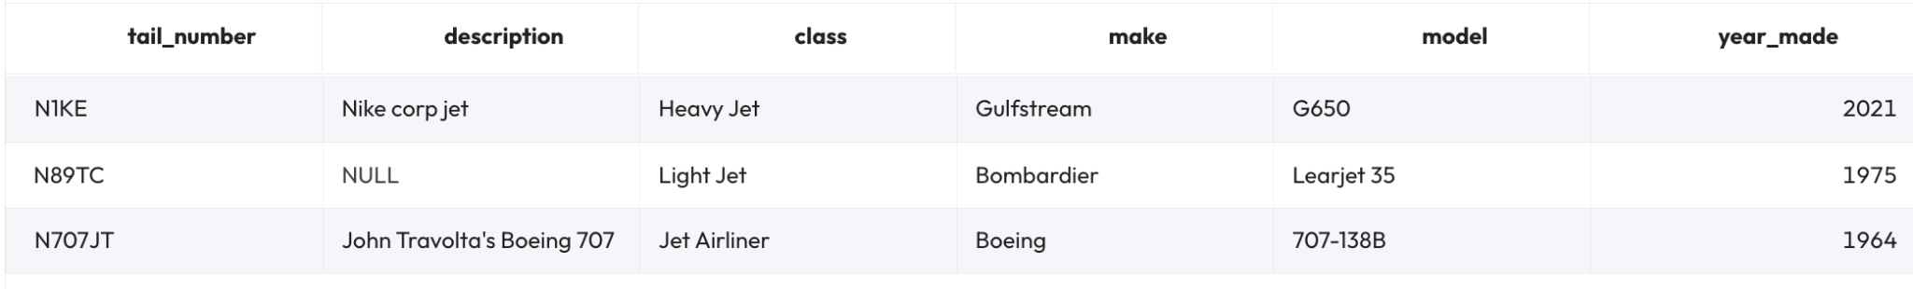

Step 8 - Rename and partition table
Imagine that your company has now decided to carry other types of aircraft, not just planes.

You can use ALTER TABLE to rename the planes table to allow for additional types, such as helicopters, to be added. The new name for the table will be aircrafts.

ALTER TABLE planes RENAME TO aircrafts;

Also, add partitioning on the class column.

ALTER TABLE aircrafts
SET PROPERTIES partitioning = ARRAY['class'];

Step 9 - Add two new helicopters into modified table
Add two helicopters to the table as new records using the code below.

INSERT INTO aircrafts
(tail_number, class, year_made, make, model, description)
VALUES
('N535NA', 'Helicopter', 1969, 'Sikorsky', 'UH-19D', 'NASA'),
('N611TV', 'Helicopter', 2022, 'Robinson', 'R66', null);

When complete, verify that these records have been added using the code below.

SELECT tail_number, class, year_made, make, model, description
FROM aircrafts ORDER BY tail_number;

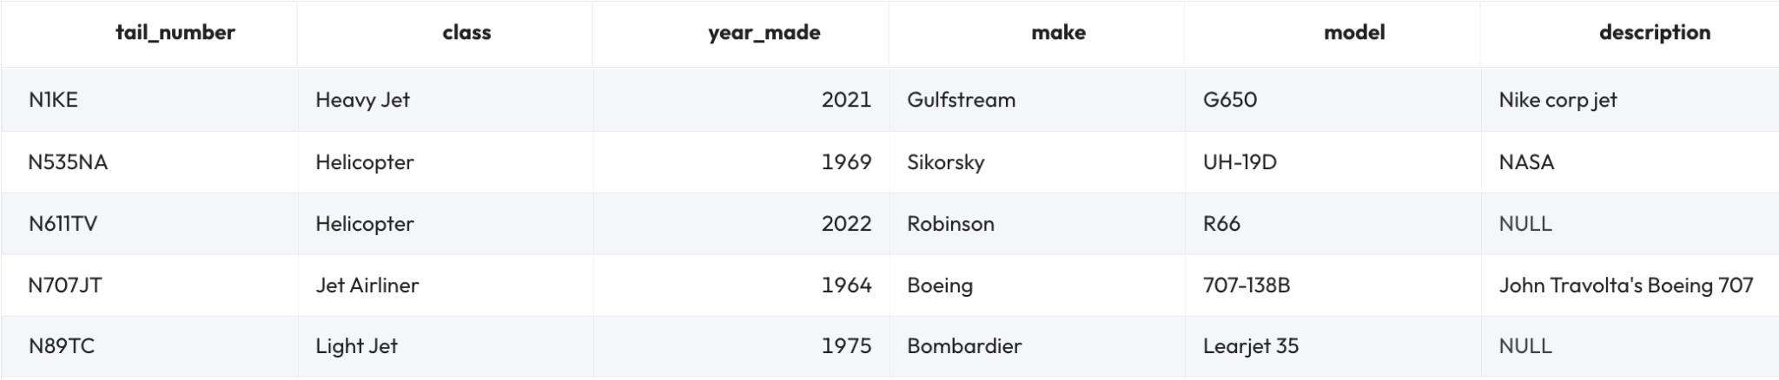

Step 10 - Check partition metadata
Check the $partitions metadata table to ensure that the metadata for the new records is being collected properly. There should be two records in the new partition. Use the code below.

SELECT partition, record_count, file_count
FROM "aircrafts$partitions";

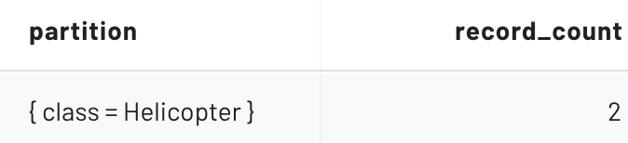

Step 11 - Eliminate partitions
Imagine that the needs of the business change. Fewer aircraft are being purchased than anticipated, and fewer are being added to the table as a result. Upon deeper analysis, you decide that partitioning is no longer necessary because the business need that gave rise to them is no longer true.

Eliminate the partitions using the ALTER TABLE command seen below.

ALTER TABLE aircrafts
SET PROPERTIES partitioning = ARRAY[];

Step 12 - Add new record to table after partitions eliminated
Add another helicopter record.

INSERT INTO aircrafts
(tail_number, class, year_made, make, model, description)
VALUES
('N911MU', 'Helicopter', 2012, 'MD Helicopters', '369E',
'St Louis County Police Dept');

Verify that 3 helicopters are present in the table.

SELECT tail_number, class, year_made, make, model, description
FROM aircrafts WHERE class = 'Helicopter';

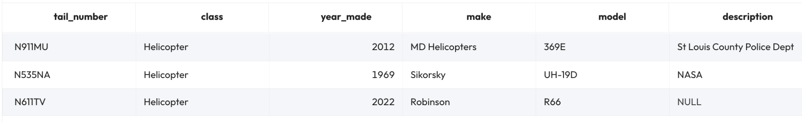

Look at the $partitions metatable again.

SELECT partition, record_count FROM "aircrafts$partitions";

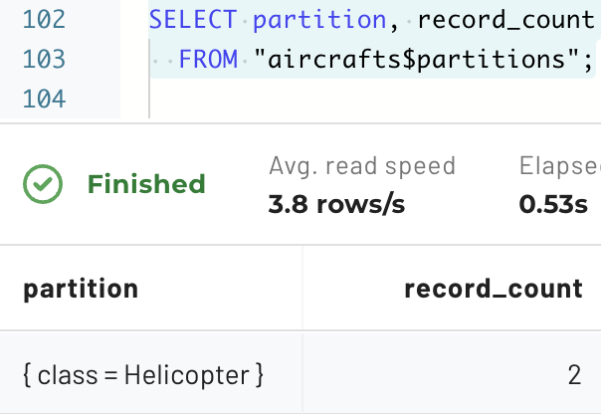

The new record has been successfully added without a partition, but the original two records remain inside the partition. This is an important point regarding the elimination of partitions. Changes to partitions only impact new records but do not automatically alter old records created when the partition was in effect.

Step 13 - Compaction
Take a look at the $files metatable.

SELECT * FROM "aircrafts$files";

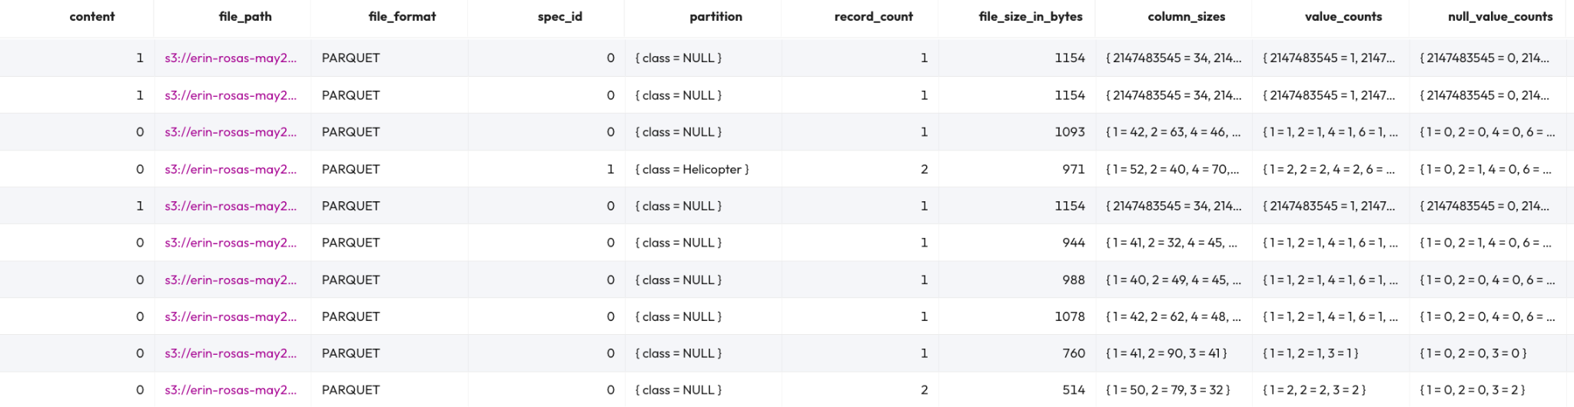

The output above shows a large number of small files. These files can be compacted together for better performance.

Run the following command. It will compact any file below a 10MB threshold.

ALTER TABLE aircrafts
EXECUTE optimize(file_size_threshold => '10MB');

Check the $files metatable again.

SELECT * FROM "aircrafts$files";

You will see there are fewer files present now using the query below.

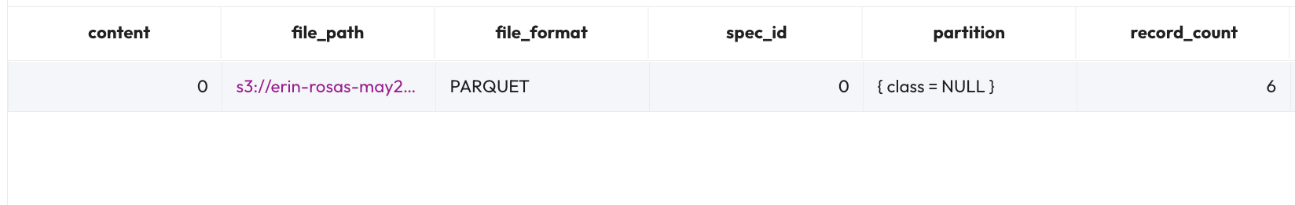

Note: This file is still very small in size due to the small number of records inserted into it. Nonetheless, the problem has been greatly reduced.

END OF LAB EXERCISE

Data lake performance

Lab 1: Create tables with multiple file formats

Estimated completion time
- 20 minutes

Learning objectives
- In this lab, you will gain experience creating tables in different file formats using the CTAS method. You will also join these tables, using a variety of techniques to build and consolidate your skills.

Activities
- Prepare for the exercise
- Create managed parquet table for orders
- Review summary information
- Create managed ORC table for line items
- Join tables
- Create managed Avro table for customer
- Verify nation table
- Modify join query to include new table
- Create managed RCText table for region
- Create managed JSON table for supplier

Step 1 - Prepare for the exercise
- Sign in and verify the students role is selected in the upper-right corner.
- Navigate to the Query editor.

Note: If you did not previously create a schema, execute the following SQL statement. Make sure that you replace yourname with your actual name, or another identifier that you prefer. Only use lowercase characters and numbers; no special characters or spaces.

CREATE SCHEMA hive.yourname
WITH (location = 's3://erin-rosas-may2025/training/hive/yourname/');

Step 2 - Create managed parquet table for orders
In this exercise, you will create tables using a variety of supported file types and leverage them together in a multi-table join statement.

The tables that exist in tpch.sf1 schema and the logical relationships between them are listed below.

Review these relationships thoroughly. You’ll need to use these relationships to proceed further in the lab.

Using the CTAS statement below, create a managed table in your own schema that contains the contents of tpch.sf1.orders. Use the Parquet file format for this new table.

USE hive.yourname;

CREATE TABLE
t_orders_parquet
WITH
(format = 'Parquet') AS
SELECT
*
FROM
tpch.sf1.orders;

Verify that the table was properly created.

SELECT
*
FROM
t_orders_parquet
LIMIT
25;

Step 3 - Review summary information
It is considered best practice to review the S3 bucket where your data is stored to gain summary information about the newly created files.
Use the SQL query below to generate the summary.

SELECT format_number(AVG("$file_size")) AS avg_file_size,
COUNT() AS tot_nbr_files,
format_number(SUM("$file_size")) AS tot_file_size
FROM
(SELECT DISTINCT "$path", "$file_size"
FROM t_orders_parquet);

Step 4 - Create managed ORC table for line items
Using a CTAS statement, create a managed table in your own schema that contains the contents of tpch.sf1.lineitem. Use the ORC file format for this new table.

CREATE TABLE
t_lineitem_orc
WITH
(format = 'ORC') AS
SELECT
*
FROM
tpch.sf1.lineitem;

Verify that the table was properly created.

SELECT
*
FROM
t_lineitem_orc
LIMIT
25;

Run a query to determine some summary information about the newly created files.

SELECT format_number(AVG("$file_size")) AS avg_file_size,
COUNT() AS tot_nbr_files,
format_number(SUM("$file_size")) AS tot_file_size
FROM
(SELECT DISTINCT "$path", "$file_size"
FROM t_lineitem_orc);

Step 5 - Join tables
Investigate these two new tables to determine which columns should be used to join them.

Run the query below.

SELECT
o.orderkey,
l.linenumber
FROM
t_lineitem_orc AS l
JOIN t_orders_parquet AS o ON l.orderkey = o.orderkey
WHERE
l.orderkey = 1935460;

Step 6 - Create managed Avro table for customer
Using a CTAS statement, create a managed table in your schema that contains the contents of tpch.sf1.customer. Use format = 'Avro' for this new table.

CREATE TABLE
t_customer_avro
WITH
(format = 'Avro') AS
SELECT
*
FROM
tpch.sf1.customer;

Verify that the table was created properly and then determine some summary information about the newly created files using the procedure described in Step 3.

Enhance the join query to include this new table and include its name column in the results.

SELECT
o.orderkey,
l.linenumber,
c.name AS customer_name
FROM
t_lineitem_orc AS l
JOIN t_orders_parquet AS o ON l.orderkey = o.orderkey
JOIN t_customer_avro AS c ON o.custkey = c.custkey
WHERE
l.orderkey = 1935460;

The result should look similar to the image below.

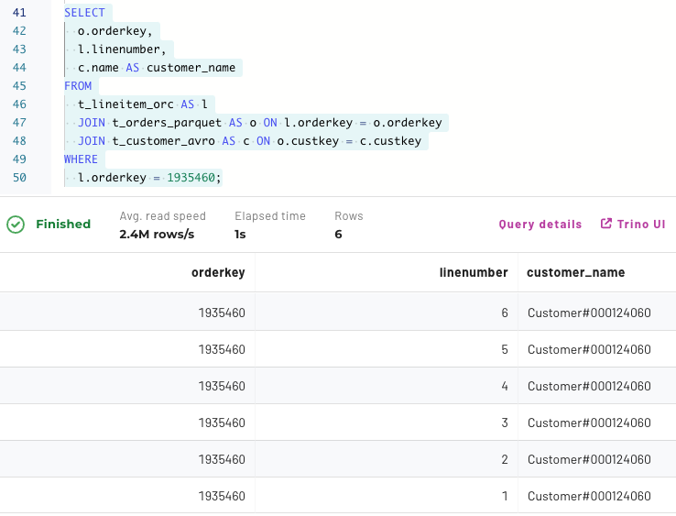

Step 7 - Verify nation table
You should already have a nation table from an earlier lab. If not, create a copy of tpch.sf1.nation with a CTAS statement using the default file format. You should leave out the format property.

Step 8 - Modify join query to include new table
Enhance the join query earlier in this lab to include the newly created table. Make sure to reference the name column in the results.

Your query should be similar to the one below.

SELECT
o.orderkey,
l.linenumber,
c.name AS customer_name,
n.name AS nation_name
FROM
t_lineitem_orc AS l
JOIN t_orders_parquet AS o ON l.orderkey = o.orderkey
JOIN t_customer_avro AS c ON o.custkey = c.custkey
JOIN nation AS n ON c.nationkey = n.nationkey
WHERE
l.orderkey = 1935460;

Step 9 - Create more tables with additional file formats
Run the following three CTAS statements utilizing some of the additional supported file formats.

Note: These file formats are not recommended for new efforts, but are supported for legacy systems that leverage some, or all, of them.

CREATE TABLE t_region_rctext
WITH (format = 'RCText') AS
SELECT * FROM tpch.sf1.region;

CREATE TABLE t_part_sf
WITH (format = 'SequenceFile') AS
SELECT * FROM tpch.sf1.part;

CREATE TABLE t_supplier_json
WITH (format = 'JSON') AS
SELECT * FROM tpch.sf1.supplier;

Step 10 - Join 7 tables of differing file formats
Finally, join all of the new tables created in this exercise.

SELECT
O.orderkey, l.linenumber,
c.name AS customer_name,
n.name AS nation_name,
r.name AS region_name,
p.name AS part_name,
s.name AS supplier_name
FROM
t_lineitem_orc AS l
JOIN t_orders_parquet AS o ON l.orderkey = o.orderkey
JOIN t_customer_avro AS c ON o.custkey = c.custkey
JOIN nation AS n ON c.nationkey = n.nationkey
JOIN t_region_rctext AS r ON n.regionkey = r.regionkey
JOIN t_part_sf AS p ON l.partkey = p.partkey
JOIN t_supplier_json AS s ON l.suppkey = s.suppkey
WHERE
l.orderkey = 1935460;

The solution above was useful to determine all the joins. A more analytical view of the data may require calculating how many line items exist for each supplier/brand name combination for each customer region. That could yield a modified aggregation query such as the following.

SELECT
s.name AS supplier_name, p.brand AS brand_name,
r.name AS region_name, --customer region, not supplier
COUNT() AS nbr_line_items
FROM
t_lineitem_orc AS l
JOIN t_orders_parquet AS o ON l.orderkey = o.orderkey
JOIN t_customer_avro AS c ON o.custkey = c.custkey
JOIN nation AS n ON c.nationkey = n.nationkey
JOIN t_region_rctext AS r ON n.regionkey = r.regionkey
JOIN t_part_sf AS p ON l.partkey = p.partkey
JOIN t_supplier_json AS s ON l.suppkey = s.suppkey
GROUP BY
ROLLUP (s.name, p.brand, r.name)
ORDER BY
S.name, p.brand, r.name;

END OF LAB EXERCISE

Lab 2: Using columnar file formats & eliminating small files
Estimated completion time
- 40 minutes

Learning objectives
Upon successful completion of this lab, students will be able to:

- Compare the performance of small CSV files with optimized ORC files.
- Explain how using fewer, larger files and choosing an efficient columnar format like ORC can improve query performance.
- Describe how these improvements come from reducing the amount of data read from the data lake and making better use of parallel processing.

Activities
- Prepare for the exercise
- Review the testing data
- Row-oriented file formats vs. columnar file format
- Cache metadata
- See reduction in bytes read with column-oriented files
- Locate metrics for amount of data exchanged
- Projection benefits with row-oriented files
- Projection benefits with column-oriented files
- Locate metrics for number of splits read
- Validate small files problems
- Use Hive special columns to check for small files
- The benefits of embedded column statistics for filtering
- The benefits of embedded column statistics for aggregations

Step 1: Prepare for the exercise
- Sign in and verify that you’re using the students role.

Step 2: Review the testing data
In this lab, you’ll explore performance and scalability improvements that come from using optimized file formats and file sizes.

You’ll take on the role of someone responsible for analyzing application log data at your company.
You’ll start by querying a table that points to raw log data as it lands in the data lake. Then, you’ll query additional tables that use performance-enhancing strategies such as optimized file formats and sizes.

In each case, the logical structure of the log data remains the same. The table below outlines the schema, includes sample data, and provides relevant notes.

Field Name | Datatype | Example Data | Additional Notes
Event Timestamp | Timestamp | 2021-07-04 13:01:01 | Format is yyyy-MM-dd HH:mm:ss
IP Address | String | 202.101.36.182 | Static set of 990 values
Application Name | String | Payroll | Static set of 26 values
Process ID | Integer | 2397 | Random number from 99 - 5999
Log Type | String | THREAT | Randomly selected from this list with highest probability from left to right; EVENT, AUDIT, REQUEST, AVAILABILITY, THREAT
Log Level | String | WARN | Randomly selected from this list with highest probability from left to right; INFO, DEBUG, WARN, TRACE, ERROR, FATAL
Message ID | String | CCE-5059 | Random value with format XXX-9999
Message Details | String | more bugs Tomcat ERP bug bugs buffer overflow App95 10aebd44-78dc-459a-a678-01e586bd6309 | Random assembly of 7 words and/or phrases from a static set plus a UUID at the end

The dataset for this lab was derived from a data generator. The generator created the log records in a delimited file format; in this case, comma-separated values, or CSV.

Below is a sample of records from one of the CSV files. Notice that the last field is truncated with “...” for readability.

2021-07-31 22:55:43,77.212.177.88,App95,1964,EVENT,ERROR,PYV-1342,heckofa lot of issues to …
2021-07-31 22:55:43,147.101.31.147,App02,3813,REQUEST,DEBUG,UDD-5791,App92 more bugs App91 …
2021-07-31 22:55:43,237.101.33.237,App95,1198,EVENT,INFO,ZOA-3359,ERP WebLogic algorithm a …

The server log files in the data lake span 35 days, from June 27, 2021 through July 31, 2021. For this scenario, a single log file that collects multiple servers' output is created every five minutes. Here are some more characteristics of the complete dataset.

Record size (bytes) | 200
Records/ingestion file | 10,000
Ingestion file size (bytes) [see avg_file_size in query below] | 2,000,000
Files/day | 288
Daily file size (bytes) | 576,000,000
Number of days | 35
Total number of ingested files [see tot_nbr_files in query below] | 10,080
Total dataset size (bytes) [see tot_file_size in query below] | 19,160,000,000
Total number of records | 100,800,000

Step 3: Row-oriented file formats vs. columnar file formats
File formats define how data is stored within each file—and not all formats store data the same way.
For example, the logs_5min_ingest_csv table contains a series of files, each holding five minutes of log data across the servers, stored in CSV format. The file format can significantly impact query performance due to differences in how data is organized and accessed.
In general, data lake file formats fall into two main categories:

- Row-oriented formats: Store full records one after another, with a delimiter separating each row.
- Columnar formats: Store all values for a given column together, enabling faster reads for queries that access specific columns.
The image below illustrates how columnar storage differs from row-based formats and why it can improve performance.
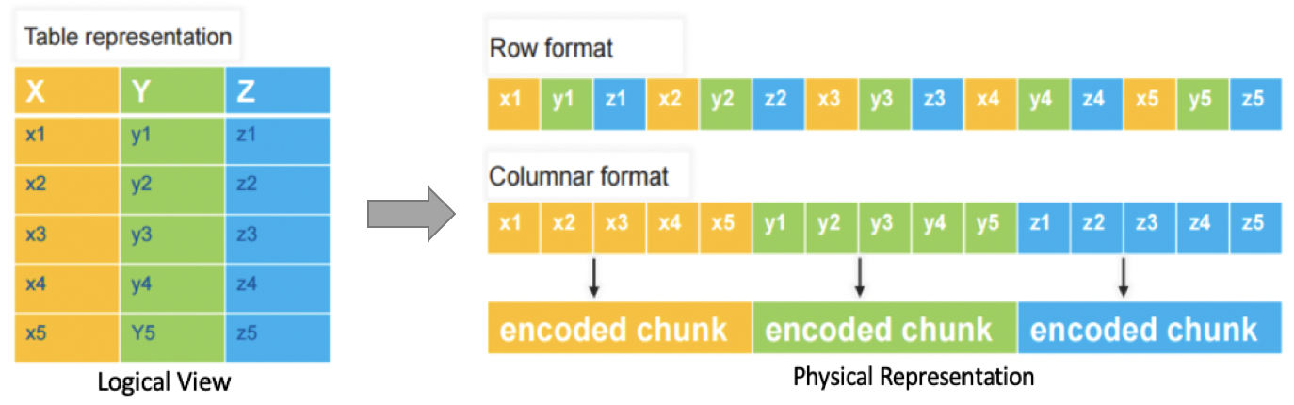
Columnar file formats are inherently designed for improved performance with analytics-based queries. When only the relevant columns are referenced, there is a significant reduction in the amount of data that needs to be retrieved from disk.

Additional benefits include efficient encoding and compression techniques that can drastically reduce storage requirements without sacrificing query performance.
The most popular columnar file formats are:
- Apache ORC
- Apache Parquet
Both Parquet and ORC file formats store data in blocks of logical rows, and each block can contain multiple segments of data. A key advantage of these formats—especially for analytics—is that they include file-level metadata such as headers and footers.
This metadata goes beyond supporting schema evolution. It also contains valuable column-level statistics like count, minimum, maximum, and the number of null values. These statistics help query engines like Starburst optimize performance by reducing the amount of data scanned during query execution.
Starburst fully supports both Parquet and ORC file formats, making them ideal choices for high-performance analytical workloads.

Step 4: Cache metadata
As this exercise is focused on verifying performance improvements, you do not want your results to be skewed by any waiting resources.

- Run the following queries to ensure the environment is ready for your testing efforts. This will also cache the table’s metadata.

SELECT *
FROM hive.serverlogs.logs_5min_ingest_csv
LIMIT 10;

SELECT *
FROM hive.serverlogs.logs_5min_ingest_orc
LIMIT 10;

SELECT *
FROM hive.serverlogs.logs_daily_rollup_orc
LIMIT 10;

Step 5: See reduction in bytes read with column-oriented files
- Run the following query against the table that is aligned with the 10,080 CSV ingested files described above.

SELECT *
FROM hive.serverlogs.logs_5min_ingest_csv
WHERE app_name IN ('CRM', 'ERP')
ORDER BY app_name, log_type, log_level,
message_id, ip_address;

- Let’s take a look at some of the performance metrics you’ll be using in this lab. Click on the eyeball icon above and to the right of the query results. This will take you to the Query details page.

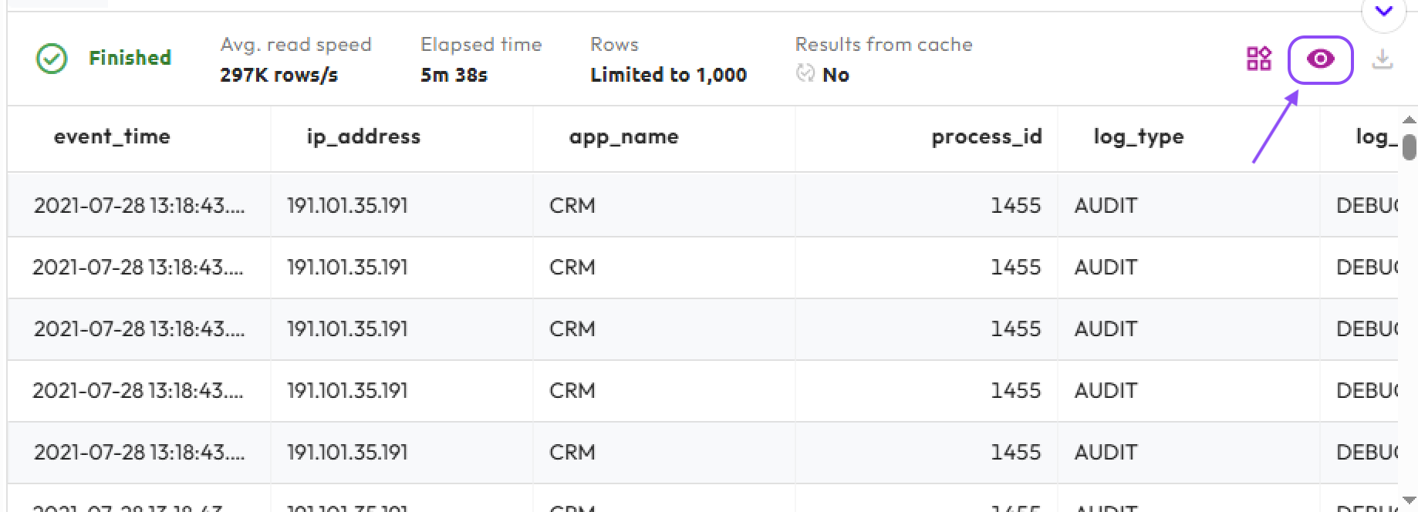

- Select the Advanced tab on the Query details page.

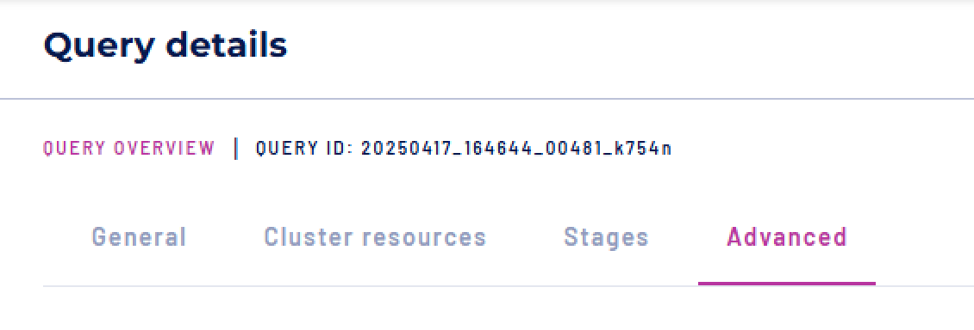

- Now, locate the Execution details section of the page.

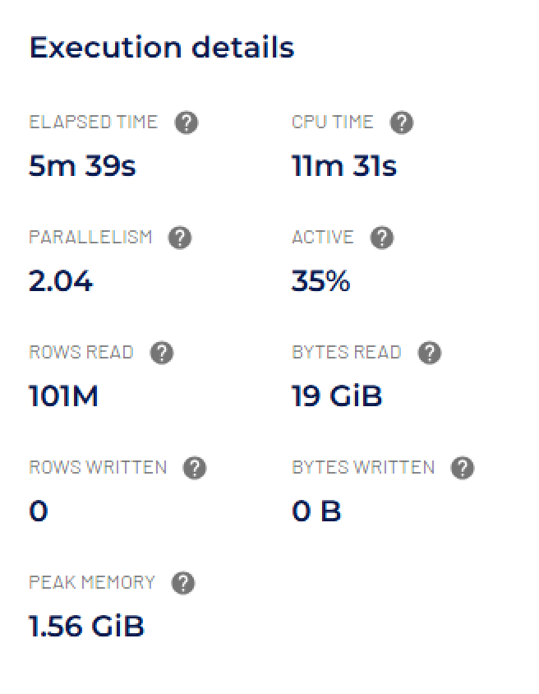

The ROWS READ and BYTES READ values shown in the image above match the dataset details described in Step 2—specifically, the query scanned the entire dataset: 101 million rows totaling 19 GB of server logs.
You’ll also notice the cluster used approximately 11.5 minutes of CPU TIME. If you hover over the question mark next to that label, you’ll see an explanation: this value represents the total CPU time spent running the query, summed across all Workers in the cluster.

- Now, run the same query on a different table that has the same logical structure. The key difference is that this version of the data has been compacted into fewer, larger files and stored in the ORC file format.

SELECT *
FROM hive.serverlogs.logs_daily_rollup_orc
WHERE app_name IN ('CRM', 'ERP')
ORDER BY app_name, log_type, log_level,
message_id, ip_address;

Note: During lab testing, the following error surfaced:

Query exceeded per-node memory limit

If you hit this error, please use the following command to temporarily bypass per-node memory restrictions:

SET SESSION resource_overcommit = true;

Use this only for the query that triggers the memory-limit error. It is meant to unblock an ad hoc query, not to permanently change cluster behavior. The query can still fail if the cluster does not have enough memory available at runtime.

Once you have completed the query, set the resource_overcommit to false.

- Navigate to the Advanced tab of the Query details page again.
- Notice that the number of rows read remains the same, but the total CPU time was reduced by over 50%. This improvement is due to querying a more optimized table—one that uses fewer, larger files in the ORC format—rather than a table made up of many small CSV files.

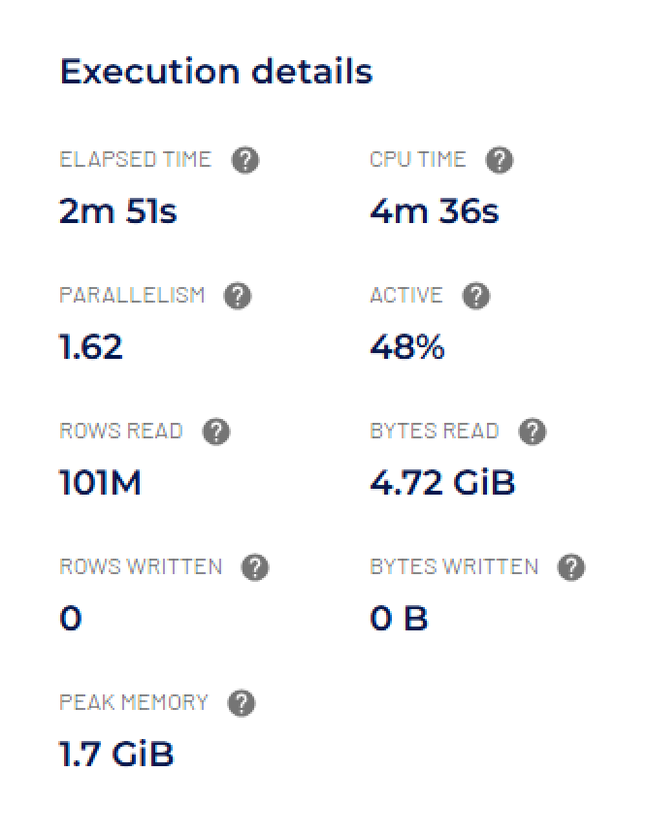

Although the same number of rows were read, the total bytes read were only about 25% of those read from the CSV-backed table.

This efficiency comes from the ORC columnar file format, which applies encoding and compression when data is written. As a result, significantly less data needs to be stored and read from the data lake.

Note: Your Elapsed Time metrics may vary depending on factors like cluster size and concurrent query load. However, your CPU Time should be comparable to what's shown here, as it reflects the actual compute resources required to complete the query.

Step 6: Locate metrics for amount of data exchanged
This step highlights how much data is transferred from the source stage to the next dependent stage in a query. While the concept of query stages will become clearer when we cover query plans in more detail, here's what you need to know for now:

Transferring data between stages adds processing overhead. Just as you aim to minimize the amount of data read from the source system, it's also important to reduce the amount of data passed from one stage to the next.

- To view the metrics, go to the Query details page and select the Advanced tab (as described in Step 5).
- Look for the Query plan section, which should resemble the following example.
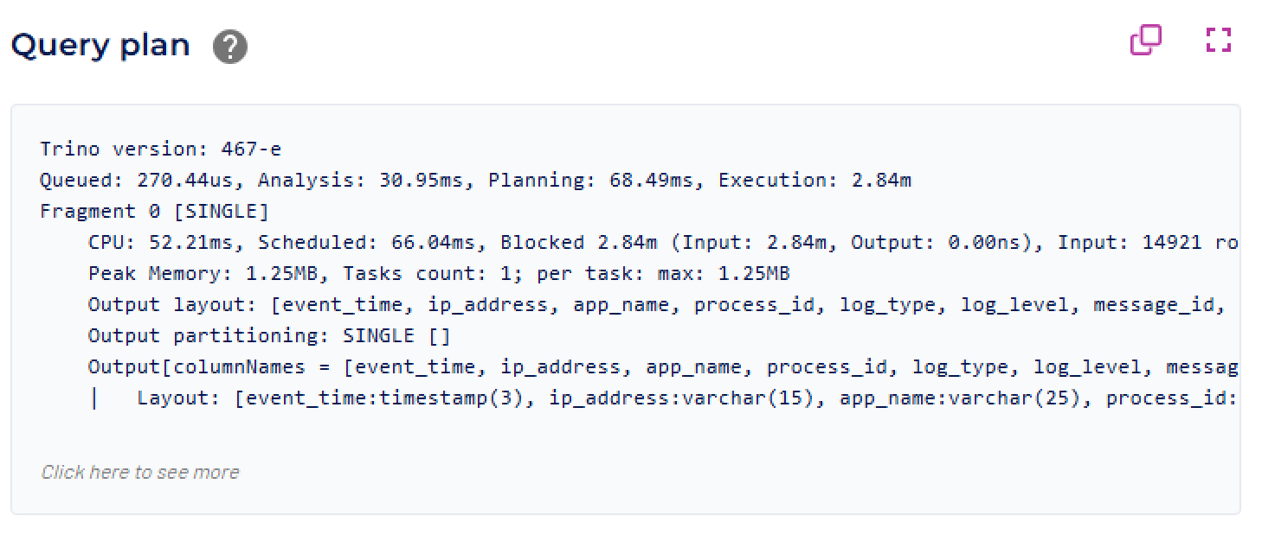
- Click the Click to see more link at the bottom to explore the Query Plan.
- Scroll down to the bottom to find the source fragment (identified as Fragment n [SOURCE]), as illustrated in the following image.
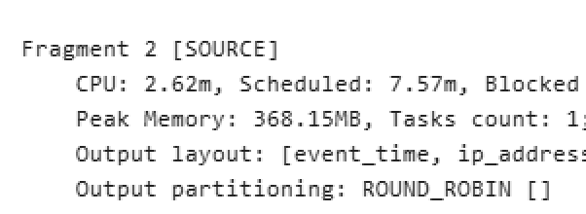
The Fragment number may change from query to query, but if you remember to scroll down to the last Fragment, you can search the far right of the first line of the stage to locate the Output details.
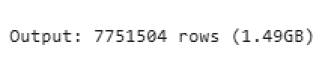
The image above shows that approximately 7.8 million rows—totaling around 1.5GB—were exchanged from the source stage to the next step in the query execution.
You may notice that these values are the same for both tables queried in Step 5. That’s because, by the time the data reaches this stage of the query, it no longer matters whether it originally came from a CSV or ORC file. The same number of rows and columns are being exchanged, so the transfer size remains identical.
Step 7: Benefits of using projection with row-oriented files
In this step, you will modify the query from Step 5 to retrieve a specific set of columns, rather than retrieving all columns. This is called projection, and it always improves performance.

- Run the modified query on the CSV table.

SELECT app_name, log_type, log_level,
message_id, ip_address
FROM hive.serverlogs.logs_5min_ingest_csv
WHERE app_name IN ('CRM', 'ERP')
ORDER BY app_name, log_type, log_level,
message_id, ip_address;

- View the query’s execution details.

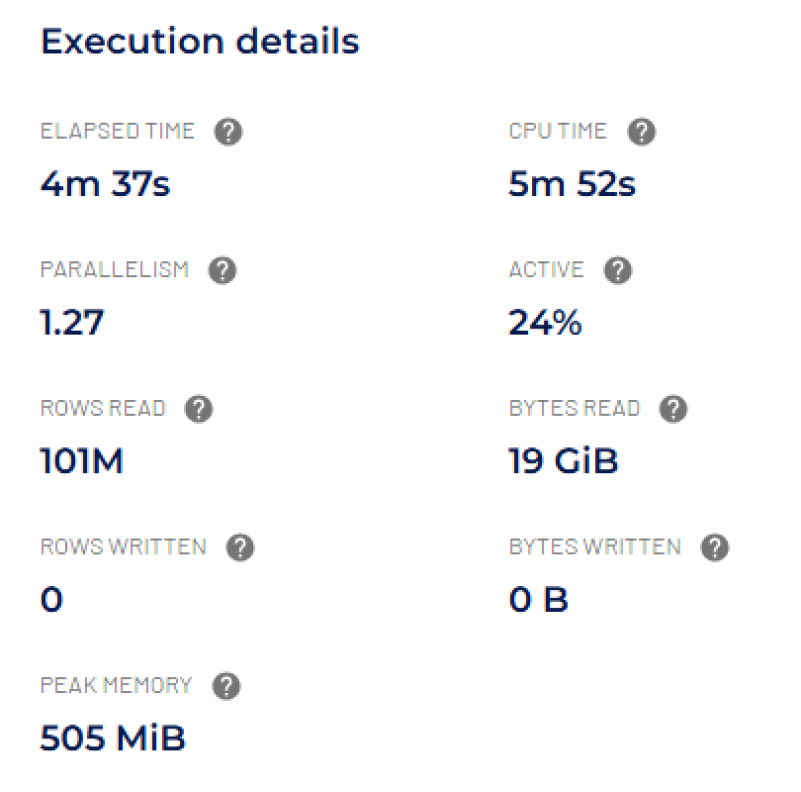

When you compare these metrics to the query execution from Step 5 on the same table, you'll see similar results. While the row-oriented CSV file format can’t fully optimize for reading only a limited set of columns, there is still a performance benefit when projecting specific columns.
- To better understand this, use the approach from Step 6 to check the data exchange metrics and see how much data is passed between stages.

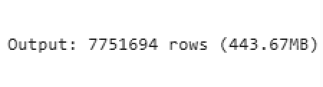

You’ll notice that, while the number of rows exchanged remains around 7.8 million, the data size has dropped to about 30% of the 1.5GB exchanged in the previous query without projection. This reduction is possible because, although the engine couldn't limit how much data was read from the CSV files initially, it can avoid passing along unnecessary columns that weren’t part of the query. By excluding those unused columns during the data exchange, the query uses less memory and improves efficiency.

Step 8: Benefits of using projection with column-oriented files
- Update the query from Step 7 to use the table stored in ORC format. This will allow you to observe the performance benefits of using a columnar file format—specifically when projection is applied.

SELECT app_name, log_type, log_level,
message_id, ip_address
FROM hive.serverlogs.logs_daily_rollup_orc
WHERE app_name IN ('CRM', 'ERP')
ORDER BY app_name, log_type, log_level,
message_id, ip_address;

- Review the Execution details.
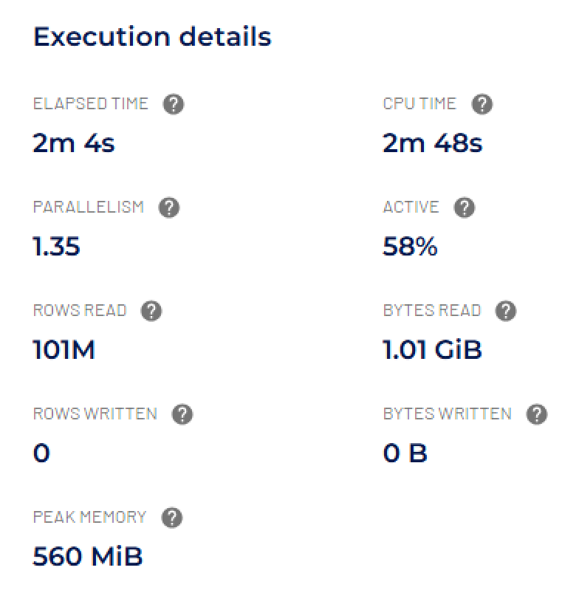

When using the same ORC-backed table from Step 5, we see that the number of rows read remains the same. However:
- The amount of data read is now only about 20% of the original 5GB stored in the data lake.
- CPU time has been reduced by approximately half.
These improvements are due to the columnar file format, which enables the query engine to read only the columns specified in the query.
Comparing these results to the CSV-backed table from earlier in this step, the differences are even more significant:
- Data read from the data lake is reduced to just 5%—only 1GB compared to 20GB.
- CPU time drops to about 25% of the original.
Since reading from the data lake often accounts for a large share of query resource usage, these kinds of optimizations can lead to major performance gains.

Step 9: Locate metrics for number of splits read
When reading from a data lake, the number of files the query engine must access plays a key role in how processing is parallelized. The full dataset is divided into smaller units called splits, which are used to distribute the work across the cluster.

The more files there are, the more splits get created. However, each file access introduces I/O overhead. Ideally, files should be large enough that the engine can read the same number of rows by accessing fewer files, improving efficiency.

- Run the following query to see how many splits were used to read from the data lake.

SELECT ip_address, log_type, log_level, message_id
FROM hive.serverlogs.logs_5min_ingest_orc
WHERE app_name IN ('CRM', 'ERP')
AND log_type = 'THREAT'
AND log_level = 'FATAL'
ORDER BY app_name, log_type, log_level, message_id;

- Navigate to the Query details page again, but this time, select the Stages tab.
- Scroll down, and click to expand each stage.
- Each stage has a list of tasks.

For now, just note that each task corresponds to a worker that was involved in running the query. In the screenshot below, you can see an IP address listed in the Host column on the left—this represents the worker.

For this step, focus on the column with the checkmark (✓) heading. This column represents the number of splits that were processed by the worker. In this case, there were approximately 10K splits.

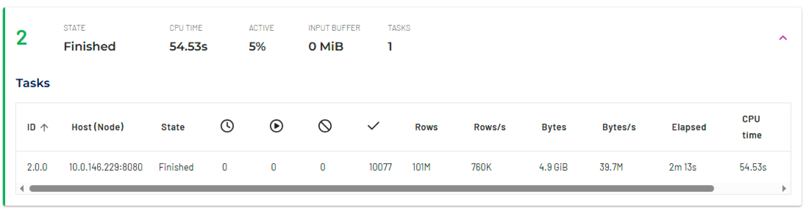

Step 10: Validate small files problem
In earlier steps, we compared logs_5min_ingest_CSV (a table with many small, row-oriented files) and logs_daily_rollup_orc (a compacted table using columnar file formats) to highlight performance differences. In this step, we’ll use a third table, logs_5min_ingest_ORC, to more clearly isolate the impact of small files—by changing only the file format, not the file size.

This table is a hybrid of the two we've already used. Like the CSV table, it contains a large number of small files (i.e., it's not compacted). However, it uses the ORC file format. Because the number and size of files are the same as in the CSV version, this makes it an ideal test case to show the performance impact of small files—separate from the benefits of columnar storage.

When you ran the query in Step 9 using this ORC small-files table, you may have noticed that there was one split per file—highlighting the overhead caused by a high number of small files.
Now, let’s examine the query plan from that execution. If you need a refresher on how to find it, refer back to the instructions in Step 6.

Note: Query plans are read from the bottom up. In Fragment 2, look at the first two metrics displayed.

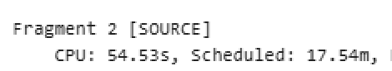

The CPU metric represents the actual amount of CPU time used to process the query, as previously discussed. In contrast, the Scheduled metric reflects the total CPU time that was reserved for the operation—in this case, for reading from the data lake.
In this example, the Scheduled time is 17 times higher than the actual CPU time used. This indicates that much of the time the CPU was reserved, it was actually idle—waiting for I/O operations (such as reading from files) to complete.
This large gap highlights an inefficiency: if we can reduce the time spent waiting on I/O, and therefore close the gap between scheduled and actual CPU time, we could significantly improve query performance.
- Now it’s time to run the query from Step 9 using the new ORC file. Run the following SQL:

SELECT ip_address, log_type, log_level, message_id
FROM hive.serverlogs.logs_daily_rollup_orc
WHERE app_name IN ('CRM', 'ERP')
AND log_type = 'THREAT'
AND log_level = 'FATAL'
ORDER BY app_name, log_type, log_level, message_id;

- Now continue with the remaining instructions in Step 9 to observe the number of splits processed for this table. Your output should resemble the image below, which highlights that the small files table has two orders of magnitude more splits—10,000 compared to just 210—due to the significantly higher number of files.

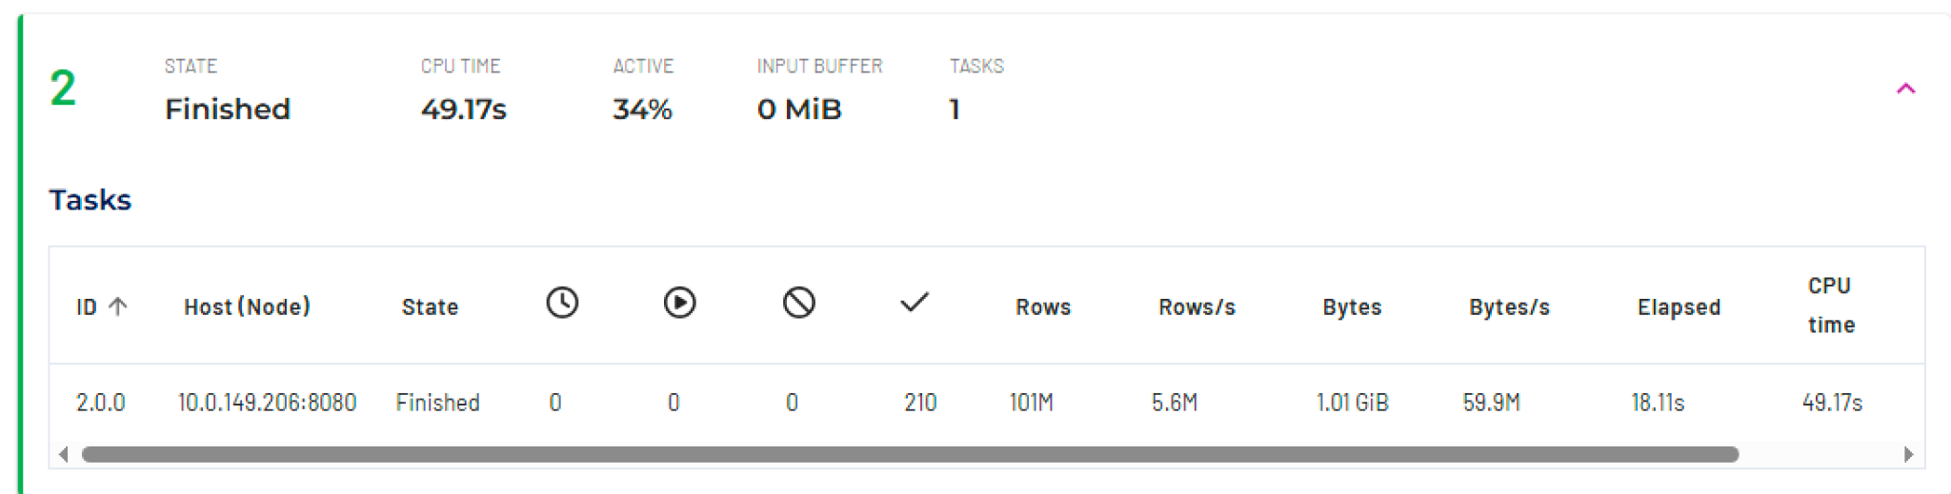

- Determine the CPU and Scheduled metrics for this query.

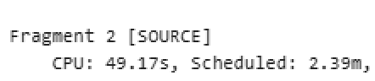

When comparing these metrics to those from the ORC table with small files, you can see that the actual amount of time to process the data was about 50% as much. In addition, the amount of time the CPUs were devoted to reading data is 1/9th as much. This large difference means that all that extra CPU waiting time cannot be allocated to other activities.

Step 11: Use Hive special columns to check for small files
Starburst's Hive connector includes a number of special metadata columns that can show more information about a particular table. These columns are:

- $bucket: Bucket number for this row
- $path: Full file system path name of the file for this row
- $file_modified_time: Date and time of the last modification of the file for this row
- $file_size: Size of the file for this row
- $partition: Partition name for this row

You can use the $path and $file_size columns as a shortcut to check for small files.

- Run the following query, which counts the number of distinct data files in the logs_5min_ingest_orc table and then computes the average file size (in bytes) across all data files accessed by the query.

SELECT COUNT(DISTINCT "$path"), AVG("$file_size")
FROM hive.serverlogs.logs_5min_ingest_orc;
The image below shows a result of 10,077 distinct files and an average file size of ~0.6 MB. This would automatically be a cause for concern.

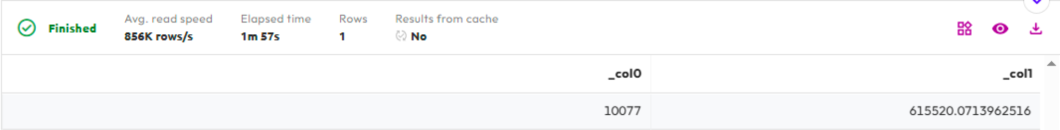

Step 12: The benefits of embedded column statistics for filtering
Column-oriented file formats like ORC and Parquet store column-level statistics for the records within each file. These statistics enable a form of predicate pushdown, where the query engine can read just a small portion of each file to access the stats before scanning the entire file.

Using this metadata, the engine can quickly determine whether a file might contain relevant data—or definitely does not. For example, if the WHERE clause filters on a specific column, the engine can check that column’s minimum and maximum values in the file’s stats to decide whether to skip reading it entirely.

- To see this in action, update your previous query to include filters on the event_time column, and switch back to the CSV table. Since CSV files don’t store column-level stats, they won’t benefit from this optimization.

SELECT ip_address, log_type, log_level, message_id
FROM hive.serverlogs.logs_5min_ingest_csv
WHERE app_name IN ('CRM', 'ERP')
AND log_type = 'THREAT'
AND log_level = 'FATAL'
AND event_time >=
from_iso8601_timestamp(
'2021-07-02T00:00:00')
AND event_time <
from_iso8601_timestamp(
'2021-07-05T00:00:00')
ORDER BY app_name, log_type, log_level, message_id;

- Review the Execution details:

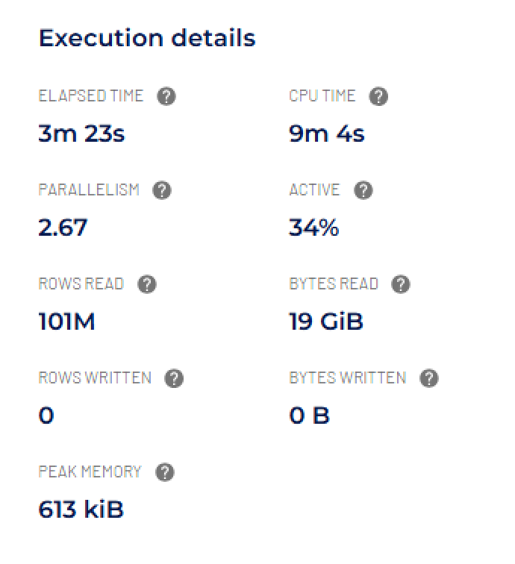

Notice that all rows were read from the table, and that it consumed ~ 9 minutes of CPU time.

- Run the query again, but this time against the ORC table.

SELECT ip_address, log_type, log_level, message_id
FROM hive.serverlogs.logs_daily_rollup_orc
WHERE app_name IN ('CRM', 'ERP')
AND log_type = 'THREAT'
AND log_level = 'FATAL'
AND event_time >=
from_iso8601_timestamp(
'2021-07-02T00:00:00')
AND event_time <
from_iso8601_timestamp(
'2021-07-05T00:00:00')
ORDER BY app_name, log_type, log_level, message_id;

- Review the Execution details:

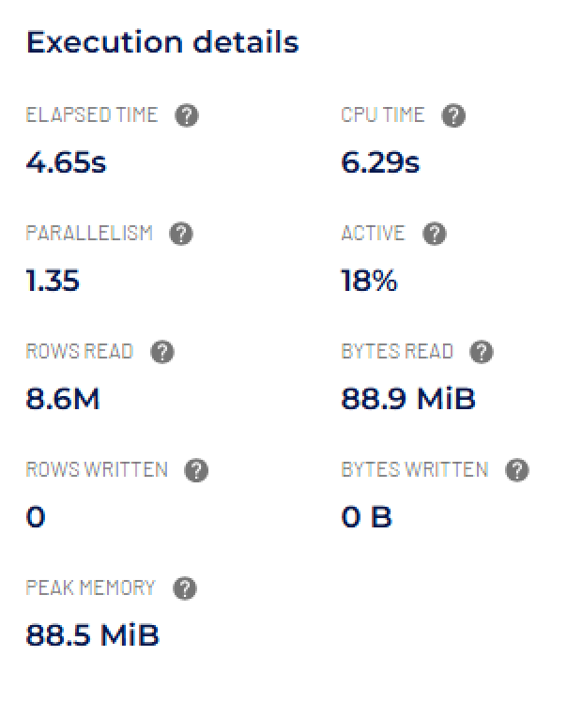

Because the three data files for each day were logically sorted by the event_time field during ingestion and compaction, the query engine could use the file-level statistics to skip unnecessary data. It determined that only 15 out of 105 files contained data relevant to the July 2–3 filter in the query. The remaining files were ignored since their event_time ranges didn’t match the filter criteria.

As a result, fewer than 9 million rows were read, totaling under 100MB of data. This significant reduction in data read led to the query using just 3% of the CPU time compared to the row-oriented file format!

Step 13: The benefits of embedded column statistics for aggregations
Column-level statistics in column-oriented file formats also improve the performance of aggregation queries. For example, simple MIN or MAX calculations in a GROUP BY clause can use the embedded statistics directly, allowing the query engine to quickly determine the result without scanning all rows.

- Run the following query on the CSV table.

SELECT app_name, count() as num_events
FROM hive.serverlogs.logs_5min_ingest_CSV
GROUP BY app_name
ORDER BY num_events, app_name;

- Review the Execution details:

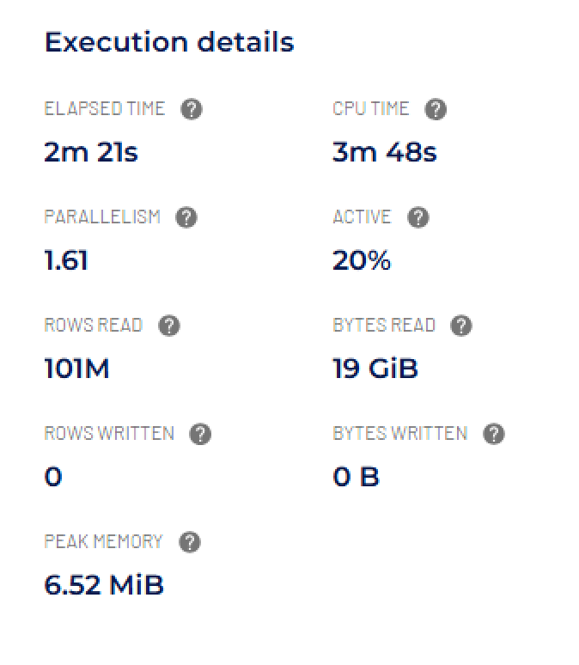

These results are very similar to those on the same table in Step 11 because the entire dataset had to be read.

- Run the query again against the ORC table.

SELECT app_name, count() as num_events
FROM hive.serverlogs.logs_daily_rollup_orc
GROUP BY app_name
ORDER BY num_events, app_name;

- Review the Execution details:

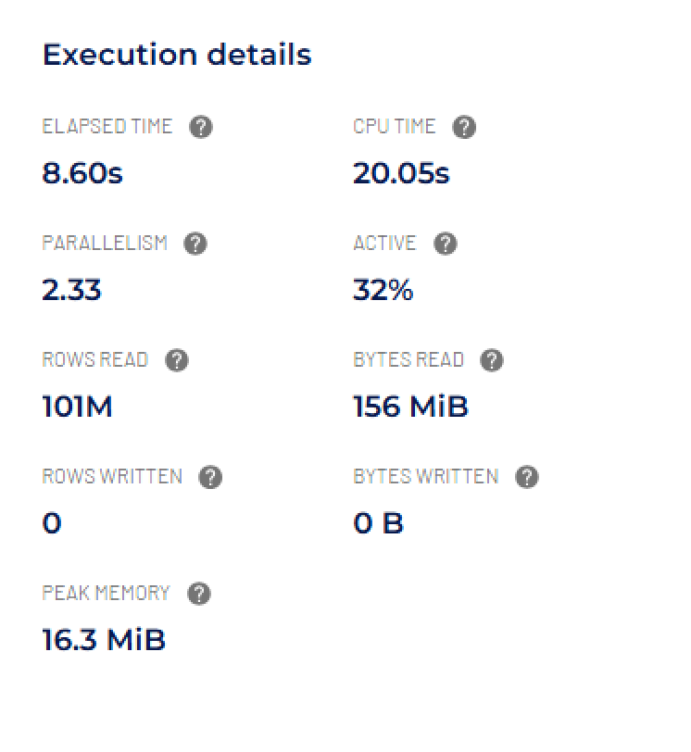

Note that the query run against the ORC table used only about 9% of the CPU time compared to the same query run against the CSV table.

Summary
- You reviewed the differences between row-oriented and columnar file formats which start with a much smaller number of bytes needed due to encoding and compression.
- You determined how small files create performance issues because of significant CPU waiting time on I/O operations.
- Regardless of file format types you validated the benefit of the project & filter – early & often mantra.
- You realized the further performance benefits of projection and filtering with column-oriented file format.
- You saw how column statistics embedded within an individual file improves performance with filtering and aggregations.

END OF LAB EXERCISE

Lab 3: Exploring table partitioning and bucketing
Estimated completion time
- 40 minutes

Learning objectives
- In this lab, you will explore how table partitioning and bucketing, used independently or together, can improve performance. You will see how both of these strategies will read far less data than a full scan of a table when there is a filter that aligns appropriately. You will understand the common strategy for creating a partition column that is derived from a more finite timestamp value.

Activities
- Prepare for the exercise
- Review partitioning & bucketing functionality
- Create a data lake table from TPCH orders table
- Locate metrics for data read
- Table scan orders searching by priority
- Create an orders table partitioned on priority
- Identify partition folders that were read
- Leverage partition pruning with partitioned orders table
- Using a partition column derived from a timestamp
- Table scan orders searching by customer
- Create an orders table bucketed on customer
- Read fewer files with bucketed orders table

Step 1 - Prepare for the exercise
- Sign in and verify the students role is selected in the upper-right corner.

Note: If you did not previously create a schema, execute the following SQL statement. Make sure that you replace yourname with your actual name, or another identifier that you prefer. Only use lowercase characters and numbers; no special characters or spaces.

CREATE SCHEMA hive.yourname
WITH (location = 's3://erin-rosas-may2025/training/hive/yourname/');

Step 2 - Review partitioning & bucketing functionality
Partitioning is just a way to divide data into subfolders. The field(s) you partition a table on become subfolders of the table’s data lake folder. When a WHERE clause is aligned to the partitioned field, then only the folder(s) that meet the particular criteria are read – the rest are ignored.

With bucketing you choose the number of buckets up front and this number if fixed. The values for each row for the bucketed field determine which bucket (a file) the row will consistently go into. When a WHERE clause is aligned to the bucketed field, then only the appropriate file(s) are read – the rest are ignored.

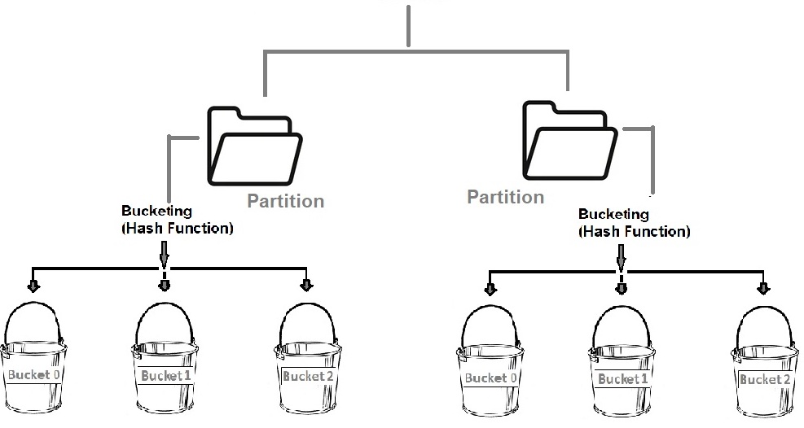

Partitioning and bucketing can be used together or by themselves.

Note: Be careful when creating small files using these features.

Step 3 - Create a data lake table from TPCH orders table
Run a CTAS statement to make a data lake table from the data present in the TCPH orders table.

USE hive.yourname;

CREATE TABLE orders_no_pttn
AS
SELECT *
FROM tpch.sf1.orders;

Verify that the following query returns 941 rows.

SELECT * from orders_no_pttn
WHERE totalprice >= 430000.00;

Step 4 - Locate metrics for data read
Click the Query details icon to the right of the Create data product button.

Click on the Advanced tab.

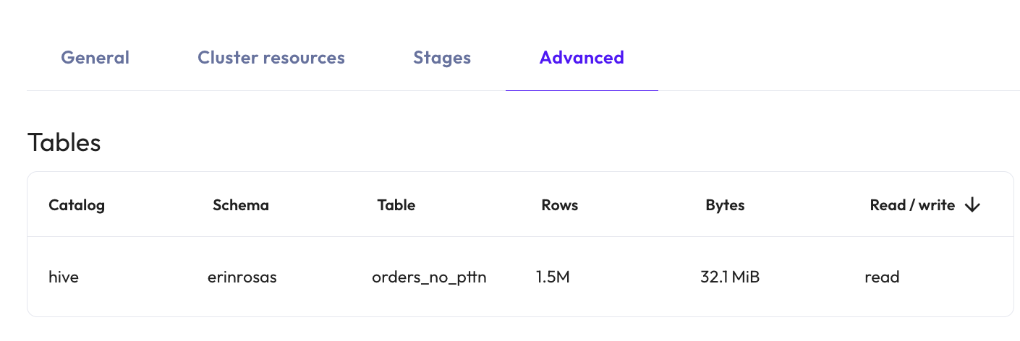

In the Tables section of the Advanced tab you will see values for number of Rows, and the Bytes, read.

For the last query in Step 3, all rows (1.5M) were read from the order_no_pttn table which accounted for 32 MiB of data. For this table, that equated to a full table scan of all records from the data lake.

Step 5 - Table scan orders searching by priority
Enhance the query filtering on the order’s priority field with the following query that returns 187 rows.

SELECT * from orders_no_pttn
WHERE totalprice >= 430000.00
AND orderpriority = '4-NOT SPECIFIED';

Using the process described in Step 4, verify that a full table scan occurred of all 1.5M rows and 32 MiB of data.

Step 6 - Create an orders table partitioned on priority
To create another version of the orders table using the priority field for the partitioning strategy, modify the CTAS statement from Step 3. Enhance it with the appropriate partitioned_by value.

CREATE TABLE orders_pttn_priority
WITH (
partitioned_by = ARRAY['orderpriority']
)
AS
SELECT *
FROM tpch.sf1.orders;

You will receive the following error.

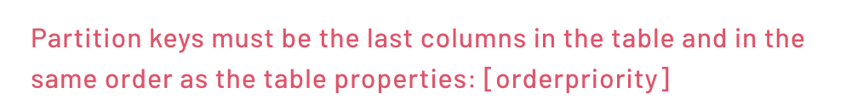

Just as it states, the partition field needs to be the last column in this (Hive) table.

Execute the following statement that reorders the columns so that orderpriority is last.

CREATE TABLE orders_pttn_priority
WITH (
partitioned_by = ARRAY['orderpriority']
)
AS
SELECT orderkey, custkey, orderstatus, totalprice,
orderdate, clerk, shippriority, comment,
orderpriority
FROM tpch.sf1.orders;

Step 7 - Identify partition folders that were read
Run the original query from Step 3, but on this new partitioned table.

SELECT * from orders_pttn_priority
WHERE totalprice >= 430000.00;

Using the process described in Step 4, verify that a full table scan occurred of all 1.5M rows and with a bytes read value similar to the non-partitioned table.

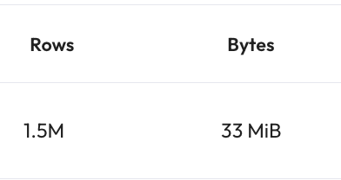

This means that all partition folders for the distinct values of the partitioned field were all read. To verify, look for the Query plan section on the same page as you are now on. If you navigated away, click on Query details then the Advanced tab.

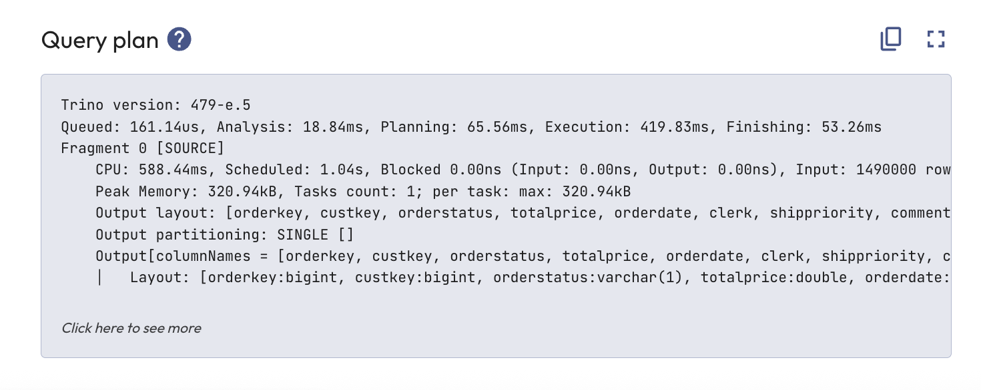

Now, click on the Click here to see more link at the bottom of the Query plan section.

Focus on the two lines above the final output line. These should start with the partitioned_by column name.

Output

orderpriority := orderpriority:varchar(15):PARTITION_KEY
:: [[1-URGENT], [2-HIGH], [3-MEDIUM], [4-NOT SPECIFIED], [5-LOW]]

Because this is a partitioned column, the query plan will show you the folders that were read. The five above represent all of the distinct values for the orderpriority column. This is further evidence that a full table scan occurred.

Step 8 - Leverage partition pruning with partitioned orders table
Add an orderpriority filter to the query and execute it.

SELECT * from orders_pttn_priority
WHERE totalprice >= 430000.00
AND orderpriority = '4-NOT SPECIFIED';

Determine how many rows and bytes were read while executing this query.

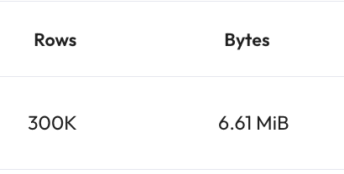

This represents about 20% of the full table scan’s metrics. The sample data we used from TPCH was relatively evenly distributed across the five order priority values which provides anecdotal evidence that only one of the partition folders was read.

Using the process described in Step 7, determine which folder(s) were read during this query’s execution.

Output

orderpriority := orderpriority:varchar(15):PARTITION_KEY
:: [[4-NOT SPECIFIED]]

This solidifies the anecdotal evidence with actual results. When the query engine can read a subset of the partition folders, this is referred to as partition pruning.

Step 9 - Using a partition column derived from a timestamp
To make the benefits of partitioning more obvious, this step will utilize a larger table holding 35 days of server logs with 101M rows.

Run the following to understand how this partitioned table was created.

SHOW CREATE TABLE hive.serverlogs.logs_daily_part_csv;

Output

CREATE TABLE hive.serverlogs.logs_daily_part_csv (
event_time timestamp(3),
ip_address varchar(15),
app_name varchar(25),
process_id smallint,
log_type varchar(15),
log_level varchar(15),
message_id varchar(15),
message_details varchar(555),
log_date char(10)
)
WITH (
external_location =
's3://erin-rosas-may2025/serverlogs/logs_daily_part_csv',
format = 'TEXTFILE',
partitioned_by = ARRAY['log_date'],
textfile_field_separator = ','
)

Note: You can see the table is partitioned on the log_date field, but there is also an event_time field. It is a common practice with Hive tables that need to be partitioned on a more coarse-grained representation of a timestamp to create a second field like this log_date example. That is to say that the log_date will always be the same for any record with an event_time for that same day.

You do not have access to review the data in S3, but here is an example of the contents of one of the 35 days (June 27 - July 31, 2021) as stored in a partition folder.

Each of the 35 days has a single file of ~ 555MB in size in their respective partition folders. This totals up to ~ 20GB of data.

Run a query attempting to leverage only three of the 35 days of data.

SELECT ip_address, log_type, log_level
FROM hive.serverlogs.logs_daily_part_csv
WHERE app_name IN ('CRM', 'ERP')
AND log_type = 'THREAT'
AND log_level = 'FATAL'
AND event_time >=
from_iso8601_timestamp(
'2021-07-02T00:00:00')
AND event_time <
from_iso8601_timestamp(
'2021-07-05T00:00:00')
ORDER BY app_name, ip_address;

Determine how many records and bytes were read.

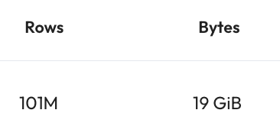

This indicates that a full table scan was performed.

Determine which directories were read.
Output

log_date:char(10):PARTITION_KEY
:: [[2021-06-27, 2021-07-31]]

This shows that an array of directories from 2021-06-27 through 2021-07-31 were read. This verifies that the entire data set was searched through.

The full table scan occurred as the query used the event_time column, not the partitioned log_date column.

Revise the query to use the column that will be leveraged more efficiently.

SELECT ip_address, log_type, log_level
FROM hive.serverlogs.logs_daily_part_csv
WHERE app_name IN ('CRM', 'ERP')
AND log_type = 'THREAT'
AND log_level = 'FATAL'
AND log_date >= '2021-07-02'
AND log_date <= '2021-07-04'
ORDER BY app_name, ip_address;

Determine how many records and bytes were read.

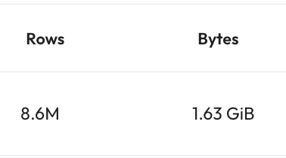

The 101M rows and 20GB of data are relatively evenly distributed across the 35 days. The query was expected to read three of the 35 folders (3/35 or 8.5% of the full data). Performing some quick calculations provides anecdotal evidence that only three of the partition folders were read.

Determine which folders were read during this query’s execution.

Output

log_date:char(10):PARTITION_KEY
:: [[2021-07-02], [2021-07-03], [2021-07-04]]

This solidifies the anecdotal evidence with actual results. The partition pruning resulted in only the three specific day’s folders being read.

Step 10 - Table scan orders searching by customer
Now, run the following query on the non-partitioned orders table to see that searching by a particular customer will result in a full table scan.

SELECT *
FROM hive.yourname.orders_no_pttn
WHERE custkey = 130000;

Verify that all 1.5M rows were read.

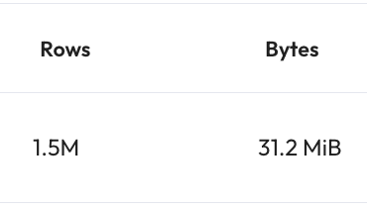

Step 11 - Create an orders table bucketed on customer
Create another table with the same data, but bucket it on the customer identifier column.

CREATE TABLE hive.yourname.orders_bckt_custkey
WITH (
bucketed_by = ARRAY['custkey'],
bucket_count = 4
)
AS
SELECT *
FROM tpch.sf1.orders;

You do not have access to review the data in S3, but here is an example of the contents of this table. The data was even spread by custkey into four separate files of similar size.

Adding them all up validates that a full table scan would read a similar byte count as seen in Step 10.

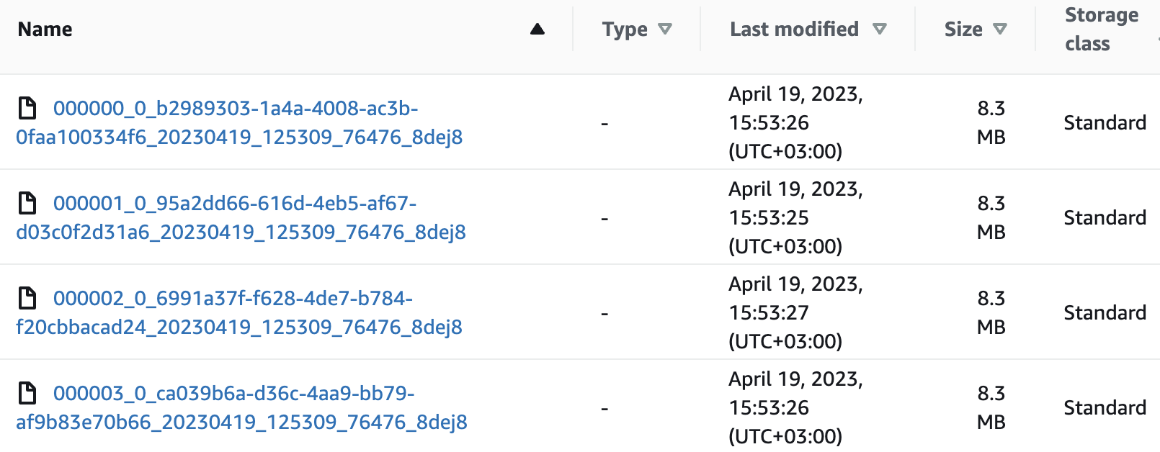

Step 12 - Read fewer files with bucketed orders table
Run the query again, but against the bucketed table.

SELECT *
FROM hive.yourname.orders_bckt_custkey
WHERE custkey = 130000;
Determine how much data was read.

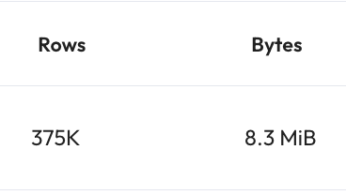

Only about 25% of the data was read because the specific custkey value could only be in one of the four buckets on the data lake.

The customer identifier would not have been a good partitioning column because there are so many unique customers and each customer only has a few orders. That would create a very small file problem. Bucketing was a better choice for this kind of performance expectation.

Remember, partitioning and bucketing can be used independently or in combination.

Summary
- You reviewed the functionality of partitioning & bucketing and how they can be used independently or together
- You determined how to tell if a full table scan was executed to complete a query
- You created a partitioned table that was designed for a particular filter
- You determined how to see if partition pruning worked as expected
- You explored strategies for when a partition needs to be created based on a more coarse-grained aspect of a timestamp
- You created a bucketed table that was designed for a particular filter
- You realized that the bucketed table only reads a single bucket/file when filtering on the bucketed column

END OF LAB EXERCISE

Starburst cache service

Lab 1: Table scan redirection in action
Estimated completion time
- 20 minutes

Learning objectives
By the end of this lab, participants will be able to:

- Explain how table scan redirection works in Starburst.
- Identify connectors and use cases that benefit from redirection.
- Detect when redirection is taking place via the SEP web UI.
- Disable table scan redirection.

Activities
- Verify table scan redirection is working
- Disable table scan redirection
- Re-enable table scan redirection

Cache rules overview
As the administrator of the cluster used in this lab, your instructor has prepared a configuration file that defines how table scan redirection should be applied.

The top-level properties specify that any cached copies of redirected tables will be stored in the hive.cache catalog and schema.
cache-rules.json

{
"defaultGracePeriod": "5m",
"defaultMaxImportDuration": "5m",
"defaultCacheCatalog": "hive",
"defaultCacheSchema": "cache",

"rules": [
{
"catalogName": "bootcamp",
"schemaName": "public",
"tableName": "orders",
"refreshInterval": "24h",
"cacheCatalog": "hive",
"cacheSchema": "cache"
}
]
}

The rules property contains a list of complex objects identifying each table needing to be cached. In the example above, there is only a single configuration and it is for the bootcamp.public.orders table. It is configured to be refreshed once a day.

Table scan redirection use cases
There are two main reasons to consider using table scan redirection:

- Performance improvement: If you want to enhance the performance of SQL queries executed against a table, you can cache data from a smaller database or from one located across a slow network link. By caching the table in a faster data source like object storage, you can leverage a faster connector that supports parallel processing, resulting in improved SQL performance.
- Impact reduction on the source table: Suppose you have a front-end relational database management system (RDBMS) that supports a critical online transaction processing (OLTP) application. While analytics are important, they are not as critical for this particular database compared to transaction processing. By caching the table in a different location, you can significantly reduce the load on the primary database. SQL will only be executed once per interval (e.g., every hour) on the primary database, while all analytic queries will use the cached copy of the table.

Step 1: Verify table scan redirection is working
- Execute the following SQL statement.

SELECT
o.orderkey AS "Order #",
c.name AS "Name",
c.phone AS "Phone",
o.orderpriority AS "Priority"
FROM
bootcamp.public.orders o
JOIN tpch.sf1.customer c ON o.custkey = c.custkey
WHERE
o.orderstatus = 'O'
and o.orderpriority = '2-HIGH';

- Navigate to the Advanced tab of the Query details page.

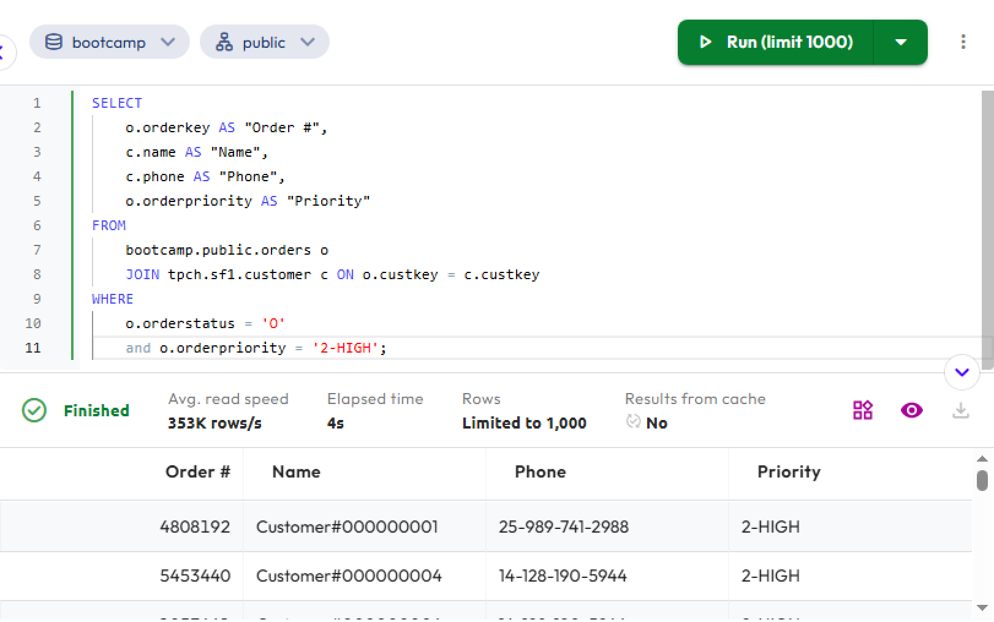
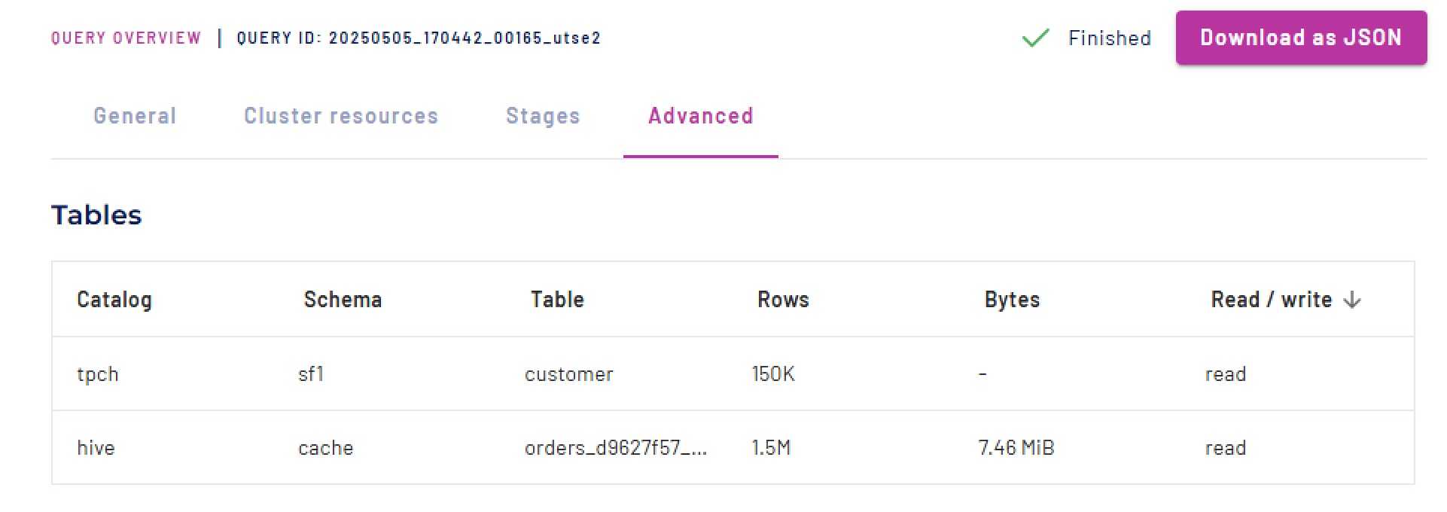

- Notice that instead of the bootcamp catalog, you see the hive catalog and the cache schema. This is showing that at run-time, the cluster determined that this cached table copy could be used instead of accessing bootcamp.public.orders directly.
- Locate the cached copy of the orders table in the Cluster explorer.

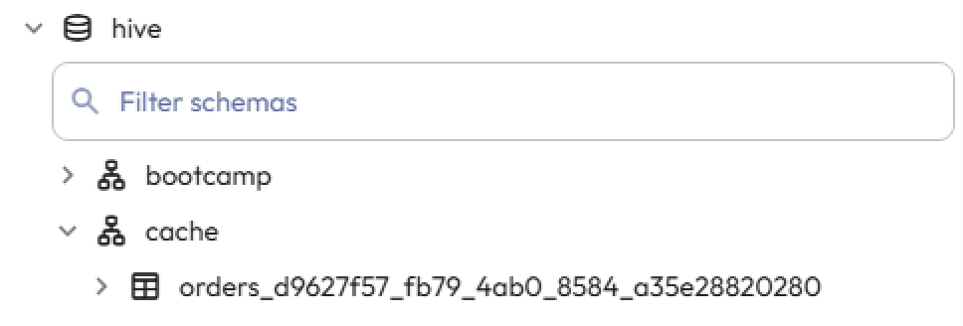

Typically, users executing queries will not be able to view this catalog. You have been given permissions to help you understand the table scan redirection functionality.

Step 2: Disable table scan redirection
- To disable table redirection for any tables configured for cache in the bootcamp catalog, execute the following SQL statement:

SET SESSION bootcamp.table_scan_redirection_enabled = false;

- Run the query from Step 1 again, and verify that the actual bootcamp.public.orders table was read this time:

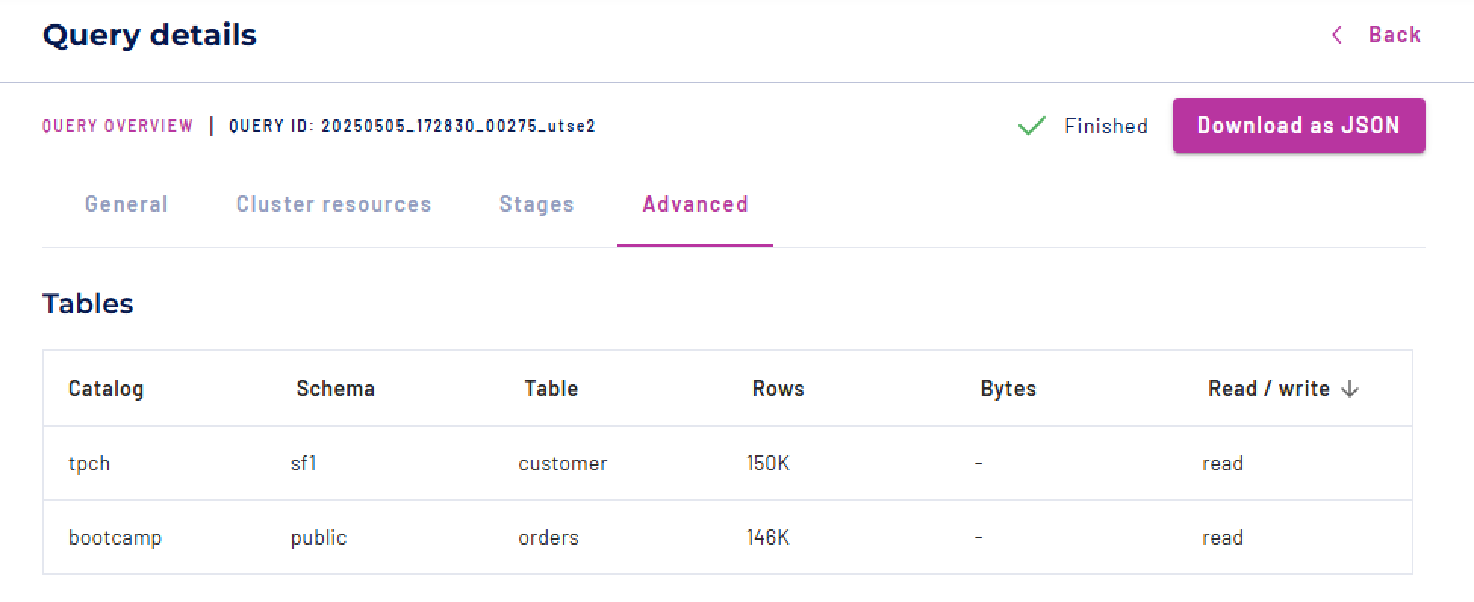

Step 3: Re-enable table scan redirection
- To re-enable table redirection for any tables configured for cache in the bootcamp catalog, execute the following SQL statement:

SET SESSION bootcamp.table_scan_redirection_enabled = true;

- Run the query from Step 1 again, and verify it is now redirecting to the table’s cached copy.

END OF LAB EXERCISE

Lab 2: Using materialized views for performance gains
Estimated completion time
- 20 minutes

Learning objectives
Upon completion of this lab, students will be able to:
- Create and drop materialized views
- Refresh materialized views
- Query materialized views

Activities
- Identify a slow or expensive query
- Create a materialized view
- Refresh the materialized view
- Query the materialized view
- Drop the materialized view

Step 1: Identify a slow or expensive query
The example query for this lab joins two tables from the tpcds.sf1 catalog and schema. The query calculates the total amount of product returns (sr_return_amt) from the store_returns table, grouped by both customer and store, but only for returns that happened in the year 2000.

- Run the query:

SELECT
sr_customer_sk ctr_customer_sk,
sr_store_sk ctr_store_sk,
sum(sr_return_amt) ctr_total_return
FROM
tpcds.sf1.store_returns,
tpcds.sf1.date_dim
WHERE ( (sr_returned_date_sk = d_date_sk) AND (d_year = 2000) )
GROUP BY sr_customer_sk, sr_store_sk;

- Navigate to the Advanced tab of the Query details page to review the query’s Execution details.
- Note the ELAPSED TIME and ROWS READ metrics.

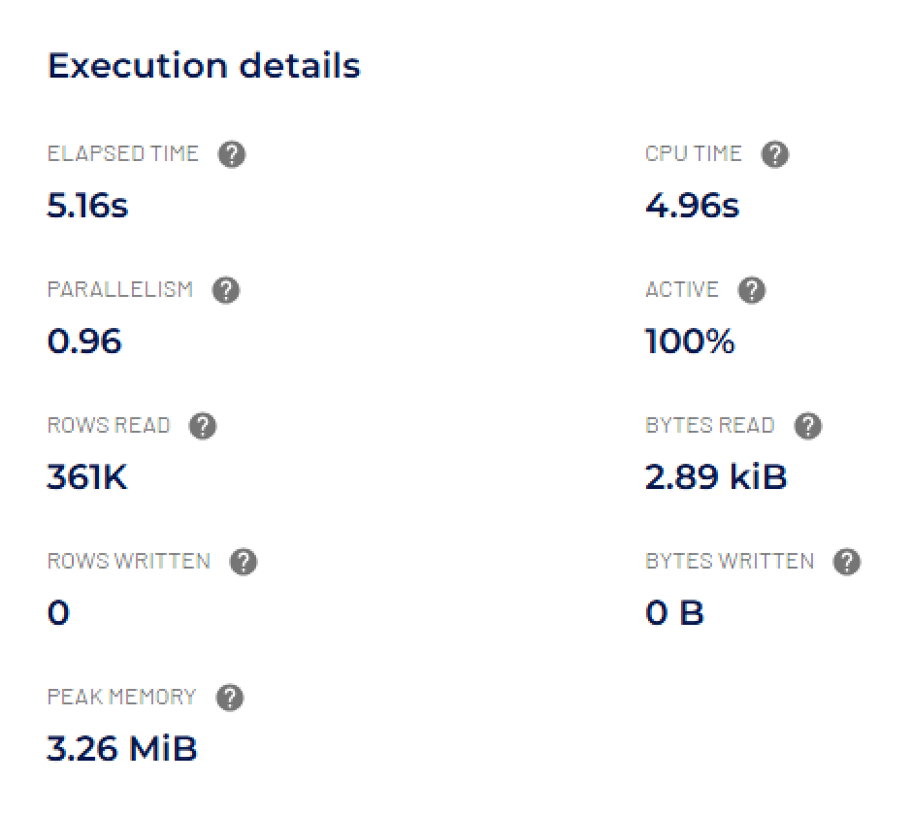

Step 2: Create a materialized view
- Use the following SQL to create a materialized view from the query you just ran.

CREATE MATERIALIZED VIEW hive.materialized_views.customer_total_return
WITH (
grace_period = '5m',
refresh_interval = '5m',
max_import_duration = '4m'
) AS
SELECT
sr_customer_sk ctr_customer_sk,
sr_store_sk ctr_store_sk,
sum(sr_return_amt) ctr_total_return
FROM
tpcds.sf1.store_returns,
tpcds.sf1.date_dim
WHERE ( (sr_returned_date_sk = d_date_sk) AND (d_year = 2000) )
GROUP BY sr_customer_sk, sr_store_sk;

Starburst Documentation includes a section that covers materialized views quite extensively. You can also find details about the options in the query above here. The following are definitions of those options:
- grace_period: Specifies the amount of time in-flight queries can run against an expiring snapshot.
- refresh_interval and cron: Choose one method to specify a refresh frequency. The defined interval must be greater than or equal to five minutes.
- max_import_duration: Specifies how long to allow a refresh to complete before failing.

Step 3: Refresh the materialized view
The first time you query a materialized view, it may not run any faster than the initial query. This is because the CREATE MATERIALIZED VIEW command does not initiate the first materialization. Recall that the caching service handles this, using the refresh-interval as a guide. Ours is set to 5 minutes, which would be the maximum amount of time you would potentially have to wait for the view to refresh.

- Instead of waiting for the refresh, you can force it with the following command:

REFRESH MATERIALIZED VIEW hive.materialized_views.customer_total_return;

Step 4: Query the materialized view
- Run the following SQL to query the materialized view:

SELECT * FROM hive.materialized_views.customer_total_return;

- Review the Execution details. You should see a significant improvement in both the ELAPSED TIME and ROWS READ:

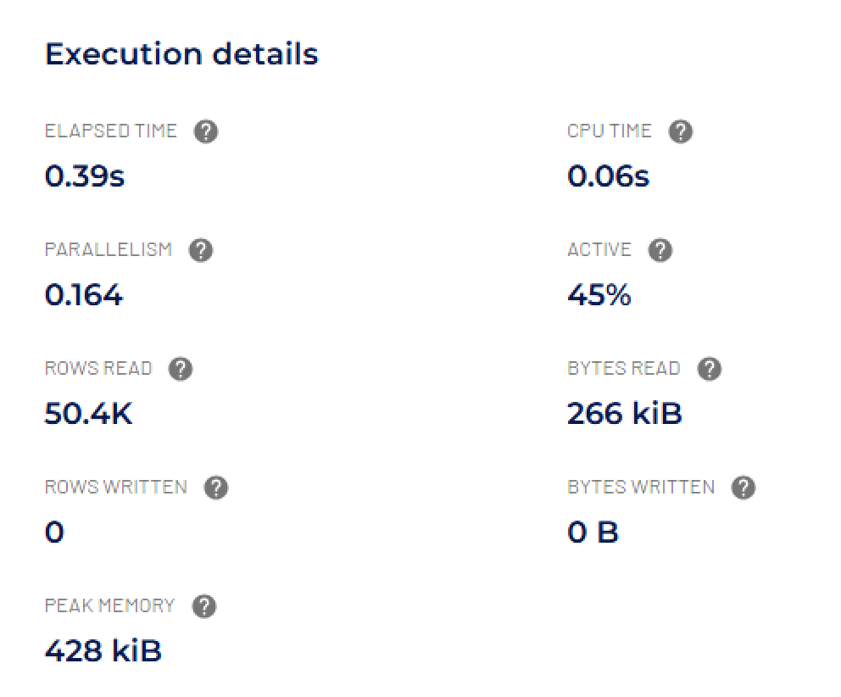

Step 5: Drop the materialized view
- If you no longer need the materialized view, you can drop it with the following command:

DROP MATERIALIZED VIEW hive.materialized_views.customer_total_return;
Summary
Materialized views in Starburst:
- Improve performance by reducing repetitive computations
- Require refresh management to remain accurate

END OF LAB EXERCISE

Data Products for Analysts

Lab 4: Compare Results from Raw Tables vs. a Curated Data Product
Estimated completion time
- 20 minutes

Learning objectives
In this lab, you will compare how customer metrics are calculated using raw source tables versus querying from a curated data product.

The curated dataset, customer_360, combines usage, billing, and CRM data into a single view with pre-calculated metrics such as lifetime_value, avg_usage_last_90_days, and churn_risk_score.

By the end of this lab, you will

- Understand the complexity of working with raw tables.
- Learn how a curated data product simplifies analysis and ensures consistent metrics.
- Use both approaches to answer a key business question: Which customer segments show the highest churn risk?

Prerequisites
- Lab 1: Access Your Lab Environment

Activities
- Explore the raw tables
- Calculate metrics from raw tables
- Query the curated Customer 360 data product
- Query raw tables to answer a business question
- Query a data product to answer a business question

Step 1: Explore the raw tables
- Start by exploring the individual datasets.

-- Raw CRM customers
SELECT *
FROM crm.customers
LIMIT 10;

-- Raw product usage
SELECT *
FROM usage.events
LIMIT 10;

-- Raw subscription revenue
SELECT *
FROM billing.subscriptions
LIMIT 10;

Notice that:
- Usage data contains daily event-level usage hours.
- Billing data contains subscription amounts and renewal dates.
- CRM data contains customer attributes such as segment.

CRM data:
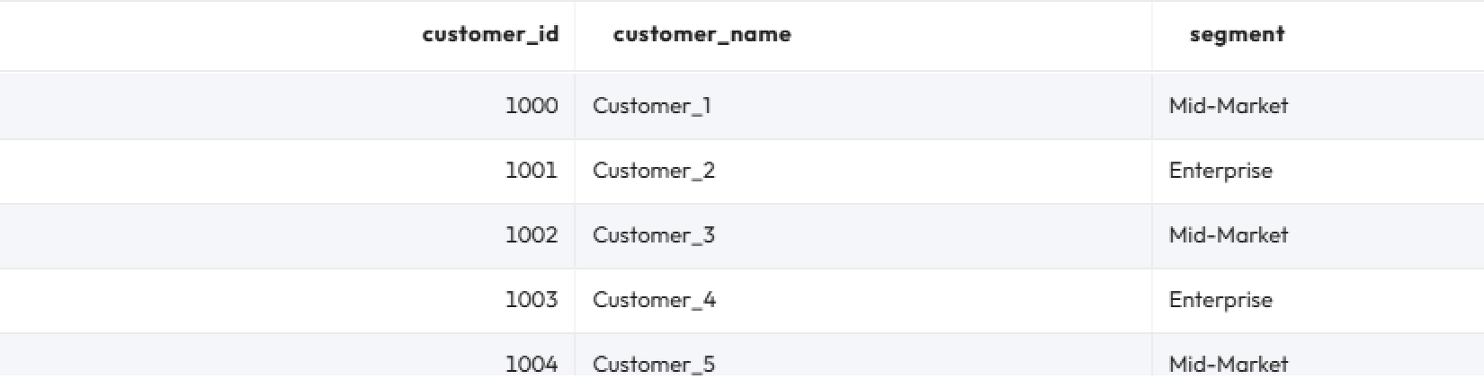

Usage data:
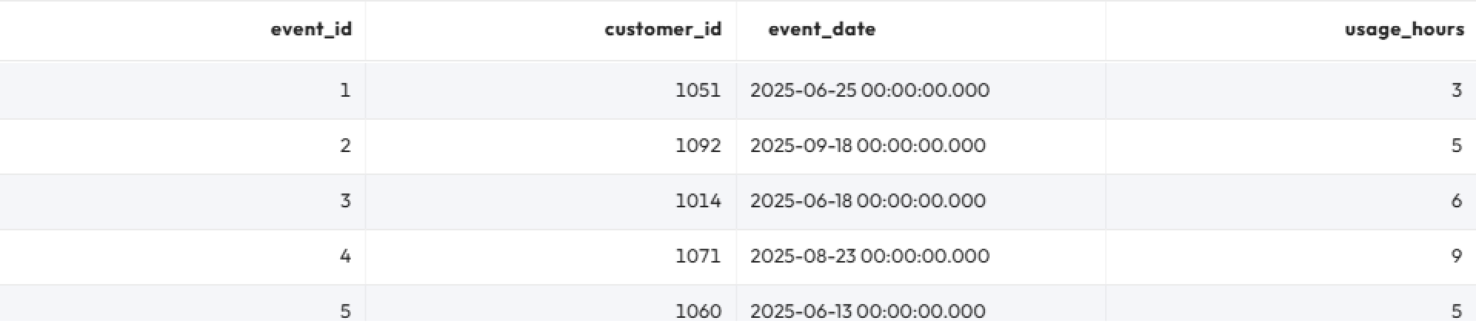

Billing data:
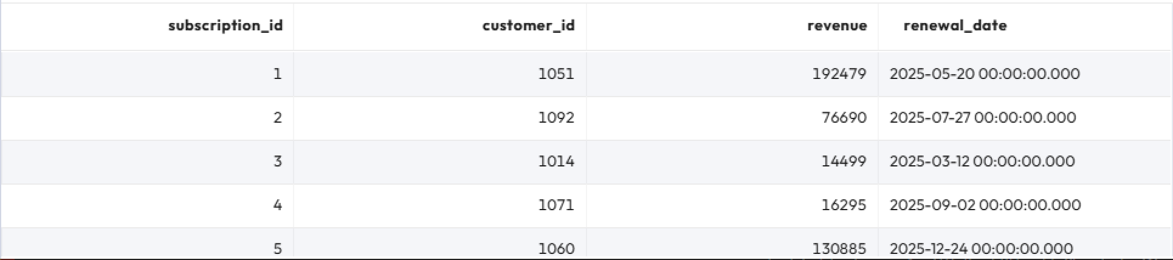

Step 2: Calculate metrics from raw tables
Let’s calculate lifetime_value, avg_usage_last_90_days, and churn_risk_score directly from the raw tables.

SELECT
ev.customer_id,
c.segment,
COALESCE(SUM(s.revenue), 0) AS lifetime_value,
COALESCE(
SUM(
CASE
WHEN ev.event_date >= current_date - INTERVAL '90' DAY THEN ev.usage_hours
ELSE 0
END
) / NULLIF(
COUNT(
DISTINCT CASE
WHEN ev.event_date >= current_date - INTERVAL '90' DAY THEN ev.event_date
END
),
0
),
0
) AS avg_usage_last_90_days,
(
0.7 * CASE
WHEN SUM(
CASE
WHEN ev.event_date BETWEEN current_date - INTERVAL '180' DAY AND current_date - INTERVAL '91' DAY THEN ev.usage_hours
ELSE 0
END
) = 0 THEN 100
WHEN SUM(
CASE
WHEN ev.event_date >= current_date - INTERVAL '90' DAY THEN ev.usage_hours
ELSE 0
END
) >= SUM(
CASE
WHEN ev.event_date BETWEEN current_date - INTERVAL '180' DAY AND current_date - INTERVAL '91' DAY THEN ev.usage_hours
ELSE 0
END
) THEN 0
ELSE LEAST(
100,
(
SUM(
CASE
WHEN ev.event_date BETWEEN current_date - INTERVAL '180' DAY AND current_date - INTERVAL '91' DAY THEN ev.usage_hours
ELSE 0
END
) - SUM(
CASE
WHEN ev.event_date >= current_date - INTERVAL '90' DAY THEN ev.usage_hours
ELSE 0
END
)
) * 100.0 / SUM(
CASE
WHEN ev.event_date BETWEEN current_date - INTERVAL '180' DAY AND current_date - INTERVAL '91' DAY THEN ev.usage_hours
ELSE 0
END
)
)
END + 0.3 * CASE
WHEN MAX(s.renewal_date) <= current_date + INTERVAL '60' DAY THEN 30
ELSE 0
END
) AS churn_risk_score
FROM
hive.usage.events ev
LEFT JOIN hive.billing.subscriptions s ON ev.customer_id = s.customer_id
LEFT JOIN hive.crm.customers c ON ev.customer_id = c.customer_id
GROUP BY
ev.customer_id,
c.segment;

❗This query is long, repetitive, and requires deep knowledge of how to join and aggregate across different datasets.

Step 3: Query the curated Customer 360 data product
Now query the curated dataset customer_360, which provides the same results but with much less complexity:

SELECT
customer_id,
segment,
lifetime_value,
avg_usage_last_90_days,
churn_risk_score
FROM hive.dataproducts.customer_360
LIMIT 20;

✅Notice how much simpler this query is. Analysts don’t need to know about raw schemas, join logic, or calculation rules.

Step 4: Query raw tables to answer a business question
Suppose you are trying to answer the following question: “Which segments show the highest churn risk?”

- Begin by querying the raw tables to answer the question. Note that this query only averages customers that have a computed churn score.

SELECT
c.segment,
AVG(pc.churn_risk_score) AS avg_churn_risk_score,
COUNT(pc.customer_id) AS customers_with_metrics
FROM
crm.customers c
LEFT JOIN (
-- per-customer metrics (usage + subscription) and churn_risk_score
SELECT
u.customer_id,
u.usage_last_90,
u.usage_prev_90,
-- usage score computed once
CASE
WHEN u.usage_prev_90 = 0 THEN 100
WHEN u.usage_last_90 >= u.usage_prev_90 THEN 0
ELSE LEAST(
100,
(u.usage_prev_90 - u.usage_last_90) * 100.0 / u.usage_prev_90
)
END AS usage_score,
COALESCE(subs.lifetime_value, 0) AS lifetime_value,
COALESCE(subs.renewal_score, 0) AS renewal_score,
-- final churn score per customer
(
0.7 * CASE
WHEN u.usage_prev_90 = 0 THEN 100
WHEN u.usage_last_90 >= u.usage_prev_90 THEN 0
ELSE LEAST(
100,
(u.usage_prev_90 - u.usage_last_90) * 100.0 / u.usage_prev_90
)
END + 0.3 * COALESCE(subs.renewal_score, 0)
) AS churn_risk_score,
-- useful context
COALESCE(u.usage_last_90 / NULLIF(u.days_last_90, 0), 0) AS avg_usage_last_90_days
FROM
(
-- usage pre-aggregate per customer
SELECT
ev.customer_id,
SUM(
CASE
WHEN ev.event_date >= current_date - INTERVAL '90' DAY THEN ev.usage_hours
ELSE 0
END
) AS usage_last_90,
SUM(
CASE
WHEN ev.event_date BETWEEN current_date - INTERVAL '180' DAY AND current_date - INTERVAL '91' DAY THEN ev.usage_hours
ELSE 0
END
) AS usage_prev_90,
COUNT(
DISTINCT CASE
WHEN ev.event_date >= current_date - INTERVAL '90' DAY THEN ev.event_date
END
) AS days_last_90
FROM
usage.events ev
GROUP BY
ev.customer_id
) u
LEFT JOIN (
-- subscriptions pre-aggregate per customer
SELECT
s.customer_id,
SUM(s.revenue) AS lifetime_value,
MAX(s.renewal_date) AS next_renewal_date,
CASE
WHEN MAX(s.renewal_date) <= current_date + INTERVAL '60' DAY THEN 30
ELSE 0
END AS renewal_score
FROM
billing.subscriptions s
GROUP BY
s.customer_id
) subs ON u.customer_id = subs.customer_id
) pc ON c.customer_id = pc.customer_id
GROUP BY
c.segment
ORDER BY
avg_churn_risk_score DESC;

❗This query is difficult to read and maintain. It would be much easier to query a data product.

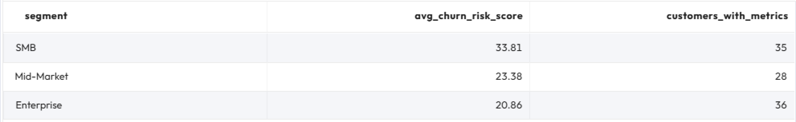

Step 5: Query a data product to answer a business question
- Let’s query the Customer 360 data product to answer the business question “Which segments show the highest churn risk?”

SELECT
segment,
AVG(churn_risk_score) AS avg_churn_risk_score,
COUNT(customer_id) AS customers_with_metrics
FROM hive.dataproducts.customer_360
GROUP BY segment
ORDER BY avg_churn_risk_score DESC;

✅The curated dataset makes answering the business question clear, fast, and reliable. You reach the same results but with much less effort.

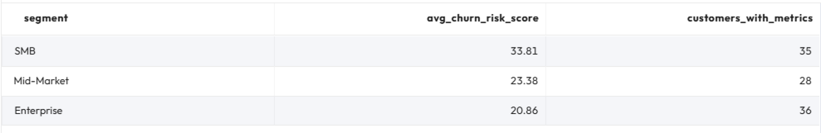

Summary
- Both methods (querying raw tables and data products) produce the same results.
- The raw approach requires a long, complex query.
- The curated approach requires just a few lines.
Key takeaway: Curated data products like Customer 360 enable analysts and business users to focus on insights rather than wrestling with raw schemas.

END OF LAB EXERCISE

Cost-based optimizer

Lab 1: The EXPLAIN command
Estimated completion time
- 20 minutes

Learning objectives
- In this lesson, you will examine query plans using the SQL command EXPLAIN. You will use the EXPLAIN command with two different catalogs, hive and MySQL.

Activities
- Understanding pushdown
- Using EXPLAIN on a relational database
- Run the query
- Run the EXPLAIN command for the previous query
- Review EXPLAIN plan fragments and operators
- Review plan Fragment 1
- Review plan Fragment 0
- Running EXPLAIN on a data lake
- Run EXPLAIN on the query for the first time
- Review plan Fragment 1

Step 1 - Understanding pushdown
One common term that you will hear when learning about query plans is pushdown. Pushdown happens when Starburst pushes a portion of the query processing down to the underlying data source, allowing the data source to complete the processing.

An example of this could be a WHERE clause that will filter out some of the rows. It is more efficient to ask the underlying data source to do this, so fewer rows are returned to Starburst. Depending on the connector type, there may not be an underlying process engine. In that case, Starburst has to do the work.

As you work through this lesson, pay attention to any pushdown that is occurring.

Step 2 - Using EXPLAIN on a relational database

Open a new tab In the Starburst Enterprise query editor, and set the catalog to mysql. Set the schema to query_plan_without_stats.

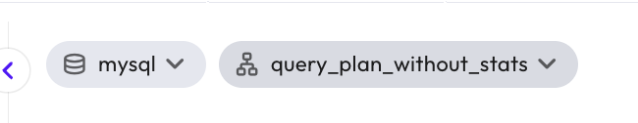

Step 3 - Run the query
This query returns a list, grouped by market segment, of the aggregated count of customers with a balance over $1,000. As you will see in the results, this query returns five total rows, showing that you have five market segments. This is an important thing to remember for later.

Run the following query:

SELECT c.mktsegment, COUNT(*)
FROM customer c
WHERE c.acctbal > 1000
GROUP BY c.mktsegment;

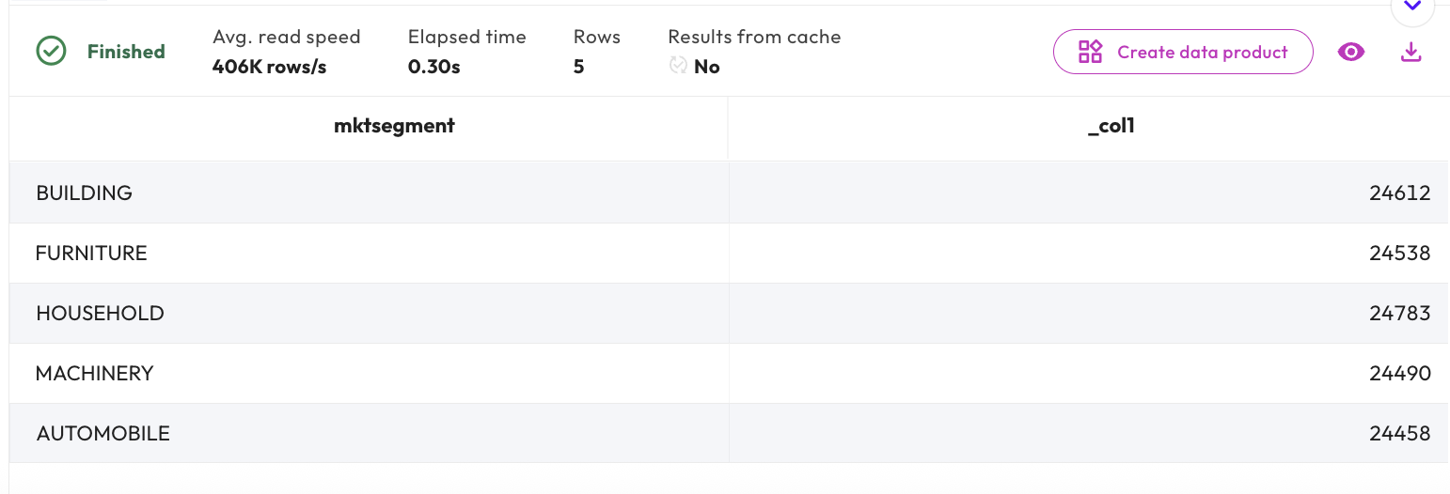

Step 4 - Run the EXPLAIN command for the previous query
Notice that the SQL is almost identical to the previous step; you are just adding EXPLAIN to the beginning.

EXPLAIN
SELECT c.mktsegment, COUNT(*)
FROM customer c
WHERE c.acctbal > 1000
GROUP BY c.mktsegment;

Step 5 - Review EXPLAIN plan fragments and operators
Please note that your exact results may differ from the images shown, depending on the number of nodes you are using.

Begin your analysis with the highest-numbered fragment at the bottom. Always read from the bottom up to review fragments. You should also read from the bottom up within each fragment.

The bottom fragment will always be the SOURCE fragment. Fragments that are not SOURCE fragments will have a RemoteSource [X] Operator, where X is the number of the lower fragment that sent (exchanged) data to the current fragment.

Fragment 0 [HASH]
Output layout: [mktsegment, count]
Output partitioning: SINGLE []
Output[columnNames = [mktsegment, _col1]]
│ Layout: [mktsegment:varchar(255), count:bigint]
│ Estimates: {rows: ? (?), cpu: 0, memory: 0B, network: 0B}
│ _col1 := count
└─ Project[]
│ Layout: [mktsegment:varchar(255), count:bigint]
│ Estimates: {rows: ? (?), cpu: ?, memory: 0B, network: 0B}
└─ Aggregate[type = FINAL, keys = [mktsegment], hash = [$hashvalue]]
│ Layout: [mktsegment:varchar(255), $hashvalue:bigint, \
count:bigint]
│ Estimates: {rows: ? (?), cpu: ?, memory: ?, network: 0B}
│ count := count("count_0")
└─ LocalExchange[partitioning = HASH, hashColumn = [$hashvalue], \
arguments = ["mktsegment"]]
│ Layout: [mktsegment:varchar(255), count_0:bigint, \
$hashvalue:bigint]
│ Estimates: {rows: ? (?), cpu: ?, memory: 0B, network: 0B}
└─ RemoteSource[sourceFragmentIds = [1]]
Layout: [mktsegment:varchar(255), count_0:bigint, \
$hashvalue_1:bigint]
Fragment 1 [SOURCE]
Output layout: [mktsegment, count_0, $hashvalue_2]
Output partitioning: HASH [mktsegment][$hashvalue_2]
Aggregate[type = PARTIAL, keys = [mktsegment], hash = [$hashvalue_2]]
│ Layout: [mktsegment:varchar(255), $hashvalue_2:bigint, count_0:bigint]
│ count_0 := count(*)
└─ ScanProject[table = mysql_query_plan:query_plan_without_stats. \
customer query_plan_without_stats.customer constraint on \
[acctbal] columns=[mktsegment:varchar(255):TINYTEXT]]
Layout: [mktsegment:varchar(255), $hashvalue_2:bigint]
Estimates: {rows: ? (?), cpu: ?, memory: 0B, network: 0B}/ \
{rows: ? (?), cpu: ?, memory: 0B, network: 0B}
$hashvalue_2 := combine_hash(bigint '0', COALESCE( \
"$operator$hash_code"("mktsegment"), 0))
mktsegment := mktsegment:varchar(255):TINYTEXT
SOURCE fragment
The bottom fragment will always be the SOURCE fragment. It is also the highest-numbered fragment. Query plans should be read from the bottom up.

Remote source operator
Fragments that are not SOURCE fragments will have a RemoteSource [X] operator, where X is the number of the lower fragment exchanged (sent) data to the current fragment. So, in this case, Fragment 1 sent data to Fragment 0.

Step 6 - Review plan Fragment 1
Review the labeled graphic of Fragment 1 below. Click on each plus sign to learn more about the corresponding section of the fragment.

Note: Don't forget to read from the bottom up.

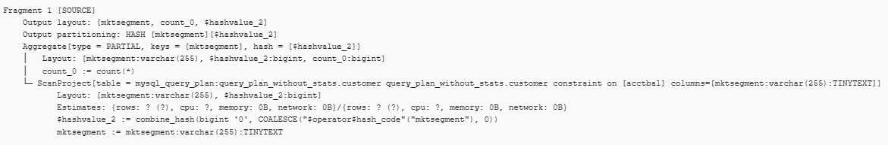

Click here to explore the query plan fragment.

Step 7 - Review plan Fragment 0
Review the labeled graphic of Fragment 0 below. Click on each plus sign to learn more about the corresponding section of the fragment.

Note: Don't forget to read from the bottom up.
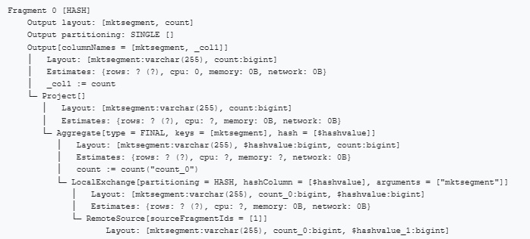

Click here to explore the query plan fragment.

Step 8 - Running EXPLAIN on a data lake
In this section, you’ll run EXPLAIN on the same query that you ran in the last section. This time, however, you will be querying a data lake rather than a relational database. The explanations provided will focus on the differences between hive and what you saw with MySQL.

Open another tab in the query editor.

Now set the catalog to hive. Set the schema to query_plan_without_stats.

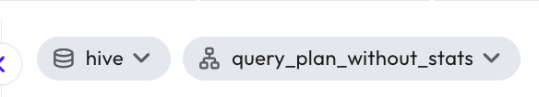

Step 9 - Run EXPLAIN on the query for the first time
Use EXPLAIN on the query using the code below.

EXPLAIN
SELECT c.mktsegment, COUNT(*)
FROM customer c
WHERE c.acctbal > 1000
GROUP BY c.mktsegment;

Step 10 - Review plan Fragment 1
Fragment 0 is identical to what you saw above with the relational database. Fragment 1 has a slightly different operator, as you’ll see now.

Review the labeled graphic of Fragment 1 below. Click on each plus sign to learn more about the corresponding section of the fragment.

Note: Don't forget to read from the bottom up.

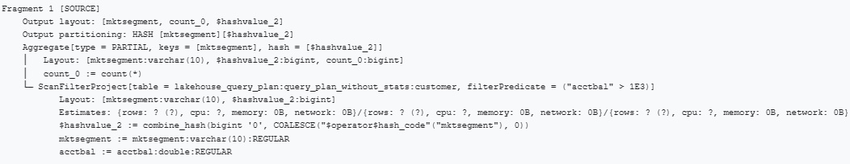

Click here to explore the query plan fragment.

The EXPLAIN command is a convenient tool used to view a logical query plan without actually executing the query. Query plans are composed of numbered fragments. When reviewing a query plan, you must always start from the bottom, or SOURCE, fragment.

Knowing how to interpret this output is critical to performance tuning. In the next lesson, you will get some more practice with query plans, this time using the EXPLAIN ANALYZE command.

END OF LAB EXERCISE

Lab 2: The EXPLAIN ANALYZE command

Estimated completion time
- 20 minutes

Learning objectives
- In this lesson, you will build upon your knowledge of query plans by examining the output of the SQL EXPLAIN ANALYZE command. You will once again compare the query plan output for a relational database and a data lake.

Activities
- Understanding EXPLAIN ANALYZE
- Set up relational database environment
- Run the EXPLAIN ANALYZE command for a query in MySQL
- Review plan Fragment 2
- Review plan Fragment 1
- Run EXPLAIN ANALYZE on a data lake
- Set up your data lake environment
- Run EXPLAIN ANALYZE for the query from the first section
- Review plan Fragment 2

Step 1 - Understanding EXPLAIN ANALYZE
EXPLAIN ANALYZE differs from EXPLAIN in that it not only provides the query plan but executes the query as well. You will see some additional information in the query plan output.

It includes the extra execution metrics that illustrate what occurred when the SQL ran.

It does not include a Fragment 0 because the result of an EXPLAIN ANALYZE is the plan itself. This is because the system does not output the results of the SQL, which nullifies the need for a Fragment 0.

Step 2 - Set up relational database environment
Begin by setting up your environment using the following steps:
- Sign in to your Starburst Enterprise account.
- Expand Query and click Query editor.
- Set the catalog to mysql.
- Set the schema to query_plan_without_stats.

Step 3 - Run the EXPLAIN ANALYZE command for a query in MySQL
Notice that the query is the same one you used in the last lesson.

EXPLAIN ANALYZE
SELECT c.mktsegment, COUNT(*)
FROM customer c
WHERE c.acctbal > 1000
GROUP BY c.mktsegment;

Step 4 - Review plan Fragment 2
Review the labeled graphic of Fragment 2 below. Click on each plus sign to learn more about the corresponding section of the fragment.

Note: Don't forget to read from the bottom up.

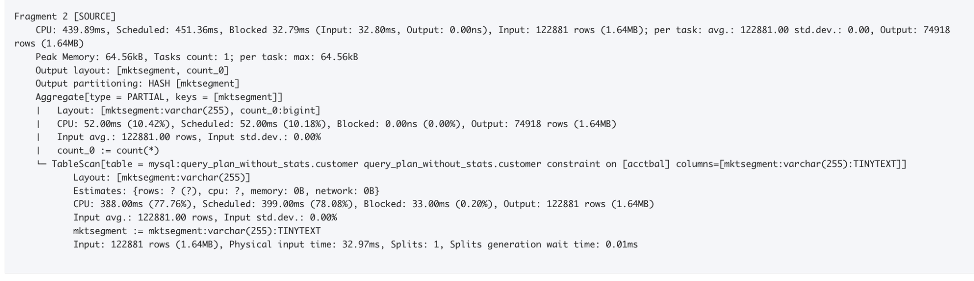

Click here to explore the query plan fragment.

Step 5 - Review plan Fragment 1
Notice that the final aggregation of the hashes is a very small part of the overall processing time. Review the labeled graphic of Fragment 1 below. Click on each plus sign to learn more about the corresponding section of the fragment.

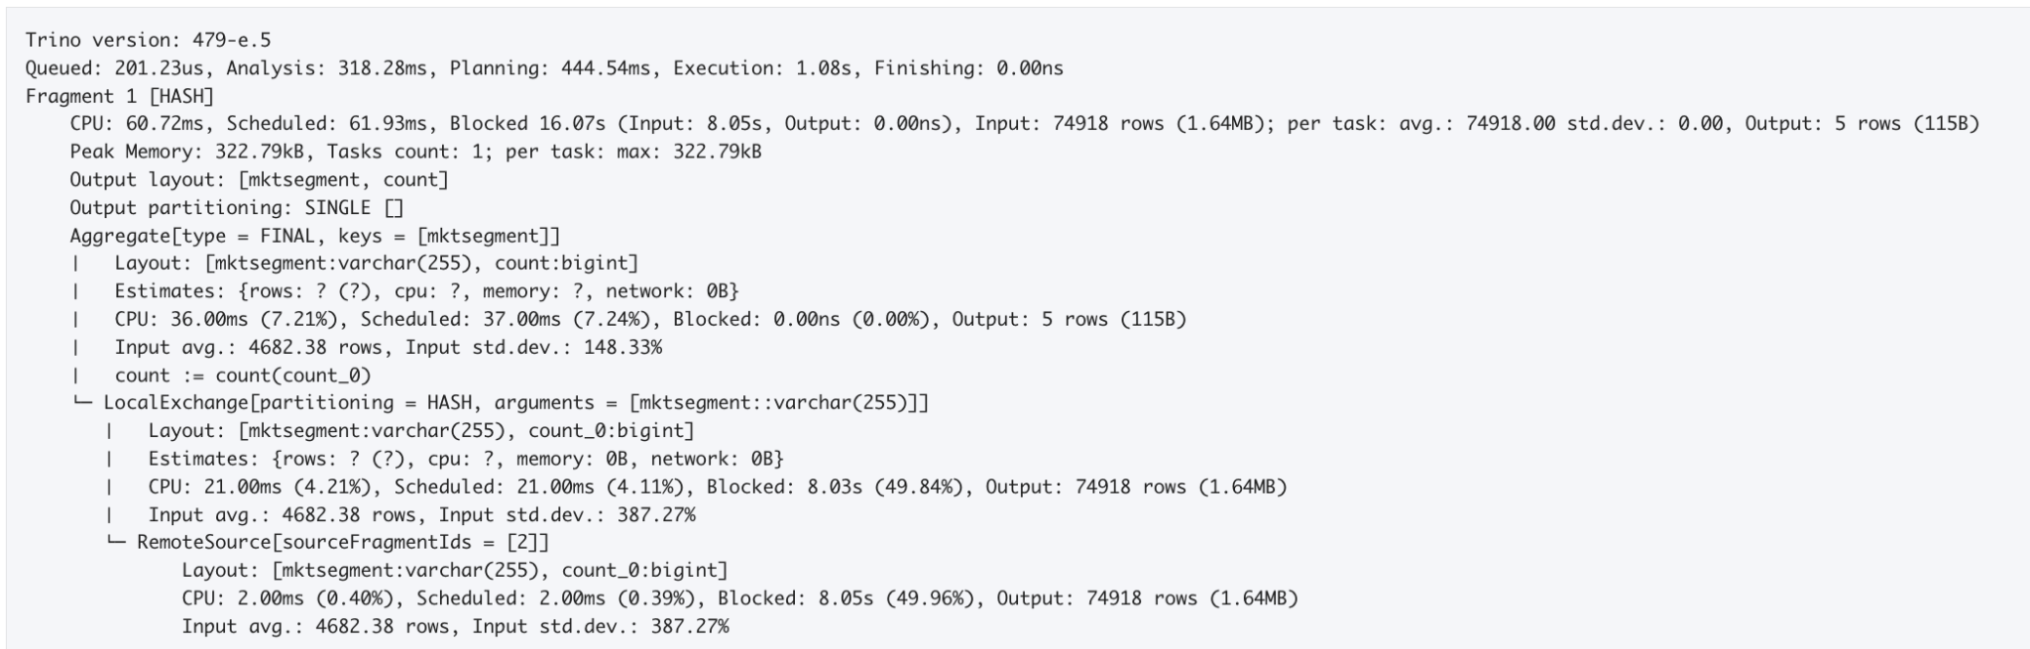
Click here to explore the query plan fragment

Step 6 - Run EXPLAIN ANALYZE on a data lake
In this section, you’ll run EXPLAIN ANALYZE on the same query that you ran in the last section. This time, however, you will be querying a data lake rather than a relational database. The explanations provided will focus on the differences between hive and what you saw with MySQL.

Step 7 - Set up your data lake environment
Begin by setting up your environment using the following steps:
- Open another tab in the query editor.
- Set the catalog to hive.
- Set the schema to query_plan_without_stats.

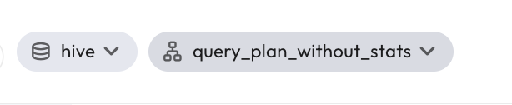

Step 8 - Run EXPLAIN ANALYZE for the query from the first section
Run the following SQL:

EXPLAIN ANALYZE
SELECT c.mktsegment, COUNT(*)
FROM customer c
WHERE c.acctbal > 1000
GROUP BY c.mktsegment;

Step 9 - Review plan Fragments 2 & 1
There are several interesting differences between the EXPLAIN ANALYZE running on MySQL and Hive.

Review the labeled graphics of Fragment 2 & 1 below. Click on each plus sign to learn more about the corresponding section of the fragment.

Note: Don't forget to read from the bottom up.

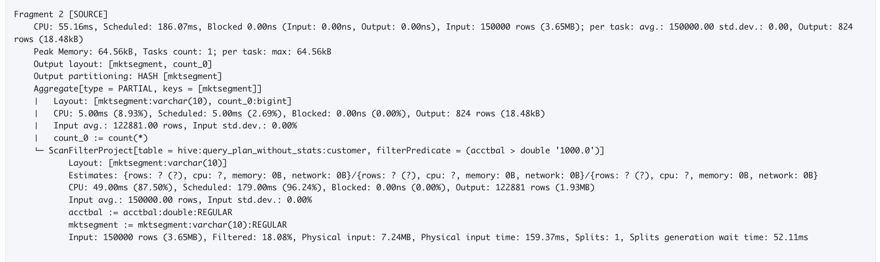
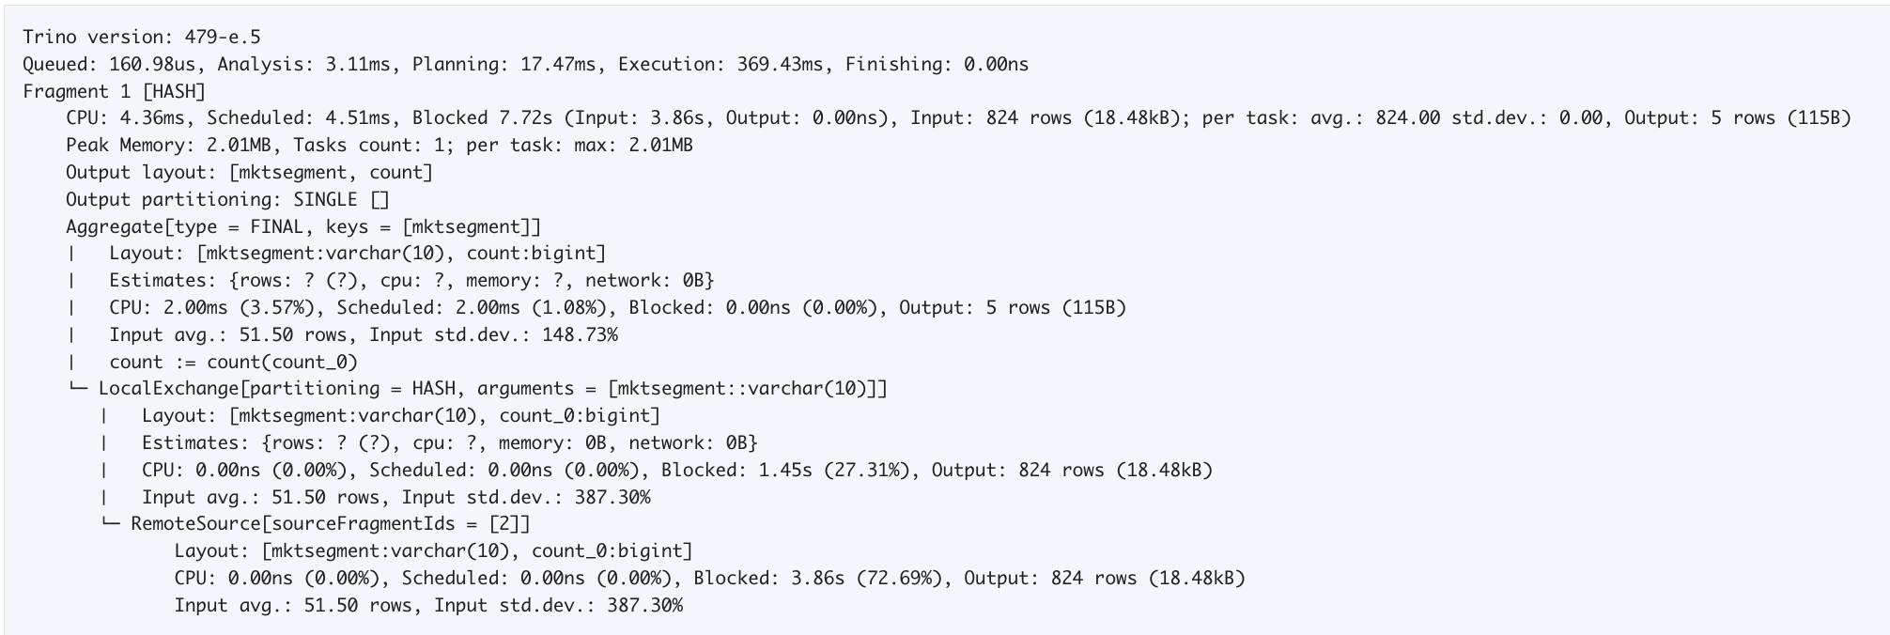

Click here to explore query plan fragment 2
Click here to explore query plan fragment 1

END OF LAB EXERCISE

Lab 3: Explore the impact of statistics on query plans

Estimated completion time
- 45 minutes

Learning objectives
- In this lesson, you will see how the Starburst Cost-based optimizer (CBO) works with SQL JOIN functions. You’ll write JOIN functions for tables with and without statistics and explore their functionality with the EXPLAIN and EXPLAIN ANALYZE commands. How you join datasets can have a huge impact on query performance, so optimizing queries that join data sets is a critical part of using Starburst. You will once again compare the query plan output for a relational database and a data lake.

Activities
- Set up data lake environment without stats
- Run the query that joins two tables
- Run EXPLAIN ANALYZE for the query
- Review plan Fragment 4
- Review plan Fragment 3
- Review plan Fragment 2
- Review plan Fragment 1
- Set up environment with stats
- View the table stats
- Run EXPLAIN ANALYZE with stats
- Review plan Fragment 3
- Review plan Fragment 2
- Review plan Fragment 1

Step 1 - Set up environment without stats
Begin by setting up your environment using the following steps:
- Log into your Starburst Enterprise account.
- Expand Query and click Query editor.
- Set the catalog to hive.
- Set the schema to query_plan_without_stats.

Step 2 - Run the query that joins two tables
Start by running the query that you will be using in this section. The purpose of this query is to return a list of the aggregated count of orders where the customers' account balance is over $5,000. The result will be grouped by order status and should show three rows.

SELECT o.orderstatus, COUNT(*)
FROM customer c JOIN orders o ON (c.custkey = o.custkey)
WHERE c.acctbal > 5000
GROUP BY o.orderstatus;

Step 3 - Run EXPLAIN ANALYZE for the query
Run the following SQL to generate the query plan.

EXPLAIN ANALYZE
SELECT o.orderstatus, COUNT(*)
FROM customer c JOIN orders o ON (c.custkey = o.custkey)
WHERE c.acctbal > 5000
GROUP BY o.orderstatus;

Step 4 - Review plan Fragment 4
Fragment 4 is one of two SOURCE fragments for this query plan. There are two because the query includes two tables. Fragment 4 is gathering data from the orders table, while Fragment 3, as you’ll see, is gathering data from the customer table.

Review the labeled graphic of Fragment 4 below. Click on each plus sign to learn more about the corresponding section of the fragment.

Note: Don't forget to read from the bottom up.

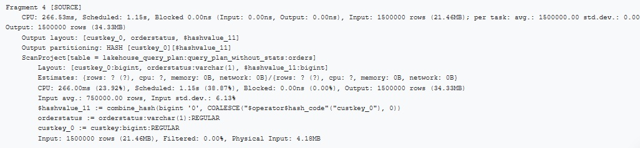

Click here to explore the query plan fragment.

Step 5 - Review plan Fragment 3
Again, Fragment 3 is responsible for the customer table.

Review the labeled graphic of Fragment 3 below. Click on each plus sign to learn more about the corresponding section of the fragment.

Note: Don't forget to read from the bottom up.

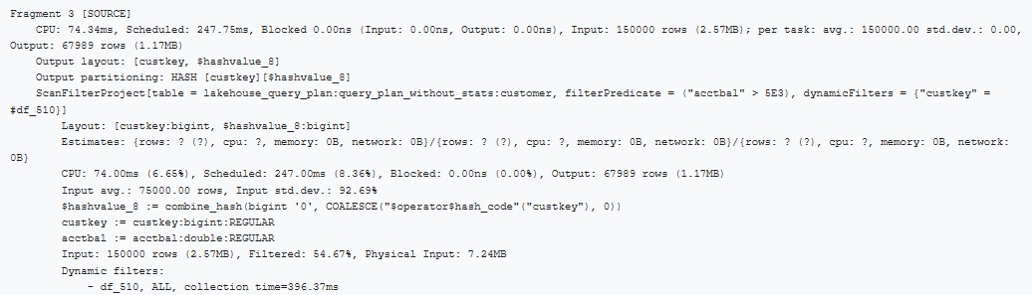

Click here to explore the query plan fragment.

Step 6 - Review plan Fragment 2
Review the labeled graphic of Fragment 2 below. Click on each plus sign to learn more about the corresponding section of the fragment.

Note: Don't forget to read from the bottom up.

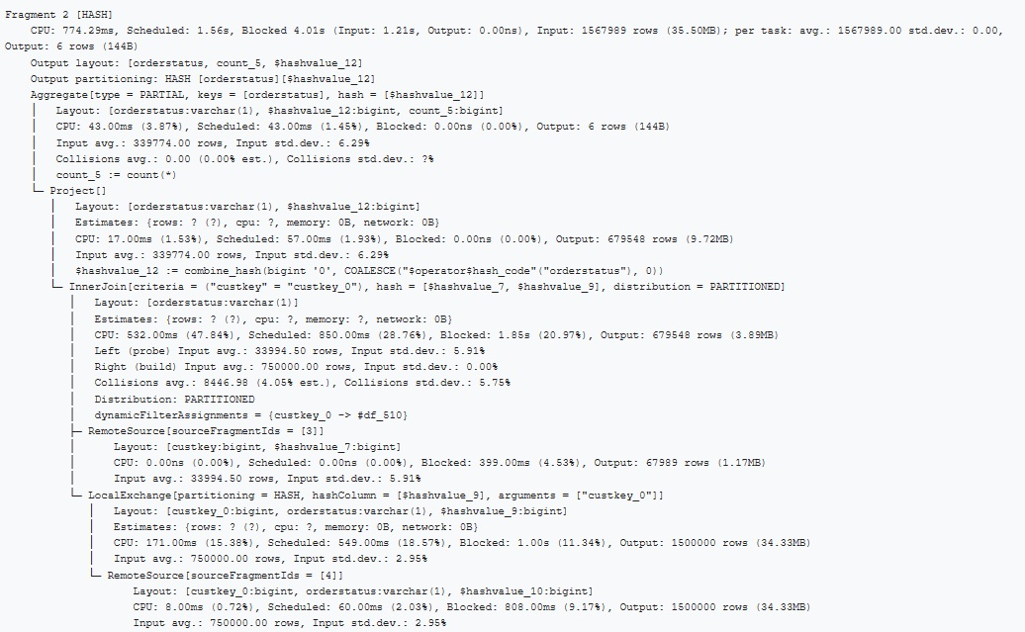

Click here to explore the query plan fragment.

Step 7 - Review plan Fragment 1
Review the labeled graphic below, which only has one item called out.

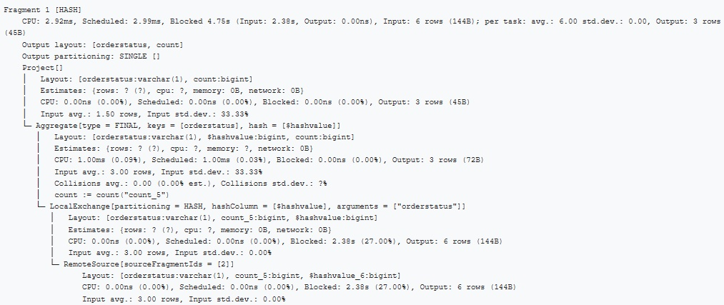

Click here to explore the query plan fragment.

Note: Because the tables have no statistics, the Query Plan you see is not as efficient as it should be.
- Without statistics for ALL tables, our CBO becomes an RBO (a rule-based optimizer) which runs the joins in the order written.
- If there were table stats (number of rows), the CBO would still decide between a Distributed/Partitioned vs. Broadcast/Replicated join strategy for each pair of tables being joined, provided that one of them is small enough to be considered for broadcasting.
- With the number of rows stats, the CBO would also decide on which side a given table should be, i.e., left/right (probe/build or outer/inner).

Step 8 - Set up environment with stats
Now that you've seen some limitations that are present when tables don't have statistics, let's see what happens when tables do have statistics. Statistics for Hive catalogs are stored in the metastore.

Begin by setting up your environment using the following steps:

- Open a new tab in the query editor.
- Set the catalog to hive.
- Set the schema to query_plan_with_stats. Notice this time, it is a different schema with stats.

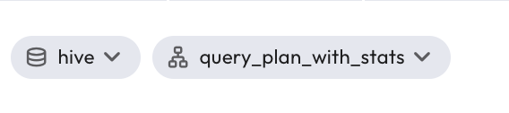
Step 9 - View the table stats
Run the following SHOW STATS commands, one at a time, to view the stats from the customer and orders tables.

SHOW STATS FOR customer;
SHOW STATS FOR orders;

Review the labeled graphic below, which shows the stats for the customer table. Click each plus sign to learn more about the corresponding item.

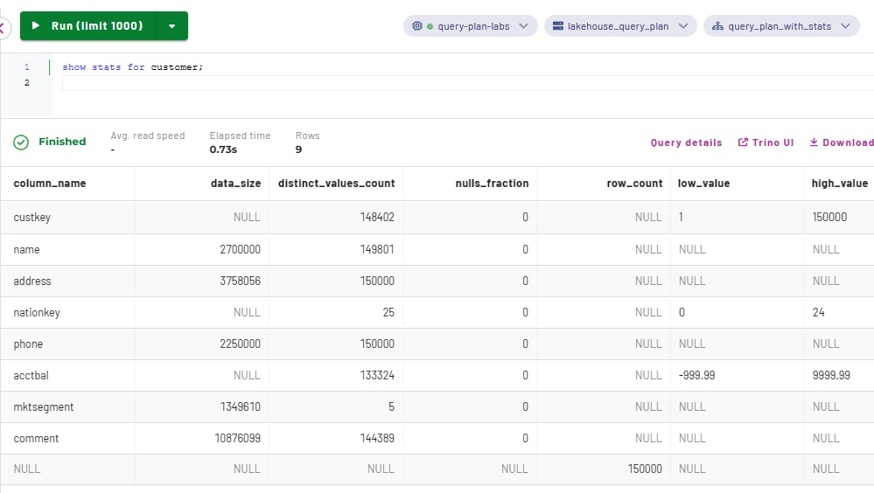

Click here to explore the table stats.

Step 10 - Run EXPLAIN ANALYZE with stats
Now that you've observed the stats, you can run the EXPLAIN ANALYZE command below. Notice that you now have one less fragment than when you ran the same query on hive without statistics.

EXPLAIN ANALYZE
SELECT o.orderstatus, COUNT(*)
FROM customer c JOIN orders o ON (c.custkey = o.custkey)
WHERE c.acctbal > 5000
GROUP BY o.orderstatus;

Step 11 - Review plan Fragment 3
Review the labeled graphic of Fragment 3 below. Click on each plus sign to learn more about the corresponding section of the fragment.

Note: Don't forget to read from the bottom up.

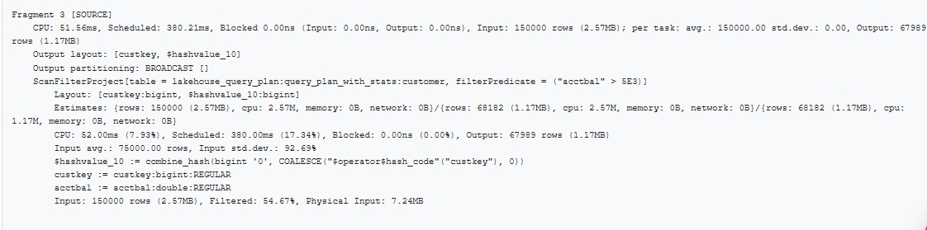

Click here to explore the query plan fragment

Step 12 - Review plan Fragment 2
Review the labeled graphic of Fragment 2 below. Click on each plus sign to learn more about the corresponding section of the fragment.

Note: Don't forget to read from the bottom up.

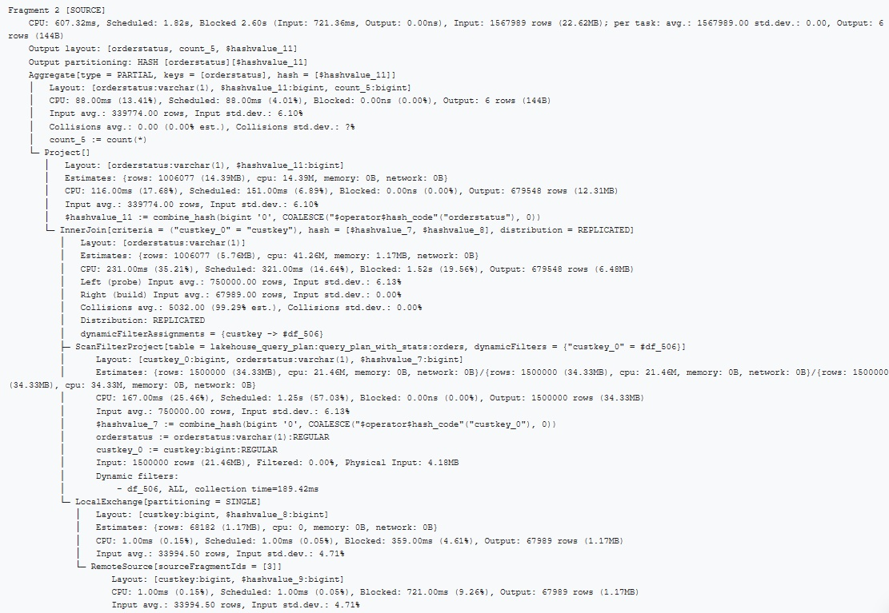

Click here to explore the query plan fragment.

Step 13 - Review plan Fragment 1
This fragment only has one item called out. Review the labeled graphic below for more information.

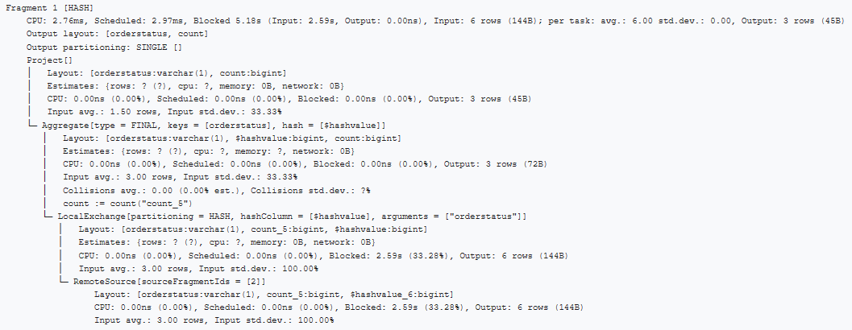

Click here to explore the query plan fragment.

END OF LAB EXERCISE

This is an exact copy of the data from tpch.sf1.nation.

